Hydrogen Super Highway Operations In Extreme Desert Conditions vs. At-Grade Steel Wheel Trains
Resilience against sand storms, dune migration, and airborne particulate is key to the successful long term operation of any transportation system in a Desert Like environment. The Hydrogen Super Highway (HSH) magnetic levitation rail system has been optimized to self sustain under solar power dedicated to the electrolysis of water which enables the reproduction of water with the recombination of Hydrogen and Oxygen produced by the electrolytic decomposition of water. Both gases are stored and when electricity is in demand to operate the sub systems, the hydrogen is recombined with the same oxygen it was separated from in the first step. This process may be repeated indefinitely in a closed loop system; therefore the external environmental conditions outside have virtually no effect on the continuous operation of the system, other than availability of sunshine. The utility substations can be buried under sand dunes and continue to function as long as they are supplied with electrical energy to power the first step of electrolysis.

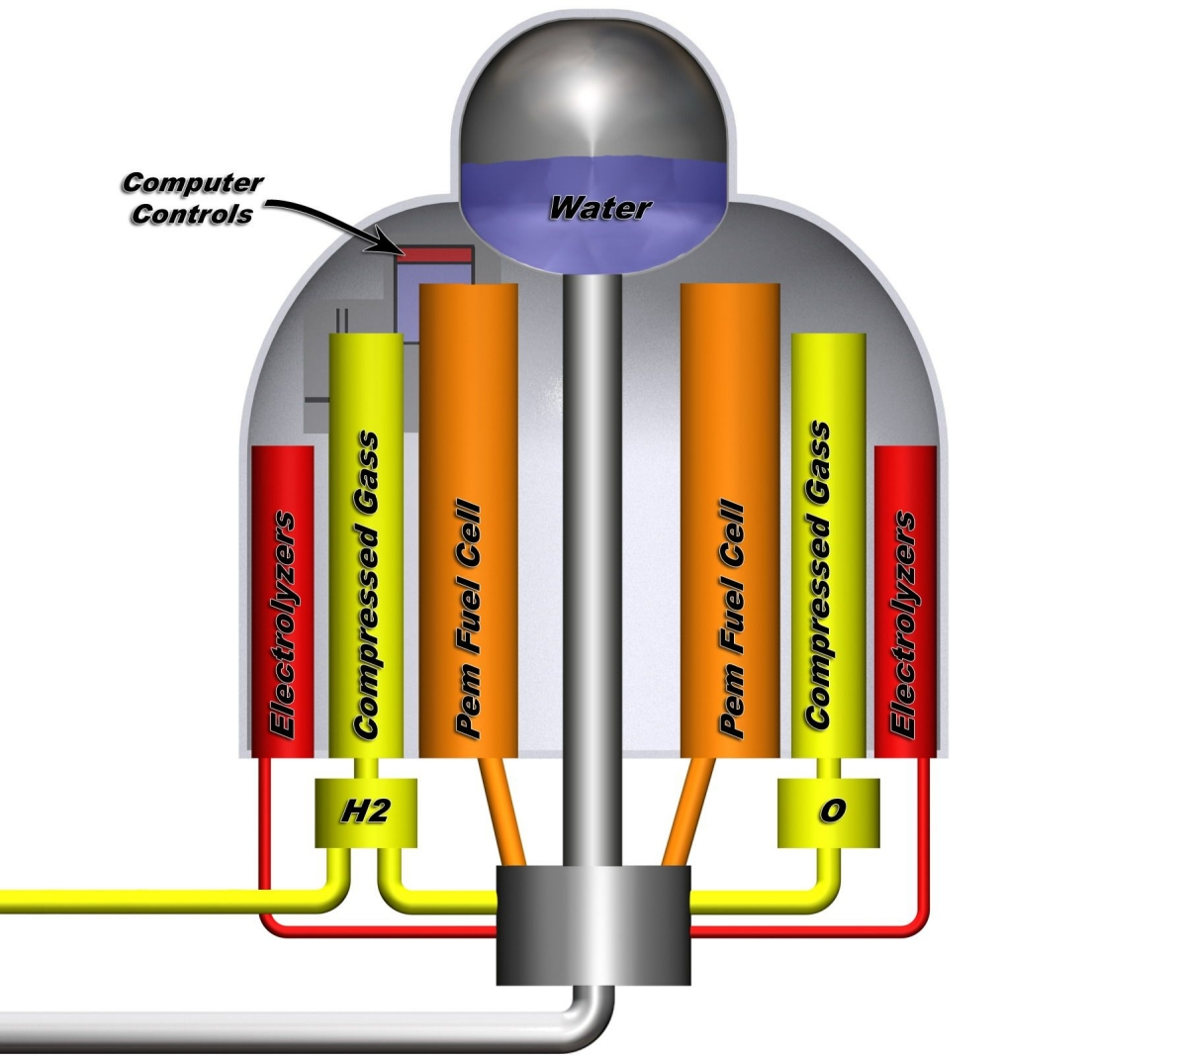
Basic environmental conditions of what is generalized as “Desert Like” can very widely in both temperature ranges and the amount of wind or rain, if any, including the formation of sand dunes, if any. Features of sand dunes such as size shape and rate of migration are easily measured and predicted and may be measured with precision resolution using satellite imaging. They can range from smaller than a meter to much greater than 500 meters in length and may become quite mountainous. Natural features, region by region, such as the amount and general granularity of available sand for eolian deposition, and large geologic features such as bed rock outcroppings, unavoidably affect a continues force that shapes the local dune formations. This reflects on how we can create large artificial structures in a sand dune environment to optimize wind currents to reshape and redirect the migration of sand dunes. This is demonstrated to a small degree with the installation of our stanchion poles which will create a new permanent airfoil that will generate an effect on local wind currents and directly begin the formation of new small dunes on the down-wind side where suitable conditions may exist.
Closed – Loop Utility Substation
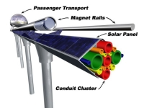
To protect the rail itself from accumulation of airborne particles the simple geometry of the rail takes into account the necessary angles to prevent the accumulation of dust and sand, any where; i.e. the tubular rails leave no place for debris to rest. The air pressure wave in front of a Transport, and eddy currents generated behind it while traveling at a high rate of speed will keep fine dust from accumulating. Additionally, purpose built service vehicles can follow a standard maintenance protocol to clean the rail.
HyRail Sand-Proof Geometry

Replaceable skins over the solar panels that protect the solar panel from abrasion may will extend usable life and ensure maximum energy generation. Centrifugal particulate filters for air circulation in Transports will be standard, yet they may otherwise operate in a closed loop air system to extend filter life during conditions of high levels airborne particulate. Installation is fast and modular and does not require the construction of a “Road Bed” or “Ballast” which is required for standard steel wheel trains.

Clearly an elevated rail system set up with sufficient height will be unaffected by most dune environments allowing for the unimpeded eolian migration of ever changing depositional structures, yet even the smallest of sand dunes can cripple a steel wheel train over night. Expansion coefficient of metal structure optimized for curvature in the rail and the choice of metallurgy such that the extreme temperatures of the desert do not cause harm to the system
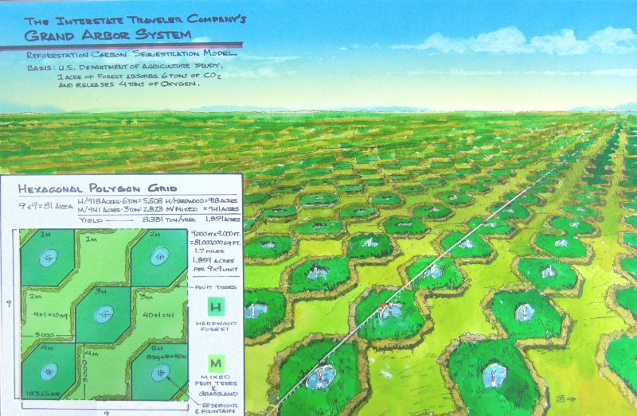
Interstate Traveler Company's Grand Arbor Program
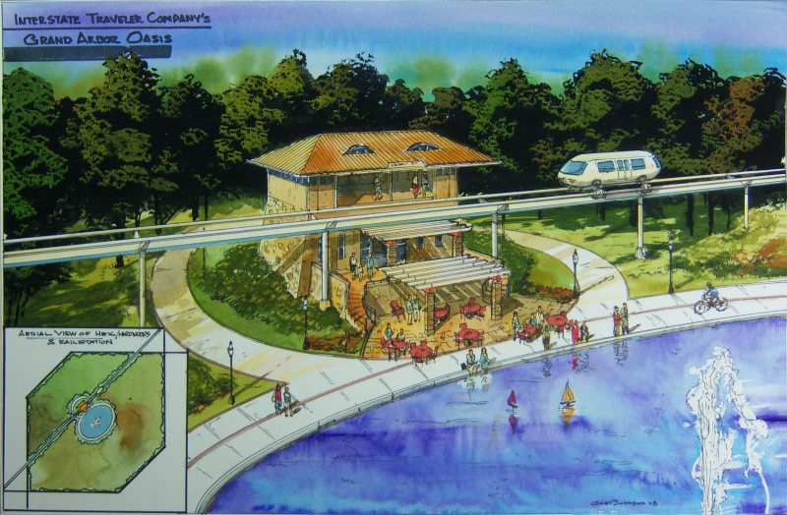
Interstate Traveler Company's Grand Arbor Oasis
Return On Investment:
When comparing a steel wheel train system to our HSH, it is clear that both serve some utility, yet the great multitude of sub-systems and services automatically provided by the HSH including net energy production enables a rapid return on investments with generational revenue thence forth supported by the reliable agricultural support methods made possible by the consumption of solid waste from cities.

Finally, our integration of subsystems such a the plasma reactor solid waste disposal method, we have the ability to generate a continuous flow of hydroponic grade aqueous solutions to grow food or fuel grade crops in the desert to expand and enhance local oases or essentially “Colonize” areas of the desert that would otherwise be unsustainable.

Ref: http://www.interstatetraveler.us/Products/GrandArbor/grand_arbor.htm
Ref: http://www.interstatetraveler.us/Forward.Thinking/Hydroponic.Highway/HydroponicTraveler.htm

