Ray Fullerton
Director of University Relations
E-mail: RFullerton@InterstateTraveler.us

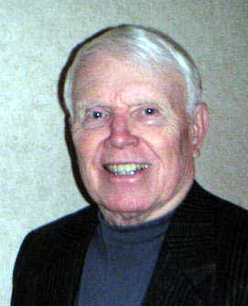

EXPERIENCE
Ray Fullerton joined Interstate Traveler Company as a partner in August 2005 and shortly took on the position of University Relations Director.
He worked at Ford Motor Company 30 years and retired in 1993.
During these years he worked on numerous vehicle programs like Mustang, Taurus and Lincoln primarily in Chassis Engineering.
He served as a design engineer on a large number of chassis parts and then a Program manager during the last 8 years at Ford. Ray was part of vehicle launch programs which were located in 11 assembly plants which were spread out all over the Midwest and Canada.
After leaving Ford, Ray served as an Engineering Consultant to 6 automotive suppliers. He was able to solve production problems and also improve designs to eliminate potential warranty issues.
The last company Ray worked with was “Mando America” a Korean Company. Ray was able to provide excellent help on a program for General Motors in which a design on the 2009 Delta was being made on drum brake program. Mando had very competitive products for both automotive brake and steering components.
EDUCATION
University of Michigan- Bachelor & Master of Science
Mechanical Engineering
Henry Ford Community College Associate of Science Degree
PERSONAL
Two accomplished children and four grandchildren.
Ray skied patrolled for 36 years at Crystal Mountain, Mi.
As Patrol Director, Ray led an effort over 3 years in which the Patrol Membership built a new first aid facility at the base of a large area slope.
Ray has enjoyed many sports including water skiing in which he was the first in Michigan to jump 100 feet.

