
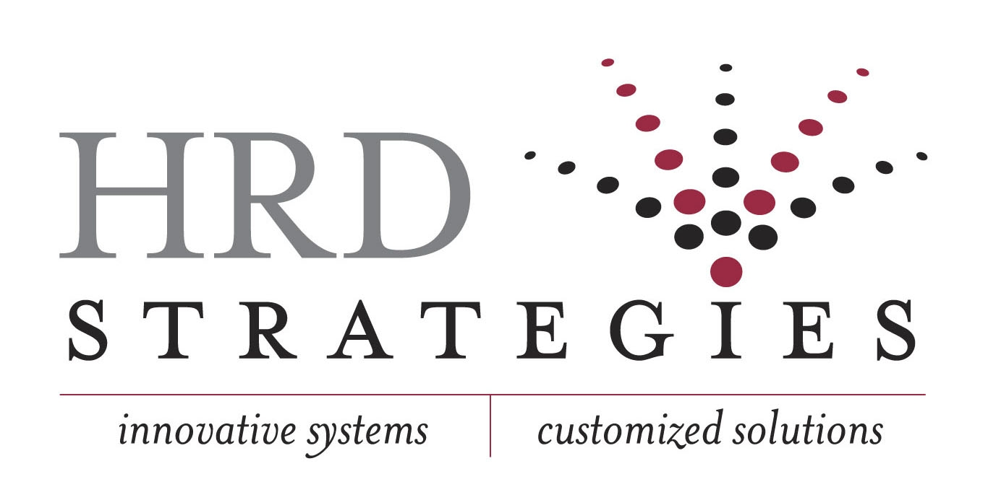
MICHAEL W. LOVETT
President and CEO
Michael is the President and CEO of HRD Strategies, Inc. HRD Strategies is a full service Organizational Effectiveness and Human Resources firm - providing innovative, customized solutions through the integration of social and technical systems. Based in Greensboro, North Carolina, HRD Strategies has been delivering customized solutions since 1988. As a consulting firm, HRD Strategies partners with organizations to evaluate the social and technical aspects of work environments and implement strategies to maximize bottom-line business results.
Mike’s experience includes organizational development, human resources, engineering, construction and manufacturing. His primary focus for the past twenty years has been corporate turnarounds, organizational restructuring, re-engineering of operational and human systems, organizational development, talent management, executive/managerial assessment and coaching, high performance work systems, labor negotiations, learning management systems and talent selection systems.
As a performance-based management consultant, Mike continually focuses on the growth and development of individuals and organizations through extensive consultation, training and coaching. Mike is noted for his organizational performance work with KnowledgeWorks, a Bill and Melinda Gates Foundation, Trans Meridian Airlines, Bacharach, Triad International Maintenance Cooperation (TIMCO), and BAMA Foods. The scope of his on-line experience with organizations such as ARCO, Duracell and Halstead Industries, is synergistic with his consultative practice in multi-dimensional industry verticals, public sectors and service organizations. Mike's practical experience in Business Operations and Industrial Psychology establishes credibility and value with clients as he is pragmatic and goal and achievement motivated.
Prior to starting HRD Strategies, Mike worked as a Director of Organizational Development and Management Systems where he designed and implemented high performance work systems with international joint ventures and re-designed traditional entities into high performance cultures. Included in his experience as CHRO is the transformation of Human Resources into strategic business partnerships with focus on added value to the business enterprise.
Additionally, Mike designs and implements human capital transformation systems, core competency analysis processes, 360 degree profiles, organizational surveys, assessment center selection and development processes, pay-for-knowledge systems, strategic compensation systems, performance management systems and succession planning. Mike also conducts various types of leadership, technical, interpersonal and management development training for all levels of employees all customized to organizational needs.
Mike has published a quarterly journal titled Employee Empower and collaborated on “Working Scared,” a business book written for managers working in trying times. He has also presented at numerous conferences including: The Society for Industrial and Organizational Psychologists (SIOP,) The Ecology of Work, Twenty First Century Work Environment, NC SHRM Conferences, Best Practices in Leadership Summits, Leadership Southside, Leadership North Carolina and various regional Human Resource Associations. Mike was featured as a Thought Leader at the Best of Talent and Leadership Summits that were held in 2009.
Mike is currently co-authoring a book entitled “Quiet Leadership” with Julie M. Copeland that will focus on the Leadership Synergy model developed over the course of his career as a performance-based management consultant.
Mike resides in Greensboro, N.C., with his wife, Nina. They have two children, Ryan and Andrea.

