Laurie S. Moncrieff
Chief Manufacturing Officer
E-mail: Lmoncrieff@schmald.com

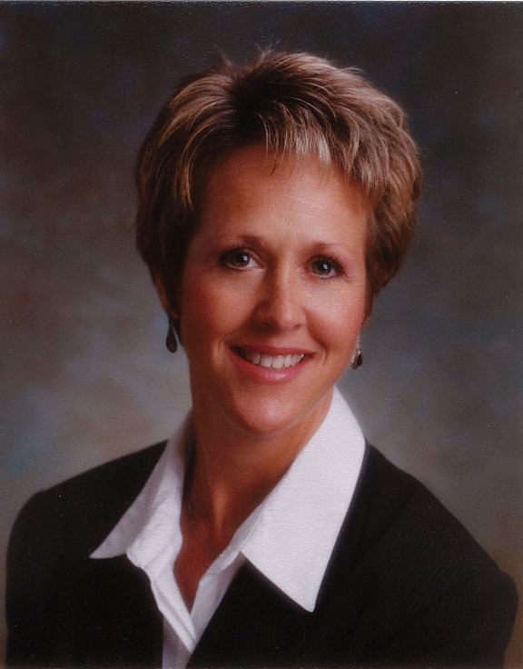

Background
Laurie Schmald Moncrieff received her Bachelor of Science Degree in Packaging Engineering from Michigan State University in 1982. She has held various sales and management positions with several Fortune 500 companies. Laurie joined her father’s company, Schmald Tool & Die, as Sales Manager in 1995. She purchased the business in 1997 to become the third generation owner. Laurie is also the owner and General Manager of Adaptive Manufacturing Solutions, LLC (AMS headquartered in Burton, Michigan. AMS is a consortium of twenty (20) member companies generating over $175 Million in annual revenue with 500 employees working in 1 million square feet of total floor space.

Federal Testimony
International Trade Commission Testimony, October 2002 on Tools, Dies, and Industrial Molds: Competitive Conditions in the U.S. and Selected Foreign Markets

House Ways and Means Trade Subcommittee Testimony, March 26, 2003, 201 Hearing on Safeguard Action on Steel

International Trade Commission Testimony, June 19, 2003, 322 Hearing on Steel Tariffs

China Commission Automotive Hearings, June 17, 2006, Hearing on China’s Impact on the Automotive Industry

Associations & Boards

Women’s Business Enterprise National Council (WBENC) member

Michigan Chamber of Commerce – Board of Directors

Governor’s Health Care Task Force

National Tooling & Machining Association (NTMA)
- Past Governmental Affairs Board Member
- Past Leader – Networking Team

Michigan Manufacturing Technology Center (MMTC) – Board of Directors

Awards
Blue Chip Award – United States Chamber of Commerce 2000
Athena Award – Flint Women’s Business Council 2001
Michigan Manufacturer of the Year – Michigan Manufacturer’s Assoc. 2002
Flint-Genesee Manufacturing Award – Flint Chamber of Commerce 2002

