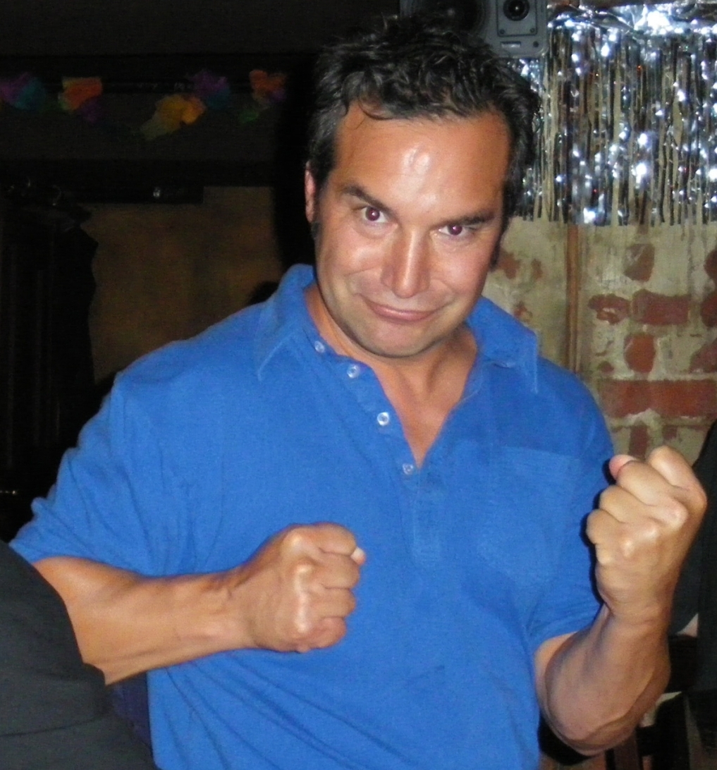
Jack Savas
Partner and Chief Far East Officer
E-Mail: jack@hyrail.us

Background
A multi-lingual former diplomat and international business specialist with 15 years of overseas work experience in Tokyo, Seoul, Singapore, Auckland and Melbourne.
Animated, Self Motivated Highly educated with conversational fluency in Japanese, Greek and English. Deal closer with negotiating skills on $100MM projects with strong emphasis on consensus building and conflict resolution. Past roles include Trade Consultant US House Ways and Means Committee Washington, D.C., State of Michigan Commerce Department International Office, Export Sales Manager at PPG Industries, business owner of a custom motorcycle company (Von Dutch) and Counselor for New Zealand Ministry of Foreign Affairs and Trade.

Education
BA International Business, James Madison College, MSU

Japanese Language, Stanford University, Palo Alto, California
Certification International Economics, Konan University, Kobe, Japan

Affiliations

YFU International Exchange Student
Golden Key National Honor Society
Foreign Correspondents Club, Tokyo Japan
Vice President, US State Office Association Japan
President, American Club, Auckland, New Zealand

Trustee Board Member, Enterprise Waitakere, New Zealand
Featured on documentaries produced by the BBC and CNN
Enjoy fitness, cooking and theatre.

