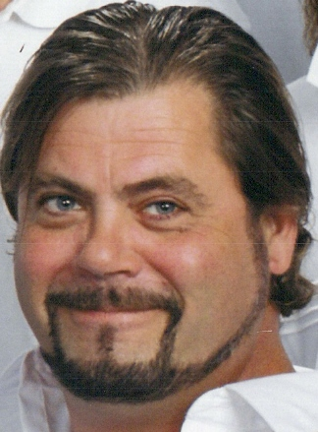

Jim Griffin
Founder /Managing Partner
Project Green America, LLC
Producers of the
Green Earth Expo Series of Events
E-mail: jim.griffin@projectgreenamerica.com

James F. Griffin is the founder and managing partner at “Project Green America, LLC”. Mr. Griffin became involved in the green movement after his youngest son battled Leukemia and his wife died from a glio-blastoma brain tumor in 2000. Griffin spent many days and weeks at the Duke University Library while his wife underwent treatment at the University’s Cancer Center.

While searching for answers about what was happening to his family; Griffin learned that many cancers are the direct result of being exposed to a myriad of toxins and pollutants from almost every quarter. From food additives and preservatives to ground water (well water) with heavy metals in it, even the construction materials used to build our homes and the furniture that goes in them. The problem was much bigger than Griffin had ever dreamed and it seemed like so few people really understood just how bad it really is.
Griffin had worked with his parents in a family owned business through-out the 1980’s producing trade shows and large expositions such as the Dallas Home & Garden Show or the Dallas Boat Sport & RV Show. With an opportunity to get into the building business in the early 1990’s he became a self employed trim carpenter and worked in his own company until October of 2006.

It had been a little over five years since Griffin had lost his best friend and wife but the world just kept going on. His youngest son was now a seven year cancer survivor and as he grew he looked more and more like his mom every day. Griffin wanted desperately to find a way to leave his four children a better and safer world to live in. It was then that Griffin sold his the tools he had made a living with for over 15 years and raised enough money to put a deposit on the Orange County Convention Center’s exhibition halls “A” & “B”.

In November of 2006, Griffin started a company called “Project Green America, LLC” and drew from his experience in the trade show industry to create the “Green Earth Expo 2008”. With over 300 businesses exhibiting green products and services and over 100 speakers, this first time event was a huge success. Green Earth Expo 2010 will be held at the Baltimore Convention Center, February 26th 27th 28th. Griffin’s company has permanently moved its headquarters to Maryland because of its close proximity to Capitol Hill and the constant opportunities to promote these amazing green businesses, the forward thinking entrepreneurs and their ideas to officials, committees, legislators and departments at the federal level.

