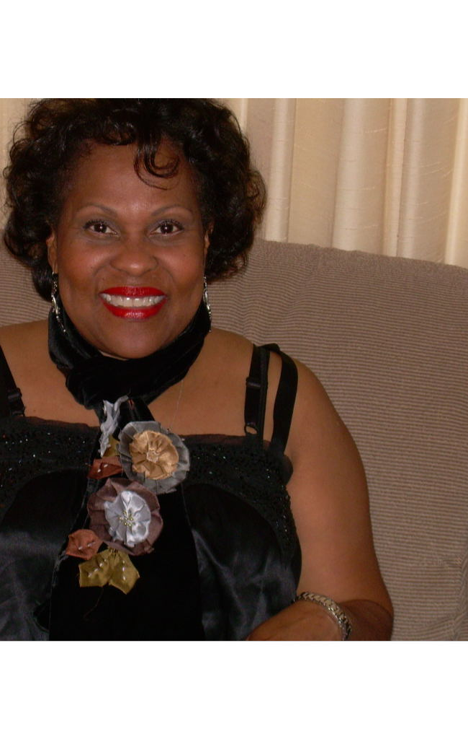
Connie Murry Cole
Government Relations Director
E-mail: connie.cole@interstatetraveler.com
Connie Murry Cole became Government Relations Director of the Interstate Traveler Company in November of 2007. Ms. Cole has experienced 35 years in applying social, cultural, and political realities to business, government and community. Showcasing skills and expertise in strategic planning, capacity building, diversity consulting, gaming development & implementation, governmental relations, business and community development.

Career Accomplishments
- First Woman Administrator in the Michigan Department of Transportation
- Deputy Director of U.S. Peace Corps in the West African Countries of Sierra Leone, and The Gambia
- Coordinator of the International Liaison with South Africa’s Education Ministries and Non-Governmental Agencies of the Northern Cape and Orange Free State on behalf of the U.S. Secretary of Energy during the U.S. delegation of the Gore-Mbeki Bi-National Summit
- Special Project Consultant for The Jemison Institute for Advancing Technology in Developing Countries at Dartmouth College
- Governmental Strategist for Atwater Entertainment Company, bringing Gaming Development and Implementation to Detroit, resulting in the Motor City Casino-Member of Mandelay Casino Group
- Special Feature Workshop Consultant-Redefine The Possible, at the 10th World Summit of Young Entrepreneurs, Let’s Make a New Deal. A Global Public-Private Partnership Mechanism Engaging Agencies of the UN System A World Trade Forum Initiative
- Real Estate Instructor, Wayne Community College

Awards/License
Senate and House Concurrent Resolution 279, Michigan Legislature
Real Estate Associate Broker License

Education

Michigan State University B.S. Community Development
Michigan State University M.A. Educational Psychology

