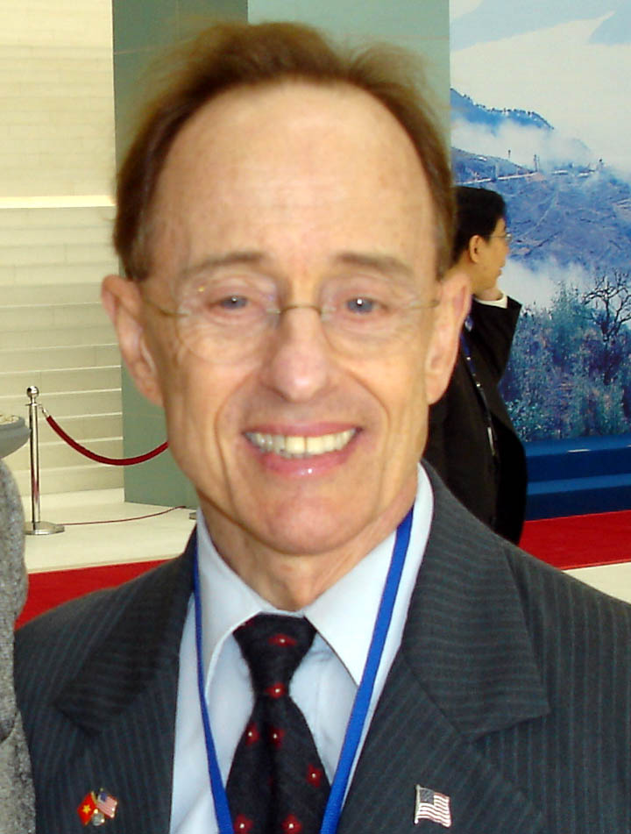

Andre Sauvageot,

Partner / Chief Representative in Vietnam
Email: andresrvusa@HyRail.us

2007-current: Director for US-Vietnam Relations & Business Development (in Vietnam), AIAK Malaysia—web site: www.aiakswiss.com.

2007-2008: Representative, Bombardier Aerospace/Regional Aircraft in Vietnam, but based in USA, with occasional visits to Vietnam.

2004-2006: Senior Advisor, Oracle Vietnam Pte Ltd. Helped Oracle win international bidding competition to provide its software as part of IT solution for Ministry of Finance & position for later win with Electricity of Vietnam ((EVN).

1993-2003: Chief Representative for the General Electric Company (GE) in Vietnam. Established GE Representative Office. Key role in winning contracts for GE Aircraft engines, 3 leased Boeing B767-300ERs to the Vietnam Airline, and major contracts for GE power equipment. Fluent in spoken and written Vietnamese, conducted GE business in the local language. Testified frequently for GE to the House Ways & Means Sub-Committee on Trade advocating support for the President’s waiver of the Jackson-Vanik Amendment against Vietnam.

1991-1992: Regional Advisor for the Comprehensive Plan of Action (CPA) to encourage asylum seekers to return voluntarily to Vietnam. Regular visits to refugee camps: Hong Kong, Thailand, Indonesia, Malaysia, Philippines. Explained Vietnam’s assistance to returnees (ineligible for resettlement in 3d countries) to reintegrate into their homeland. Regular visits to returnees in Vietnam, supported by Vietnam’s Foreign Ministry, Ministry of Labor, Social Welfare and the Ministry of Interior.

1989-1991: Political Appointment to the Foreign Service, as “Special Assistant to the Ambassador (in Bangkok) for Indochina Affairs.” Did political/economic analysis of Vietnam. Frequent travel to Hanoi during the period, consulting and interpreting for Congressional and Executive Branch delegations.

1988-1989: Political Appointment, as Assistant, Regional Political-Military Affairs, East Asia & Pacific, Defense Department. Assisted with transition from the Reagan to the Bush Administration on matters relating to Defense/security issues.

1984-1988: Manager, International Programs, Northrop Corporation, for Asia/Pacific. Based in Washington, DC office; traveled to the region to work with customers in East Asia and the U.S. Government in Washington.

1956-1984: Active duty, U.S. Army. Wartime Vietnam service (1964-73) began as a District Advisor. Various assignments included the Prime Minister's Office, and interpreter for the U.S. delegation to the Four Party Joint Military Commission meetings in Saigon to implement the Paris Agreement and end the war. Promoted to Colonel in 1980, and assigned as the Political-Military Advisor, Bureau of East Asian Pacific Affairs, State Department until retirement from the U.S. Army.

Current Memberships include: US-Vietnam Trade Council; Hanoi Chapter of Amcham—currently representing Interstate Traveler Company; Vietnam Veterans of America & US-Indonesia Society.

