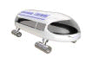

The Interstate Traveler Company, LLC
Whitmore Lake, MI

The ‘Chicken or Egg’ Dilemma
Of Alternate Fuel Vehicles:
What comes first? The Vehicles? Or the Infrastructure?

And

Its Relationship to
Public Utilities and Interstate Transportation

August, 2003

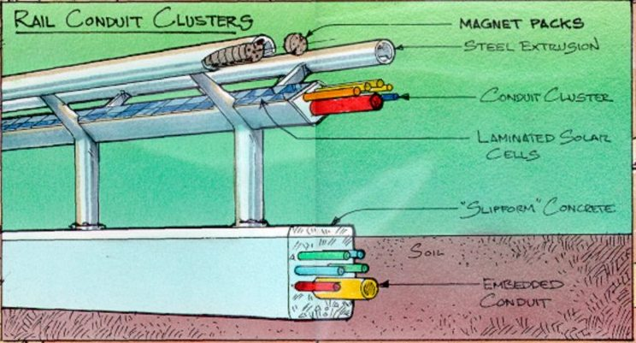
Contents

Bridging the Gap Between Status Quo & Opportunity 3
The Deliverables 4
The Benefits of the Interstate Traveler 4
Government Support 4
How The Interstate Traveler Works 5
‘Strategic Partner Opportunity’ Definition 6
The Investment 7
Relationship Between ITC and the Strategic Partner 8
Summary 9

Introduction
It seems so positively exciting! Every day, we hear of the existence right now of ‘futuristic’ automobiles that run on hydrogen rather than gasoline, and emit clean water instead of carbon monoxide and other toxins. Surely there is a market for such vehicles; but why won’t they automakers build them? Because there is currently no infrastructure to supply the existing convenient fueling stations along every highway.
Simultaneously, the newscasts tell us about the difficult times people are having all over the world. Everywhere there is overcrowding, urban sprawl, public utility failures, traffic jams, car accidents, dangerous, vulnerable and unsightly utility poles, and backed up sewer systems that contaminate local public waters. Public systems are due for an upgrade when a simple winter storm brings business to a halt and cuts power to hundreds of thousands of homes in our cities and suburbs.
What if?
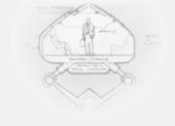
What if we could solve the ‘Chicken or Egg’ dilemma that is holding up the development of Alternative Fuel Vehicles, while simultaneously providing for a cleaner, more efficient, more cost effective public utility infrastructure and transit system?
We have done just that…
Welcome to the Interstate Traveler
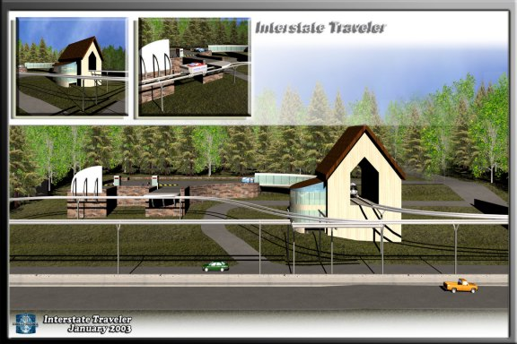

Bridging the Gap Between Status Quo & Opportunity
The Internet of National Transportation and Hydrogen Production / Distribution
The Interstate Traveler Company, LLC ( ITC ) proposes the construction of what we call the ITC Rail Conduit Cluster ( ITC Rail ) which is a mass produced elevated rapid transit system with extraordinary features and benefits. ITC Rail is the integration of basic municipal infrastructure with modern computer networks, solar power, hydrogen science, and magnetic levitation mass transit.
The ITC Rail is a magnetic levitation light rail system that draws its energy entirely from sunlight. Via a photovoltaic array along the length of the rail, sunlight is converted to electricity, which is then used to convert water into hydrogen and oxygen. That hydrogen then powers fuel cells that propel passenger, auto, and cargo vehicles along the elevated rail. Traffic is routed with the same addressing technology that directs information over the Internet (TCP/IP), allowing for ‘on/off’ stations along the entire route (whether it be in a loop around a metropolitan area or a coast to coast stretch where speeds can exceed 300 mph on the open road).
Every bit of the required technology exists today. The construction of the ITC Rail only requires a coordinated and integration process. In fact, there are several magnetic rail systems already in operation in North America, Europe and Asia. But the Interstate Traveler is unique because it goes so far beyond simply providing clean, efficient transportation: it simultaneously provides a ready-made hydrogen production & distribution network, augments electrical utility grids, and by using virtually any water source from sewer water & storm drains, to the oceans on our planet as a source for Hydrogen and Oxygen; the recombination of this Hydrogen & Oxygen will produce electricity, heat, and clean potable water.

The Deliverables

The extensive suite of products and services produced and provided by The Interstate Traveler is illustrated by the following list of featured deliverables that generate revenue, yet we do not limit this list to its current form.

- Rapid Transit = $/mile
- Hydrogen = $/kilogram
- Electricity = $/kilowatt
- Energy Storage = $/kilowatt
- Fiberoptics = $/bandwidth
- Fuel pipelines = $/gallon or cubic foot
- Liquid waste = $/barrel
- Advertising = $/sign
- Brand New Water = $/liter
- Internet/Telecom = $/minute

The Benefits of the Interstate Traveler
The creation of a national rapid transit system and a national hydrogen production/distribution system are equally important, providing huge benefits to the American people with economic mobility, jobs, and the immeasurable benefits of a clean burning hydrogen economy. Following the bilateral benefits of national rapid transit and hydrogen production is the installation of redundant municipal conduit serving all traditional consumables like potable water, electricity, waste lines, and piping for other fuel delivery. Inherent to the accuracy of a TCP/IP network control system, we will be able to provide direct revenues to Federal, State, County, Township, and City municipalities based on system usage within their ‘Network Jurisdictions’. The highest traffic areas will certainly receive the greatest revenue. Surplus hydrogen will be directly piped to all traditional fueling stations directly adjacent to the route of the ITC Rail, will be sold to other pipelines and/or will be trucked overland in tankers to reach remote populations. The benefits of a doubled or quadrupled average rate of speed (Rapid Transit) for people on the Interstate Highway System will bring benefits to business, family and friends brought closer together by dramatically reducing transit time with increased safety and reliability.

Government Support
Today, the Interstate Traveler has supporters throughout the Local, State and Federal governments, from Townships, to Multi-County Metropolitan Planning Organizations to City Governments, to House Resolution 23 and Senate Resolution 89. On all sides we have been greeted with warm enthusiasm, and we stand on solid ground.

How The Interstate Traveler Works
The Interstate Traveler Rail Conduit Cluster works using solar power to prime the hydrogen production and distribution system which then is used to power hydrogen fuel cells to energize our electrical grid. The ITC Rail is in effect an Alternative Energy Technology that collects solar power all day with each running foot of rail to power the hydrogen systems as described above, which will then provide the power to drive hundreds and eventually thousands of autonomously controlled transit vehicles that ride the ITC Rail. The entire operation is built on TCP/IP technology giving virtually unlimited network growth, maximized autonomous operations for routing of traffic, and full accounting and control of every component used in the operation of the system, in real time. With the installation of 1 massively redundant utility substation for every 4 kilometers of rail, the ITC Rail provides the perfect model of a DEG or Distributed Energy Generation system, built on a redundantly controlled automatic failover, load balancing network.
The following figure demonstrates the basic Interstate Traveler Energy Cycle:
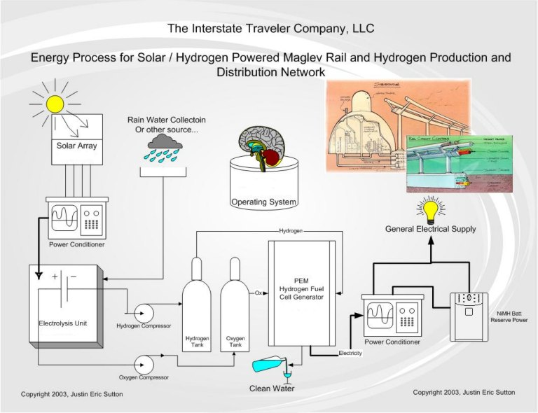

‘Strategic Partner Opportunity’ Definition

A strategic partner is a corporate entity that would directly benefit from the ITC’s existence as a vehicle to new markets. As mentioned above, a hydrogen fuel distribution network opens new markets to the automobile manufacturers who have resisted putting hydrogen fueled cars into production because there is no way today to refuel them economically, thus dooming the return on investment. Until now. Now, we can ensure the automobile industry will be able to run H₂ cars to or from virtually any place in America along the Interstate Highway System within the next 15 years

With the ITC Rail being a semi-public rail system, anyone with the means of production is welcome to build specialized maglev rail cars to operate as needed on this growing Interstate Network of maglev rail corridors. The Automobile, Travel Coach, Limousine and Aerospace industries are all welcome to build cars for Public, Private and Corporate use, from private touring buses, to public taxis, to corporate limousines, to mobile medical facilities: all cars are welcome.

Another example may be as a direct supplier to the ITC, such as a manufacturer of the tubular rails, the silicon-based magnetic cores, conduit, switches, valves, fuel cells, solid state batteries, and utility substations. Still another example includes engineering or software technology partners, whose initial groundwork for Mile 1 can be duplicated economically ad infinitum, yielding a very attractive return on investment.

The Opportunity at Hand for a Strategic Partner
The opportunity at hand is on a par with that for participants in the formation of earlier Transportation Infrastructure shifts: Boats, Trains, Planes, Automobiles, and Space exploration.
The technology used by the ITC is well developed and readily available; The Interstate Traveler Company is an entity which creates a very desirable ground floor opportunity for Strategic Partners. Most of the effort to date has been spent in due diligence and very successfully garnering Local, State and Federal governmental support.
ITC is seeking Strategic Partners to participate in these early planning stages. The return on such participation comes in continued access to the new markets the ITC will provide for their particular products or services, under favorable terms and conditions. In the near future, the ITC’s scope and capital expenditures will require spanning both private and government involvement, but at this point the financial requirements are modest. A relatively small amount of ‘seed capital’ has extraordinary potential for yielding new market opportunities for decades to come.
The opportunity to invest seed money along with the traditional Federal investment of capital costs for alternative energy and transportation systems will provide great rewards in the near future and in the long term. An appropriate agreement will be negotiated with each strategic partner.

The Investment
The Interstate Traveler is extremely cost effective relative to similar existing technologies, and uniquely so, given its inherent return on investment. By exploiting the advantages of mass production of rail segments in a factory setting, we estimate a per mile cost of $5 Million, inclusive of the commensurate infrastructure which includes Cloverleaf Substations at an average 1 for every 5 miles of ITC Rail, and even some number of passenger-and car-ferries (consider a ratio of 4 cars for every 1 mile of ITC Rail where every mile of rail is considered as a set of rails in parallel to provide uninterrupted simultaneous two way traffic). A rigorous pro forma exists that, with even the most conservative assumptions, yields a very attractive and quick ROI, giving way to sustained high profit margins for the years to come.

The total available market for the primary Interstate Highway System in the United States is in excess of 160,000 miles of right of way, which, at $5 million/mile, equates to $800 billion in sales.

As a marketable product, the Interstate Traveler ITC Rail is very attractively priced relative to the established maglev rail market, and will enjoy a strong competitive advantage. For example, comparable systems already built or in the final planning stages include:

Pittsburgh, PA
Description: 47 mile shuttle between Downtown and Airport
Cost/Mile: $18 Million *

Shanghai, PRC
Description: 19 mile shuttle between Downtown and Airport
Cost/Mile: $68 Million *

Norfolk, VA
Description: Old Dominion University, Campus Shuttle
Cost/Mile: $20 million *

* Un-official estimates from public record and Internet sources

Relationship Between ITC and the Strategic Partner

A. The Interstate Traveler Company will:
- Build/Sell/Own/Operate/License Interstate Traveler systems worldwide.
- Manage the ITC integration projects with existing transit systems
- Build a prototype ITC concept and carry out market-research program in the mass transit vehicle market.
- Grant dedicated single source supplier status to Strategic Component Partners.
- Provide/Manage design and engineering of parts and components to the ITC Program during development.
- Provide design, development, tooling, validation, and manufacturing capabilities for the ITC project.
- Market the ITC program to government authorities World Wide.
- Build academic relationships World Wide
- Maintain membership with National Standards Organizations
- Provide office space for Strategic Partner personnel at the ITC’s facility.

B. Strategic Component Partner will:
- Provide design, engineering, parts and services to the ITC program during development.
- Work with ITC to supply and develop exclusive hardware for use in the prototype Interstate Traveler to the required professional original equipment standards of function, fit, finish, and durability.
- Receive guarantee of exclusive product representation for the ITC development program.
- Receive engineering support and technical information as required.
- Receive all pertinent information from engineering development & testing and clinic evaluation.
- Provide single point of contact and open access for all development of their product.
- Supply exclusive components of/for the ITC Rail et.al.
- Take part in all clinics and exhibits at partner’s option.
- Develop, and supply parts and systems for the ITC during the term of partner’s dedicated supplier status.
- Have dedicated product and record keeping personnel
- Provide funding and/or services to the ITC Program in return for access to new markets and preferred supplier status.

Summary

The Interstate Traveler Project provides a national multimodal (passengers, automobiles & freight) maglev rail rapid transit and energy generation and distribution system using solar powered hydrogen production and hydrogen fuel cell technology, fully operated using TCP/IP.

From the local, to the national level this provides the “Internet of National Transportation and Hydrogen Distribution” with near zero environmental impact, an overall reduction in air pollution while increasing the efficiency of the national transportation system, and an increase in the productivity of the Nation’s economy.

The Interstate Traveler creates a faster moving economy providing high speed transit and the provision of public utility services as needed. Increasing the rate of change from fossil fuel based transit systems to a pollution free hydrogen based transit system, we reduce congestion on the freeway with the integration of high speed rail, provide nation wide long term job creation, reduce mortality rates based on National Highway Safety figures, and provide an armor plated fiber optic network connecting major cities and utility infrastructures together for reliability and redundancy.

We welcome your Interest and Investment.

For more information, please contact our main office:

The Interstate Traveler Company, LLC
9594 Main Street
Whitmore Lake, MI 48189
734-449-4480
Justin@InterstateTraveler.us
