Strategic Business Plan
Interstate Traveler Company, LLC
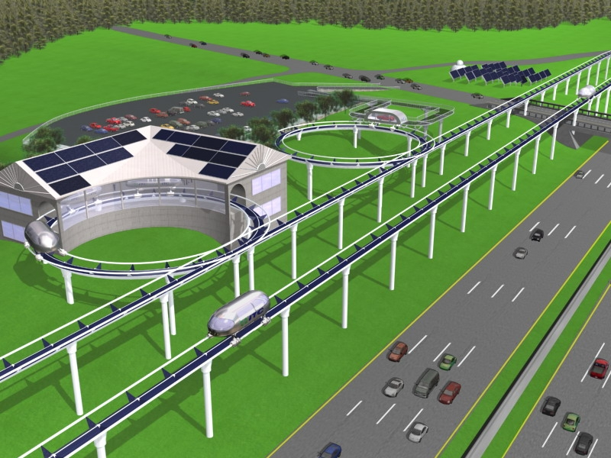
Strategic Analysis preformed by Executive MBA Team “Fists of Five” of the University of Notre Dame   | Technical and Commercial Development by The Interstate Traveler Company, LLC  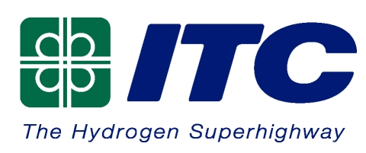
Table of Contents
ITC Business Plan 5
1. Executive Summary/Elevator Speech 5
2. Strategic Architecture 5
2.1 Vision 5
2.2 Mission 5
2.3 Plan Assumptions 5
2.4 Stakeholder Groups 7
3. Strategic Content 7
3.1 Problems to be solved 7
3.2 Purpose of the business 8
3.3 Description of Uses 8
3.4 Primary Customer and Type 8
3.5 Environmental Impact 8
3.6 Social Responsibility 9
1. Strategic Analysis 10
2. Industry Description and Size 10
5. Strategic Formulation 14
5.1 Market Plan 14
5.1.1 Customer Trends 14
5.1.2 Segmentation 17
5.1.3 Competitive Advantage 19
5.1.4 Product/Service/Business 20
5.1.4.1 Description including customer need and benefit 20
5.1.4.2 Unique Features 20
5.1.4.3 Target Customers 21
5.1.4.4 Innovation Requirements & Migration Path 21
5.1.4.5 Marketing Budget 22
5.2 Core Competencies and Organization Plan 22
5.2.1 Core Competencies 22
5.2.2 Management Team Description 22
5.2.3 Culture Description 23
5.2.4 Change Management and Organization Plan 23
5.3 Ops and Technology Plan 24
5.3.1 Make/Buy Decisions including types of potential partners 24
5.3.1 Technology Plan 25
5.3.3 Product, Manufacturing, Operations, Labor and Quality Plans 28
5.4 Financial Plan 30
5.4.1 Economic Engine / Business Model 30
5.4.2 Financial Assumptions 33
5.4.3 Pro Forma Financial Statements 34
5.4.3.1 Cash Flows 34
5.4.3.2 Income Statement 35
5.4.3.2 Balance Sheet 36
5.4.4 Break-Even Analysis 36
6. Contingency Plans 37
7. Tactics and Implementation 38
7.1 Timeline 38
7.2 High level project plan 38
7.3 Key measures of success 38
7.4 Overall Management Process 39
7.5 The Management Team 39
Managing Partners 39
Board of Directors 40
Board of Presidents 40
Regional Directors 41
ITC Advisory Board 42
8.0 Technical Documentation 48
8.1 Summary of Proprietary Information 48
8.2 Socio-Economic Impact Assumption 49
8.3 Revenue Sources 51
8.4 ITC Rail 52
8.5 ITC Rail Switch 53
8.6 Central Support Conduit Cluster and Utility Substations 54
8.7 Connector Plate 55
8.8 ITC Rail and Connector Plate Interaction 55
8.9 ITC Rail, Connector Plate and Stanchion Pole Interaction 56
8.10 ITC Slotted linear motor and magnetic levitation nacelle 57
8.11 ITC Rail Slotted Linear Motor Detail 58
8.12 ITC Coil Density Plan 59
8.13 ITC Radius Study 61
8.14 ITC Transporter Suspension 62
8.15 The G-Force Compensator 63
8.16 ITC Rail Assembly Process 64
8.17 ITC Rail Pile Driver Apparatus 65
8.18 ITC Energy Cycle 66
8.19 ITC TCP/IP Control Systems 67
Appendix A - Interstate Traveler Nomenclature 69

ITC Business Plan

Executive Summary/Elevator Speech
Interstate Traveler Company offers public transportation that provides high-speed, safe, solar-powered and environmentally friendly service to commuters, consumer travelers and commercial businesses through integrating technologies, neighborhood train stations and our current interstate system supported by local, state and federal government agencies.

2. Strategic Architecture

2.1 Vision
Move the State of California’s economy to a hydrogen economy in 15 years

2.2 Mission
ITC will bundle existing technologies to provide a high-speed, safe and environmentally friendly public transportation system by utilizing solar energy and water. We have a social responsibility to make the world Green, Clean and Lean. We have a duty to provide affordable public transportation with the aspiration of spurring increased travel, leisure, and production. ITC strives to preserve our precious environment, provide an avenue for employment opportunities, and develop the infrastructure for Hydrogen Fuel Stations ensuring the freedom of all.

2.3 Plan Assumptions
Key Alliances:
- Public & Private Partnership between ITC and the Government
- Government will authorize ITC to use real estate along existing highways
- Auto makers are focused and highly motivated to produce hydrogen powered vehicles
- Steel Companies (4,800 tons of steel used per mile)
Financial:
- Government partners with ITC to have a commercial venture and generate profits
- Revenue sharing with local, state and federal governments
- Payback period less than 10 years
Market:
- Consumers with a desire to have more time and less stress in their travels
- Businesses and the Department of Transportation have an interest in improving the safety of its highways by relieving congestion on the roads on to an alternate mode of transportation with increased efficiency
Technology/Infrastructure:
- Zero emissions (quiet and environmentally non-polluting)
- 60 ft turning radius
- Cars will travel at speeds in excess of 300 mph
- System is driverless – operates on TCP/IP technology (nested domain architecture)
- Built with stainless steel – life measured in hundreds of years
- Creates fresh water from salt water, rivers and contaminated water run off
Operations:
- A continuous network throughout the US – ability to advance to other continents
- The real estate along the highway system will be used for a water drainage basin
- We will have excessive amounts of hydrogen, water and electricity to sell
- Design of Transporter will take advantage of aerodynamic lift allowing the cars to achieve efficiencies of an airplane
- Static load capacities of 88,000 lbs. per Transporter will return extensive savings to transportation costs
- Reduces delivery time, traffic congestion, and fossil fuel consumption
Note: Phase I of this project will focus on a limited radius between 2 defined cities.

2.4 Stakeholder Groups
Stakeholders are people or groups who affect, or are affected by, ITC's business activities. Our relationships with stakeholders are at the core of our organization because they define what it means for ITC to create value.
- State and Federal Government Agencies
- Department of Transportation
- EPA
- Homeland Security
- Automobile Makers
- Aeronautical Firms
- Technology Providers
- Major Transportation Organizations
- Investors
- University Systems

3. Strategic Content

3.1 Problems to be solved
The trends ITC explored include:
- Transportation impacts our environment, including pollution, greenhouse gas impacts, water, vegetation, wildlife and land.
- California is rapidly growing. Its population is expected to increase by 33 percent in the first two decades of the 21st century.
- Changes in travel behavior have lead to increased congestion even during off-peak periods. This has put greater demand on local road networks.
- Transportation security has become a growing concern in recent years.
- With the move of more employment opportunities from central cities to edge cities has increased the need for more transportation systems.
- Because housing costs are not keeping pace with employment opportunities in the urban areas transportation costs will increase in the form of longer commutes.

3.2 Purpose of the business
ITC’s purpose is to build a safe, sustainable transportation system that will enhance public safety and security, increase the capacity of the existing municipal infrastructures, improve mobility and accessibility, support the economy, enhance the environment, and finally reflect community values.

3.3 Description of Uses
ITC is engaged in the research, development, installation and maintenance of a public/private plug and play infrastructure which integrates an elevated magnetic levitation transportation system with municipal conduit, cable, fiber optics, and with a solar powered hydrogen production system of sufficient size and scope to self sustain and create a growing surplus of stored energy.

3.4 Primary Customer and Type
- Consumer Travelers
- Commuters
- Energy Companies
- Governmental Agencies
- Automobile Makers
- Water bottling Companies
- Communication Companies

3.5 Environmental Impact
- Reduction of pollution
- Improve air quality
- Improve water quality
- Increase water supply
- Improve our ecological cycle
- Preserve natural resources

Social Responsibility
The impact on regional and eventually global economies will be measured by the time saved by travelers and shippers. It will also be measured by the availability of energy, high bandwidth communications, large Traveler Stations accommodating commercial and public areas. These stations will be located at every entrance and exit to the Interstate Highway system which will create an entirely new ecosystem wherein people will live, work and travel, for generations to come.
The creation and sustained use of this system has the potential of creating millions of employment opportunities throughout the USA and worldwide. The population would have the opportunity to move to better locations that fit personal resources for employment. It will allow for environmentally friendly energy sources, including readily available hydrogen for vehicles. It will allow people to access energy without fears of brownouts or blackouts. The potable water produced through this system will reduce the draining of our nation’s great lakes and rivers, and provide water in needed areas threatened by droughts. It can reduce the need for fossil fuel and reduce world tensions related to this issue. This system can make this world a better place for it’s current and future residents.
. The ability to get to where you need to go reliably and on time is essential to a functional economy. Without it, nothing gets done on time, if at all.
According to the US Census, the average citizen had a Mean Travel Time to Work in the year 2000 of 25.5 minutes. If you consider the mean travel time of 25.5 minutes with average speeds as low as 40 miles/hour, the average person could only live an average of 17 miles from work. The ITC Rail could easily expand the Live/Work geographic envelope more than 5 times. In the same 25.5 minutes, the ITC Rail would allow someone to travel more than 100 miles making it easy to get from city to city and live almost anywhere within 100 miles of where you work.

Strategic Analysis

Industry Description and Size
The transportation industry in the state of California is at a critical time period as the market changes. In the last several years’ traffic congestion has become an issue. The worst congestion levels increased from 12% to 40% of peak period travel (The 2004 Urban Mobility Report; David Schrank & Tim Lomax). And free-flowing travel is less than half of its 1982 levels (measured in hours).

Where most people in this part of the country would drive, they are now looking for new modes of transportation. There is a shift to mass transit systems as a more acceptable means of transportation. This is evident in the large growth of the BART (the San Francisco bay area transit system). As the population increases, so does the congestion in California. With the addition of elevated gas prices, the mass transit system is a growing market. The populations of the major regions in California our project will span are as follows:
- The population of San Francisco is 6,885,000
- The population of Los Angeles is 13,374,000
- The population of the central coast is 1,378,500
- The population of the San Joaquin Valley is 3,247,100
- Total Current Market: 24,884,600
“California’s status as the world’s fifth-largest economy is connected to our ability to transport people and goods within the state,” (quoted Governor Arnold Schwarzeneger; California Transportation Plan; March 2004). California is the nations leading global gateway for Pacific Rim trade. It is estimated that CA ports will accept 11 million inbound containers (valued at approximately $250B) in 2004 (www.BTS.gov). California plans on investing $8 Billion in the next 20 years on infrastructure development.

ITC’s first proposed project, “Phase 1”, will stretch approximately 400 miles down Interstate Hwy 5 connecting Los Angeles to San Francisco. Our proposal will build a Traveler Stations approximately every 5 miles ensuring ease of entry and accessibility for our projected market summarized above. The system will feature 3 Transporters every mile with maximum capacity of 60 passengers. The transporters will reach speeds in excess of 300 mph introducing efficiencies never experienced before. The system described will increase the current highway infrastructure by 47% with the ability to provide 11.7 million 30-mile trips per day (averaging 200 mph). We will assume ITC will fulfill 10% of its year 1 capacity (1.7 million trips per day) and will consistently manage 15% growth into the future.
Phase 1: Los Angeles to San Francisco
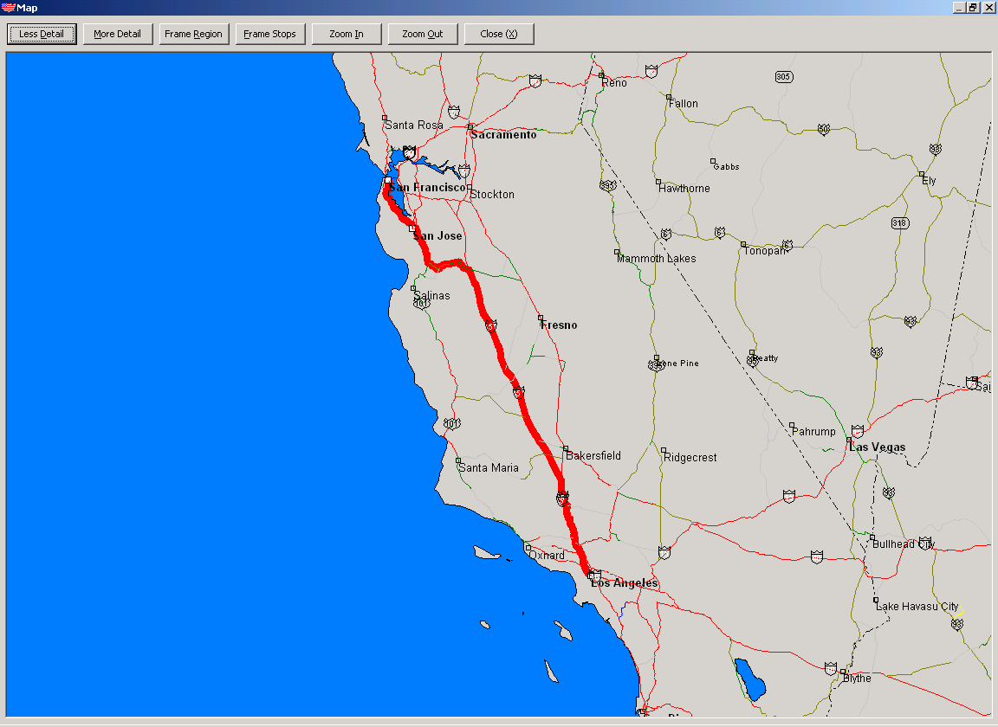
- 400 Miles in length
- Stops every 5 miles
- Cycle Time: 2.58 hours (LA-San Francisco)
- Ave Speed: 200 MPH
- 1,200 transporters (3 every mile)
- Departures every 5 minutes
- Cost to Build: $4B
- Time to Construct: 2 years
- Weight Capacity: 88,000

For further investigation, we have completed a SWOT analysis and looked at the five forces that influence competition through Porter’s Five Forces model.
SWOT Analysis
Strengths
- Improve travel time
- Generate a large revenue source
- Improve the environment
- Utilize Hydrogen power
- Create Jobs
- Create new technologies
- Help the government create new transportation infrastructure
- Move freight more efficiently
- Economic Growth creates demand for ITC system
- Utilize Photovoltaic Solar Power
Weaknesses
- Government buy-in process
- Does not currently cover all California’s Transportation needs
- Risk of political pressure wrangling with this disruptive technology
- Sheer size and scope of project
Opportunities
- Dissatisfaction with the airline industry
- Age of current public transit systems (Chicago’s L, NY subway)
- Age and capacity of municipal infrastructure
- Current awareness for the need of hydrogen power
- Environmental pioneers using alternate natural resources
Threats
- Barriers to entry – may have a struggle in each state
- Other companies creating their own version of a maglev system
- Patrician fighting
- Earthquakes (less of a threat to ITC compared to other options related to stainless steel construction)

5. Strategic Formulation

5.1 Market Plan

5.1.1 Customer Trends
Identified Discontinuities that create a demand for the Interstate Traveler:
- Environmentally Friendly  Environmentally zero tolerance
- Time is money  Time is life
- Open Freeways  Congested Freeways
- 3-5 days for delivery  Overnight delivery
- Regulated Markets  Deregulated Markets
- Local Markets  National/Global Markets
- Shipping in large orders  Shipping in smaller orders
- Shorter Lifespan  Longer Lifespan (Baby Boomers)
- Overnight decisions  Instant decisions (time compression)
- Metropolitan Lifestyle  Suburban/Rural Lifestyle
- Wired Environments  Wireless Environments

Environmental Impact/Pollution
- Air pollutants have thinned the protective ozone layer above the Earth; this loss of ozone causes changes in the environment as well as more skin cancer and cataracts (eye damage) in people
- The 1990 Clean Air Act encourages development and sale of alternative fuels
- The U.S. Environmental Protection Agency reported that highway transportation vehicles 2001 emitted almost all of transportation’s share of carbon monoxide, nitrogen oxides and volatile organic compounds
- The U.S. Cost Guard reported that most of the oil spills in the U.S. waters are transportation-related
- Highway vehicle emissions rose at an average annual rate of 2%, locomotive emissions grew at 3% and domestic aircraft emissions rose less than 1% between 1991 and 2001
Demographic Changes
- California’s Department of Finance states that the population in California will increase by approximately 11 percent. Specifically, Los Angeles will grow 21% from 13,370,400 in 2000 to 16,133,700; the Central Coast will grow 44% from 1,378,500 in 2000 to 1,991,700 in 2020; and the San Francisco Bay will grow 21% from 6,885,800 in 2000 to 8,338,100 in 2020
- The general population is expected to increase and live longer as a result of the baby boomers fueling this surge. California’s Department of Finance states that the majority of seniors 85 and over does not or can not drive
- Congestion Crisis - In terms of wasted time and fuel, traffic congestion cost the economy $78 billion in 1999, more than three-and-one-half times the $22 billion figure cited for 1982
Changes in Travel Behavior
- In recent years, the number of non-work trips have surpassed the number of commuting trips; thereby, creating “grid-locks” on the highway
- There are a number of potential causes for the increase in non-work trips, including the rise of consumer culture resulting in increasing shopping, entertainment, and recreational trips; changing ethnic and demographic lifestyle characteristics and choices; changing family structure; an increasing number of multi-income, multi-vehicle households; increasing household income; and changing urban form and community design
- Transportation Exchanges Blurring the Lines between Transport Modes - many transportation related exchanges focused purely on information, costs and service levels related to point to point movements without regard for mode
- Compared to other weight categories, smaller sized shipments (less than 500 pounds) increased the most (56 percent) by value since 1993. The smaller the shipments, the higher the value and the more the growth since 1993
- Large-size shipments (over 50,000 pounds) comprised nearly two-thirds (65 percent) of the ton-miles of Commodity Flow Survey shipments in 2002, similar to the 1993 share, but grew 32 percent by ton-miles, 19 percent by weight, and 45 percent by value. Because of their weight, these shipments placed high demand on the transportation network, generating more than 2 trillion ton-miles
- In general, trucking dominated shipment distances of less than 500 miles adding to the increased highway gridlock while rail dominated the longer distance shipments
- During the past decade, local and short-haul shipments grew 41 percent by value, 16 percent by weight, and 19 percent by ton-miles. This is critical to state and metropolitan area economies, using local roads, tracks, and facilities
- Shipments traveling over 250 miles grew faster—51 percent by value, 34 percent by weight, and 36 percent by ton-miles
Transportation Security
- Location Technology - Just as RFID technology is now ready for prime time, vehicle location technologies such as microburst, GPS and satellite hybrids are now also reaching feasibility. Real time location tracking of vehicles and other mobile equipment such as cages and pallets can now complete the SCM loop
- California Department of Transportation identified that thirty-two percent of the fatal crashes involved alcohol, and speed was identified as the primary collision factor in 28 percent of the fatalities
Employment
- Transportation investments can facilitate economic development, creating jobs, income and additional economic activities, in communities without an existing economic base or with a struggling one, and in those communities whose economies are already robust
- Based on estimates developed for California by the U.S. Department of commerce, a $1 billion investment in highway and transit improvements would directly and indirectly provide over 26,000 jobs, generating about $870 million in personal income, and almost $2 billion net increase in the Gross State Product
Housing/Employment Mismatch
- Currently, affordable housing supplies in the San Francisco Bay area and Los Angeles area are not keeping pace with employment growth. This has resulted in long commutes and congestion on corridors linking affordable housing in surrounding suburban areas with employment centers in urban areas
- Nearly 10 percent of Californians commute more than one hour to reach their place of work, which is 2.5 percent higher than the national average. If the housing - employment mismatch continues, Californians will experience increasing transportation costs in the form of longer commutes, increased vehicle maintenance, fuel and insurance costs, and degradation of air quality

5.1.2 Segmentation
- Customers traveling via road
- Daily commuters
- Students
- Customers traveling via rail
- Inter-state
- Long-distance
- Customers Shipping Freight
- Shippers and Business
- Hazardous materials and pipeline movement
- A single intermodal train can take up to 280 trucks (equivalent to more than 1,100 automobiles) off our highways
- The second fastest growing segment of freight transportation is railroads which carried approximately 144 million tons of freight traffic on California’s tracks during 2000
- Freight railroads are one environmentally responsible means to combat highway congestion and reduce the need for major new highway investments
- Air cargo is the fastest growing segment of freight transportation according to the U.S. Customs Service, $173 billion worth of air cargo moved through California’s airports in 2000, and is expected to increase at an annual rate of about 6 percent through 2020. Worldwide, air cargo is expected to triple by 2010.18 With the fifth largest economy in the world, the influence of air cargo on California’s economy is dramatic
- Trucking
- Customers Purchasing Energy
- Current trends of increasing travel and greater commuting distances, and the growing popularity of less fuel-efficient vehicles, indicate transportation fuel consumption in the state will increase by approximately 40 percent over the next 20 years
- California must begin transitioning from petroleum as its predominant source of transportation energy to an environmentally and economically sustainable source
- Customers Purchasing Water
- Water quality is degraded through storm water run-off from roadways and parking facilities and impermeable surfaces that limit water filtration via soil percolation

Competitive Advantage
- Hydrogen Production – Electrolyzing water with zero byproducts
- Liquid Waste Reduction
- Hydrogen with an energy content equal to a gallon of gasoline will be delivered at half the cost of a gallon of gasoline
- Production and Distribution of Potable Water
- Production and Distribution of Electricity
- Environmentally Safe
- Speed - An average of 200 mph for public pedestrian cars (because of frequent stops), and average 250mph for private cars, car ferries and freight, and faster where possible.
- Save American Steel
- Design of Transportation System
- Near zero maintenance
- Rail System can be attached to an existing Bridge Structure
- Small, agile, lightweight, switchable cars that work autonomously like data packets on a data network
- Full TCP/IP automation, solar powered hydrogen production, storage and distribution built-in as the primary power system, with grid shunts to 'give and take' with the national power grid
- Full integration of cryogenically cooled superconductor cables that create the most efficient power distribution network in the world where ever the Interstate Traveler is installed
- The Rail Conduit Cluster provides water, sewer, fiber optics, etc, so we can build a transit station anywhere without having to disturb the existing ecology with installation of terrestrial bound water, sewer, etc., we bring it all with us
- Utility substations break down water all day long creating massive stock piles of hydrogen and oxygen, which when recombined, create clean water that will be introduced into the potable water system and electricity that will be consumed by the transportation system, stations, lights, heaters
- The Passenger Transporters are planned to seat 60 passengers.

Product/Service/Business

5.1.4.1 Description including customer need and benefit
- ITC is a collection of necessary municipal utilities bundled into what ITC calls the “Conduit Cluster”: providing a first of its kind full integration of solar powered hydrogen production and distribution with a high speed maglev public transit network within the right of way of the US Interstate Highway Systems, and any other permissible right of way where such a machine would be of benefit. The transportation system, is accessed by traveler stations that are built within the right of way of the Interstate Highway within the land locked real-estate of the clover leaf interchanges providing maximum ease of access for people who live anywhere near the Interstate Highway.
- Daily news reports tell us every day about the difficult times people are having all over the world. Everywhere there is over crowding, urban sprawl, public utility failures, traffic jams, car accidents, utility poles that are easily damaged by bad weather, and backed up sewer systems that contaminate local public waters. The science of all these problems being significant unto themselves as a business, a municipal responsibility and as a personal plight. The transportation system creates a more resilient solution to all of these problems in a single relatively inexpensive mass produced rapid transit rail system

5.1.4.2 Unique Features
- Passenger Transport
- Comfortable Space for 60 passengers
- Car provides 840 square feet passenger area
      - Public and Private cars share the same rail system
      - Inviting, spacious and comfortable passenger cabin
    - Car Ferry
- Passengers can remain in their car
- Transport Recreation Vehicles or Trailers
    - Delivery of Freight
      - Move 2 53ft containers per Freight Transporter
      - Max weight capacity of 88,000 lbs
    - Creation of Natural Resources
      - Electrical Power generation, control, storage, distribution and load balancing
      - Hydrogen and Oxygen Production and Storage
      - Water generation from Hydrogen Fuel Cells
      - Potable water storage and pumping
- Network System
      - Automated TCP/IP traffic control system using ports, and sub networks
- Wireless carriers

5.1.4.3 Target Customers
    - In Phase One, the target customer will involve the State of California DOT
- San Francisco bay area, Central coast, San Joaquin Valley, and Los Angeles
    - End Users
- Commuters, Travelers, Haulers, Water suppliers, Energy resellers

5.1.4.4 Innovation Requirements & Migration Path
The dream space for this project is creating a hydrogen economy in the state of California. The first involves changing the current competencies. Currently the greatest percentage of transportation is done with automobiles with gasoline power. Almost all the cars are manufactured the way making the introduction of hydrogen power very hard. The new competency would require a greater acceptance of using mass transit systems to fulfill transportation needs. The next objective is changing the consumers / markets to one of hydrogen power. First, gas stations would now be hydrogen stations and the production would have to meet the demand. The customers’ pattern would also change to demand a transit system over all other means of transportation. The end result will be a migration toward this new means of transportation and producer of energy and clean water source.

5.1.4.5 Marketing Budget
The Marketing plan will start out strong with a rough estimate of 3% of revenue projection in the first year.
The next several years this would be reduced to 1 ½% to 2% the following years.

5.2 Core Competencies and Organization Plan

5.2.1 Core Competencies
Innovation – Allowing everyone at all levels of the organization be creative, have the latitude and ability to develop, test and implement new and creative solutions. Individuals must be willing to embrace new solutions.
Services – Growing from the traditional activities of riding the train to a larger and broader vision. Our new vision includes investing in our business and technology to grow and improve the services we provide to customers and the way we actually service it. Through higher technology, we have the ability to go beyond your normal train ride. By doing so, we will improve our customers' competitive positions. Our pursuit of revolutionizing the travel industry will rapidly change our dealings with our vendors, partners, and most of all, our customers.
Customer Focus – Ensuring that everything we do provides value to our customers. It means creating a partnership that - combined with our expertise in service and technology industries - maximizes customer profitability and ensures quality.

5.2.2 Management Team Description
- The Board of Directors shall consist of eight officers.
- The Board of Presidents shall consist of technology leaders and specialists.
- The Advisory Board is assembled from leaders in commercial industry, veteran public service officials, corporate law, corporate finance, and bank representatives with experience in public works projects and traditional finance.

5.2.3 Culture Description
- ITC is a leading edge firm that requires thought leadership and innovative thinking from everyone. Continual innovative thinking is a requirement in this evolutionary market.
- ITC’s rich culture comes from the guiding principle that believes that “the essence of success for any corporation is a great team of leaders assembled from the best in the U.S. and around the world.” It's essential that ITC have many people with initiative if we are to continue to grow.

Change Management and Organization Plan
It will be imperative to the success of ITC to ensure it moves key stakeholders along the change curve. Their commitment from the initial contact phase through awareness, understanding, adoption, and finally internalization is critical. Key elements of our plan include:
- Communication to key stakeholders
- Contact with them – change is happening
- Awareness/engaged
- What is means for me?
- Is my work or the way I live/work impacted?
- Impacts to customers – Internal/external
- Success in terms of systems, integration, etc?
- Readiness
- Environment
- Do key stakeholders understand new model?
- Are we communicating to key stakeholders enough?

Ops and Technology Plan

5.3.1 Make/Buy Decisions including types of potential partners
This project involves development of an infrastructure for multiple usage. The ITC project requires system integration of multiple existing technologies. ITC intends to be the system solution provider to build and run the system as a parent company. ITC will be looking for technology providers and other agencies that are willing to be strategic partners. For this purpose, ITC has already reviewed the technology and the project with potential partners. The following is a list of potential strategic partners and the areas of their contribution –
 | Strategic Partner | Area of Cooperation
1 | State, Federal and Local Government Agencies such as department of transportation, EPA, Dept. of Homeland Security | - Providing access the highway system to build infrastructure, necessary government approvals and financial assistance/investment (Grants and Bonds).
2 | Automobile/Aerospace Manufacturers | - Produce Transporters
3 | Sun Micro Systems | - Provide, develop and maintain IT system.
4 | Universities | - Coalition of Universities to provide 3rd party validation
5 | Local Energy Companies | - Will distribute the excess power supply locally.
6 | Construction Companies | - Will be strategic partners in construction and maintenance of the infrastructure.
7 | Beverage Distributors / Bottlers | - Will distribute the clean water.

Technology Plan
The Interstate Traveler is a multi-tiered multi-technology business model. It can be described as a “pipeline company”. “The pipelines we are installing are controlled by the same TCP/IP system that controls the maglev rail component, which is a pipeline unto itself. The fiber optic component is nothing more than a pipeline for light, and the highways are a pipeline for cars. The strength of ITC lies in its capability to provide a system solution that uses existing and latest technological innovations. The system solution provided economic and environmental impact issues, which are tied in throughout primary and auxiliary services, and revenue streams. The environmental friendly, quiet, 'ITC' is intended to make use of the existing interstate highway system, which was established during President Eisenhower’s administration in 1956.
The ITC transport system has a negligible environmental impact using an energy cycle based on solar and hydrogen power providing full operation without requirements for combustion of fossil fuel. With the use of stainless steel stanchions and pilings, the elevated ITC rail has a small footprint made of inert steel without obstructing the migration of indigenous species and completely mitigating the grade level crossings for existing roadways for the wheeled traffic. The system is designed to support climatic extremes and longevity by using stainless steel for all structural elements exposed to the atmosphere.
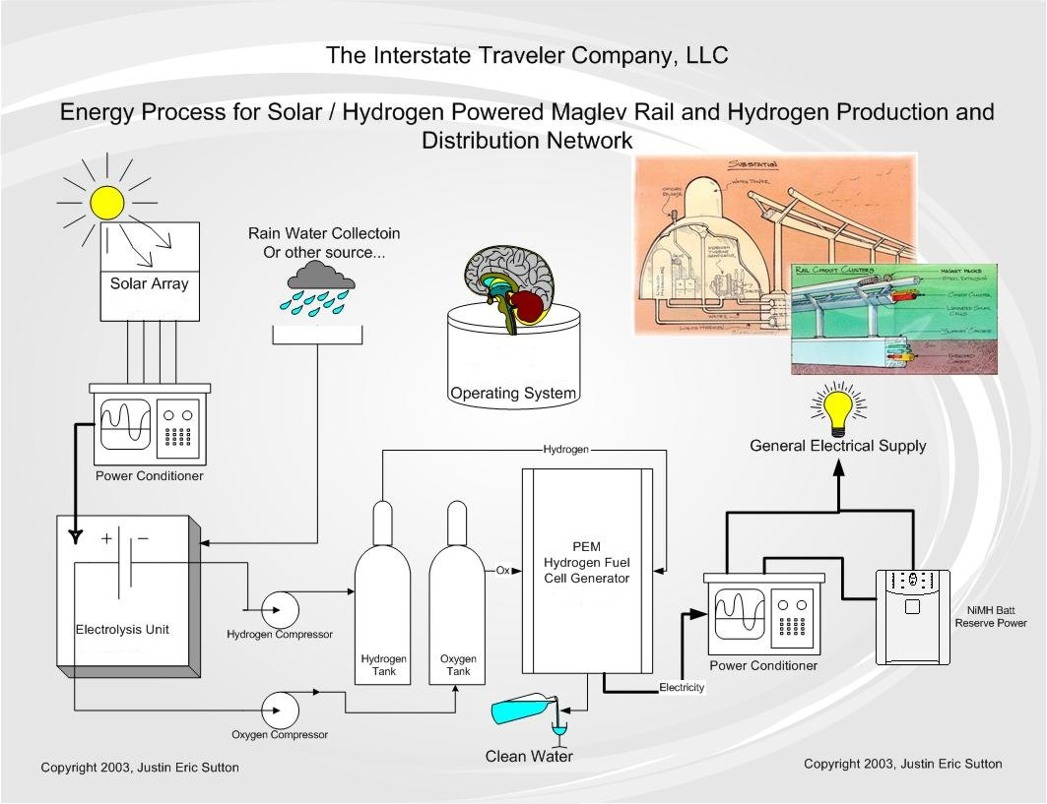

The ITC transport system is powered from collection of solar power from photovoltaic solar arrays spanning the entire length and breadth of the conduit cluster. The solar energy is collected and used to power the electrolysis process to create and store large quantities of Hydrogen and Oxygen which when recombined produces electricity and clean water.

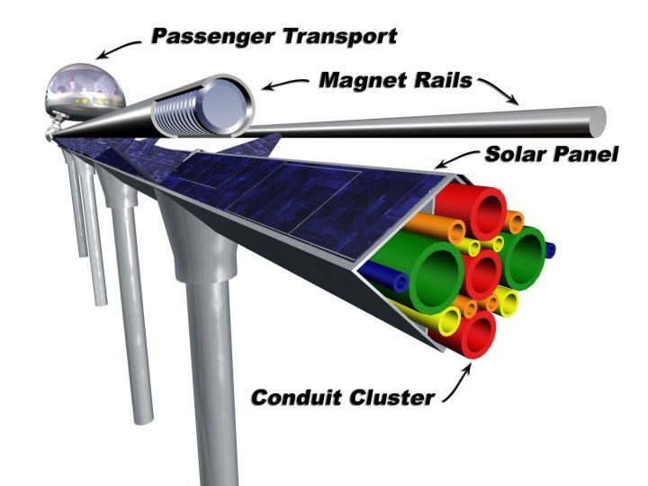

The Hydrogen and Oxygen will be transported through the Conduit Cluster, and may be used within the electromagnetic coils as a coolant to assure optimum efficiency from superconducting characteristics of the materials used. The clean water produced during this process can be sold to local beverage bottling and distribution companies for sale or support of local communities. The surplus energy not necessary to operate the system will be available for sale to local hydrogen fueling companies and utility companies.
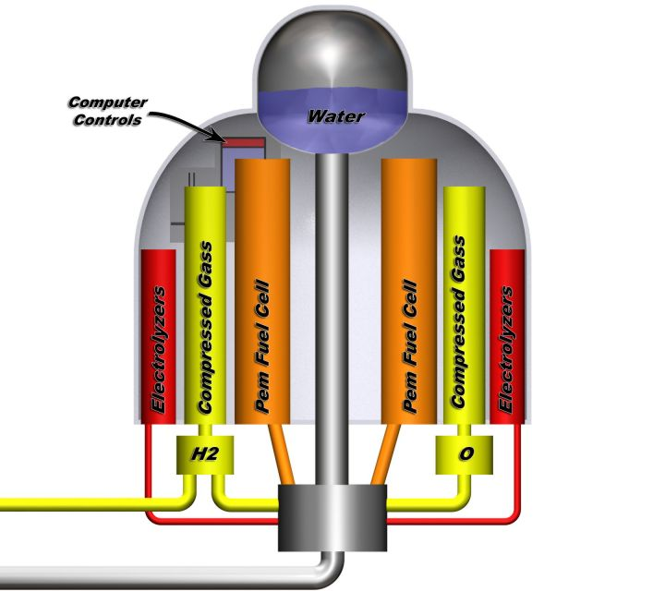

The ITC transport system is designed to function independent of the public electrical grid, yet include facilities to immediately connect to the public grid to supply power if necessary, or receive power for the purpose of storage in the ITC Utility Substations as a service to local utility companies. The ITC Transportation Network Grid Operations, featuring real-time alternatives path calculations with tracking and security based on the nested domain concepts demonstrated by TCP/IP and basic telephone networks.

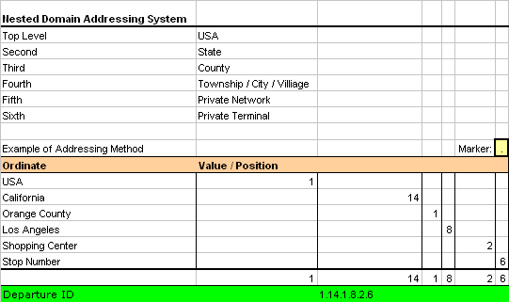

5.3.3 Product, Manufacturing, Operations, Labor and Quality Plans
The ITC transport proposes deployment of an elevated stainless steel maglev multi-modal mass transit network through the high level of integration of existing technologies. The elevated stainless steel structure houses the “Conduit Cluster” of utilities including water, sewage, Hydrogen, Oxygen, electricity, fiber optics etc. The design includes passenger stations (ITC Traveler Stations) within the real-estate of the Interstate Highway right of way which may include the land for the clover leaf interchanges, park and ride areas (see picture below). Within the proposed system, ITC will construct ITC Utility Substations for the hydrogen infrastructure on an as needed basis. ITC transport has capability to have three Interstate Traveler Transporters per mile.

ITC Transportation manufacturing and installation is designed to maximize productivity and minimize the cost of production. The installations of the rail and stainless steel structure is accomplished by modular construction of 60 foot standard lengths of ITC rail where a parallel installation of the 60 foot standard lengths constitute a bi-directional installation of ITC rail. The service vehicles are employed that ride on the rail and install one 60 foot section of the rail at a time, then moving forward 60 feet to repeat installation process

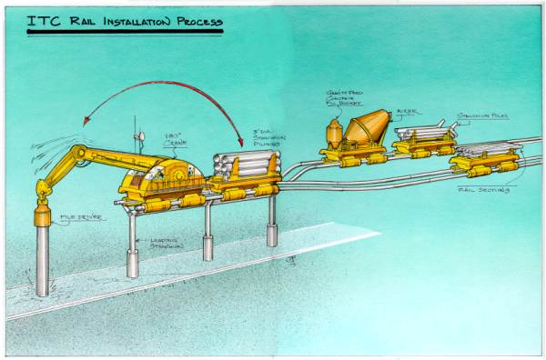

Since California is the first state to allow construction of the ITC Transport system, the ITC rail and transport vehicle manufacturing plants will be built in the state of California. The manufacturing plant will be the regional hubs of activity to build and maintain ITC system in that region. Based on current assumptions, our hiring forecast is summarized below:
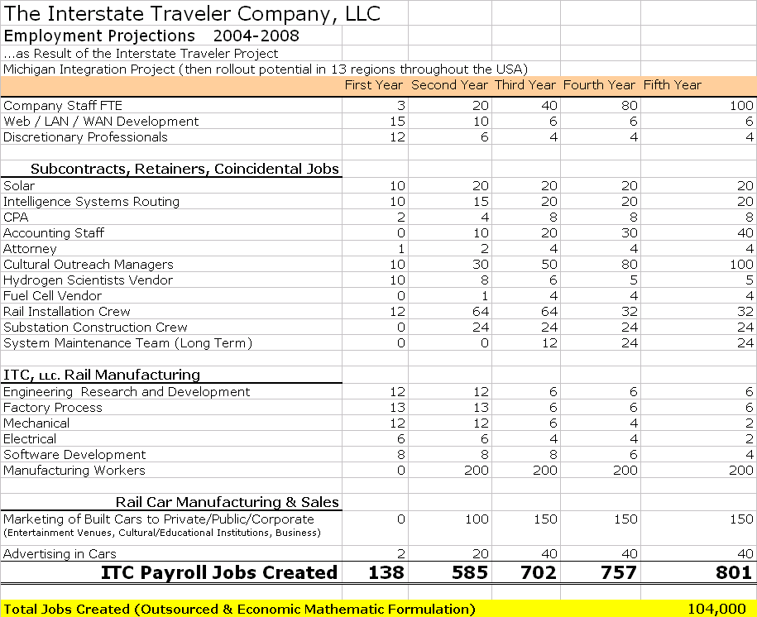

5.4 Financial Plan

5.4.1 Economic Engine / Business Model
Revenue Sources
This list of revenue generating deliverables includes but are not limited to the following:
- Advertising
- Transportation Private
- Transportation Commercial
- Energy Production
- Energy Storage
- Energy Distribution
- Energy Conversion
- Communications (Fiber/wire/wireless)
- Data Storage
- Water Reproduction
- Water Distribution
- Sewage Handling / Mitigation
- Hydrogen / Oxygen production and storage
- Commercial property leases in Traveler Stations
Interstate Traveler (ITC) service offerings are:
Rapid Transit
Maglev is clean and quiet. Maglev services will have minimal interference with existing commuters or natural environments. The Transporter design offers rides to individuals, personal vehicle and its passengers; corporate, educational or medical destination rail cars; and freight. Existing transit authorities may host the ITC rail car to supplement their existing service.

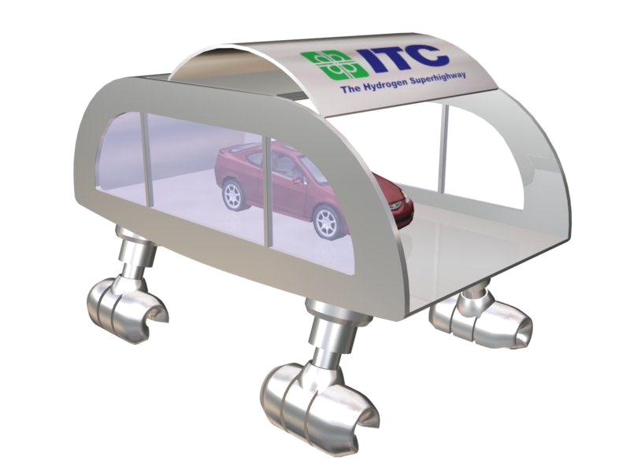
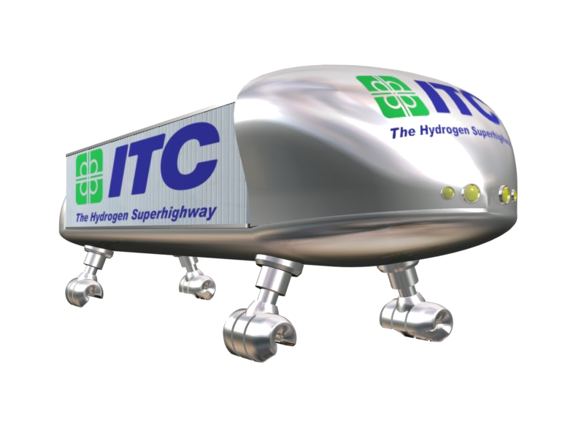
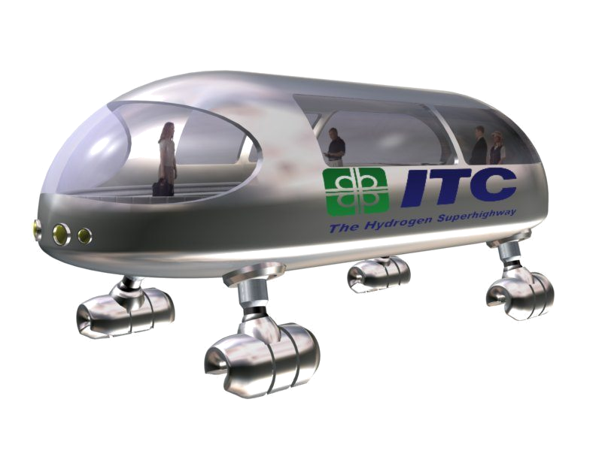
ITC Transport Vehicles

The Rapid transit will enable people to secure jobs, education, or travel for leisure to locations previously prohibitive due to distance or inclement weather. The impact on businesses as well as personal timesaving will benefit everyone using the system. There will be no delays due to snow, rain, fog or other inclement weather.
Businesses located near substations will potentially be enhanced by the new traffic at substations. New businesses could also be located at or near the substations. Existing Transit operations will have a finite destination to and from the ITC substations 24/7. This will allow businesses to plan for the demand for their services.
Advertising in multimedia packages will be available throughout the system. Public Service announcements and Community Activity Calendars will also be available. Due respect will be accommodated for in-state advertising guidelines.
Alternative Energy Distribution System
The ITC will be self-sufficient, relying on the alternative energy of hydrogen and solar power; eliminating the need for fossil fuel. The solar panels located upon the main rail will create enough energy to operate the ITC as well as have surplus electricity to provide new or redundant offering to areas the ITC is passing by. The substation every 5 miles or so will have a hydrogen distribution environment. This will support the automotive need to have fueling stations for their new automobiles. New, permanent, jobs are necessary to support the hydrogen stations and substations.
An entire new curriculum in educational systems will be derived from the development of alternative energy and its derivatives. The use of the ITC system will be a hands on experience helping the public to have a clearer understanding of what alternative energy means as the economy changes away from reliance on fossil fuels and current forms of electricity.
Conduit Cluster to support municipal infrastructures
The aging utility infrastructure will have relief provided by the ITC. The by-product of the hydrogen process is clean water. Areas who need this infrastructure support, will be able to source their water supply from the ITC system. The electricity derived from the solar power will drive not only the ITC system but also support electricity to residential, educational institutions or corporate neighborhoods where redundant systems are needed or utility infrastructures is nonexistent. This wills truly be an asset to rural areas that do not have the availability found in urban areas.
The distribution of fiber optics will provide a national redundant network and also lay the foundation for the wireless nodes network.

5.4.2 Financial Assumptions
The ITC has made several assumptions to determine their market, the demand for their deliverables, capacity constraints etc. We first wanted to determine the maximum capacity of Phase 1:
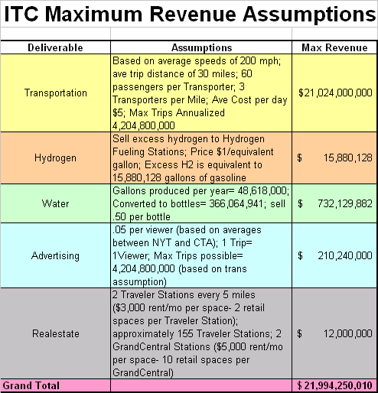

The efficiency and design of ITC’s system produce massive amounts of capacity and infrastructure for the communities in which it exists. We ignored ½ of ITC’s deliverables and still managed to generate revenue streams of approximately $22B. We will assume that ITC will utilize 10% of today’s capacity in Year 4 (or YR 1 of operation), grow at 15% per year, and reach Day 1’s capacity in approximately 21 years.
Our next set of assumptions will relate to the capital investments and construction of the maglev rail system. ITC will seek 100% of the funding for this project from State and Federal Governments. This will be a tax-exempt/interest-exempt project, as the system builds new high-tech municipal infrastructure along the US interstate highway system, while creating a state-of-the-art transit system that will increase the capacity of the LA-San Francisco alley by 47%. ITC wants to form a unique Public/Private relationship with the Government. This simply states that the Government will grant ITC use of the highway real estate and invest the initial $4.575B ($10M per mile, $250M for ITC infrastructure). The payback structure will also be unique. The lending government entities will receive 50% of all operating revenues off the top (no taxes will be paid on profits generated) for the life of ITC’s existence. We used a 15% hurdle rate to determine NPV and IRR. ITC will operate, manage, and maintain the system. The Government will be praised for its vision and earn a direct return on its investment- a return this bureaucracy as never managed to generate in the past.
The last set of assumptions we determined for ITC was used to assemble its financial statements. We figured $100M in Year 1 to build infrastructure, attract talent, complete all testing, surveying, etc. Revenues were figured at 10% of today’s capacity in Year 4 with a 15% annual growth rate. We depreciated all capital expenditures over 10 years, assuming the life expectancy of the system is 50-200 years.

5.4.3 Pro Forma Financial Statements

5.4.3.1 Cash Flows
ITC’s system is extremely capital intensive in the first three years, as the infrastructure is built and tested, requiring $4.575B of investment. However, ITC proves quickly to be a “cash generating machine” and a worthwhile investment, as it generates close to $2.9 B in its first year of operations. Below is a graphical summary of ITC’s cash flows:

5.4.3.2 Income Statement

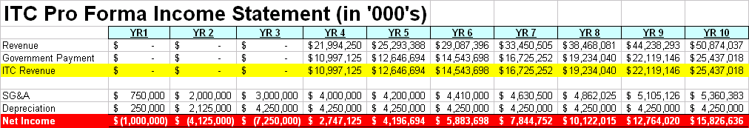

ITC proves to be an extremely profitable organization- even with its unique 50% revenue
Sharing relationship with the Government. Also, we feel we overestimated ITC’s SG&A (figured $150k salaries for 2,000 employees and high operating expenses). The fact is, ITC is a self-supporting company and has little overhead to reduce its profitability. Over the 10-year period ITC will profit over $4.7B, while supplying local, state, and federal governments over $7.5B. Gross Profit Margins are 50%; while, Net Profit Margins average 23% over the 7 operating years.

5.4.3.2 Balance Sheet
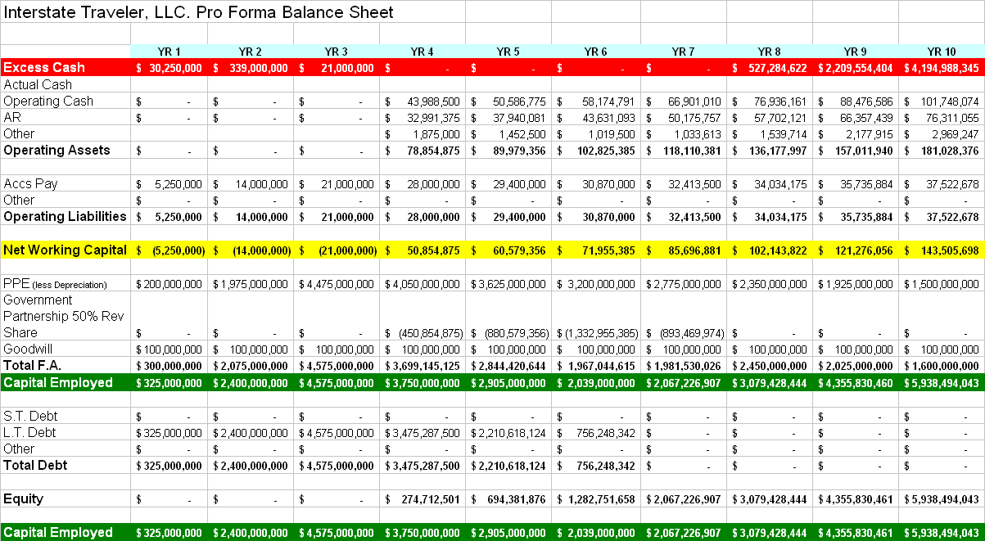
ITC is truly a cash company. We overestimated AR balances to be conservative; however our primary source of revenue is passenger transportation, which will be 90% prepaid. If an individual wants to ride our system they will have to credit their ITC account. All other deliverables will have a credit term associated to the transaction and will be negotiated case by case. Overall, we assumed an average collection period of 5 days. On the other hand, we assumed all payables would be paid within 25 days. ITC’s long-term strategy is to operate debt-free (notice above that this is accomplished in Year 7). Finally, ITC is able to accumulate billions of excess cash dollars. In year 10, ITC will be fully self-sustainable and have the ability to develop Phase 2 without any financial assistance from the Government (though 50% revenue sharing will continue on all projects).

5.4.4 Break-Even Analysis
ITC wants to ensure that the anticipated benefits from the project will justify the Government’s investment of $4.575B. We originally assumed that the payback period (the amount of time it will take to recoup original investment) would approach approximately 10 years; however, after making fair financial assumptions, we calculated the payback period as 3.14 years.
Payback Period = Original Investment / Average Cash Flows
3.14 years = 4.575B / 1.453B
ITC will obviously meet our original goal; however an accurate figure of merit must reflect that a dollar today is worth more than a dollar in the future. The time value of money is important to analyze for three reasons:
- Inflation: inflation reduces the purchasing power of future dollars related to current ones
- Uncertainty: uncertainty surrounding the receipt of a dollar increases as the date of receipt recedes into the future
- Opportunity Cost: the return one could earn on the next best alternative
Thus, we analyzed the net present value of all future cash inflows and outflows, using a hurdle rate of 25%. ITC will generate a net present value of approximately $4.25B, or otherwise stated, create an extra $4.25B while paying a 25% cost of capital (this is just for financial analysis purposes only). The government and ITC should feel comfortable embracing this project, as it is a value-creating proposition.
Lastly, we wanted to analyze the most popular figure of merit among executives, the internal rate of return. The internal rate of return is the rate of return in which the NPV of the project would equal zero (a point in which value is not created, nor destroyed). The IRR is then compared to the hurdle rate used to compute the firm’s NPV; if IRR > Hurdle Rate or Cost of Capital, then accept the investment. ITC’s IRR was calculated to be 57%; hence, Fist of Five feels extremely confident in pursuing ITC’s mission and vision.

6. Contingency Plans
The construction of the ITC Rail only requires a coordinated integration process. The Interstate Traveler has supporters throughout the Local, State and Federal governments. We also have the endorsement of various labor unions. ITC is seeking Strategic Partners to participate in the early planning stages. The opportunity to invest seed money along with the traditional Federal investment of capital costs for alternative energy and transportation systems will provide great rewards in the near future and in the long term. An appropriate agreement will be negotiated with each strategic partner.
Because of the investment required, it is important that we continue to gain support and backing from government agencies. More importantly however is the necessity to seek out an build strategic partnerships to gain investments.
We believe in our vision, but without the necessary investments to succeed, we will be forced to scale back our implementation plans and timing accordingly.

7. Tactics and Implementation

7.1 Timeline
Activity Due Date
Funding Approval March, 2005
Building of Infrastructure March, 2007
Testing/Approval March, 2008
Fully Operational March, 2009

7.2 High level project plan

7.3 Key measures of success
- Strong partnership with Government Agencies is formed
- Within the plotted timeframe and scope of Phase I the transportation system has moved to ITC’s model
- Consumers are demanding our infrastructure be expanded to other locations
- Reduction of pollution
- Improved air and water quality
- Economic growth has created an increase demand for the ITC System

7.4 Overall Management Process
The CEO, board of directors, board presidents and advisory board will work in harmony to build a strong organization with solid and aligned objectives.,
The vision and management style of the CEO consists of these thoughts:
To be successful in project management, first all manner of detail must be accounted for regarding, labor, materials, new processes to be implemented, old processes to be defunct, and transitional processes to accommodate change. Once all time (work) and materials are accounted for the values for such time and materials may be totaled. This information is used to determine return on investment where such determination may warrant a re-visitation of the workflow to further refine the process and reduce cost.
Extensive training for client personnel is paramount to the success of any project. Without the client fully understanding the nature of a solution the value is not fully perceived.
The responsibility of leadership is not merely the giving of instructions to those hired to complete a task, it is the recognition of greatness in those appointed to the task. The delegation of authority is giving someone the freedom to do something so well, that they can call it their own. If you must first give to receive, and if justice is to receive in kind what was given in kind, then great rewards are due for great accomplishments.

7.5 The Management Team

Managing Partners
Justin Eric Sutton
9594 Main Street
Whitmore Lake, Mi 48189

Lark L. Samouelian
298 Harvard
Howell, Mi 48843

H. Frank Sutton
3360 Chilson Road
Howell, Mi 48189

Board of Directors
The Chief Executive Officer CEO
Vacancy
Vacancy - Executive Assistant

The Chief Development Officer CDO
Gene DeRossett
Vacancy - Executive Assistant

The Chief Communications Officer CCO
Lark L. Samouelian
Vacancy - Executive Assistant

The Chief Financial Officer CFO
Jim Harris
Vacancy - Executive Assistant

The Chief Labor Officer CLO
Thomas P. O'Rourke
Gary M. Wellings - Executive Assistant

The Chief Technology Officer CTO
Ted Nichols of Sun Microsystems
Vacancy - Executive Assistant

Chief Operations Officer COO
Jack Salo
Vacancy - Executive Assistant

Chief Company Historian CCH
Vacancy

Chief Information Officer CIO
Vacancy

Board of Presidents
President and Chairman
-- Justin Sutton

Senior Vice President, Asian/American Academic Relations
--- Zixiang (Edward )Xiong

Senior Vice President, Geological Sciences
--- Li Zhang

Regional Directors
Click the name of the Region to generate an email to the ITC Team covering that area.
United States
Arizona
Gordon Niles
Arlene Oisten

California
Brian Petersburg
Lorne Darnell
Bill McCulloch

Florida
Dick Chrysler

Georgia
Brian Petersburg
Lorne Darnell

Great Lakes Woodlands Area Native American Tribes
Rochelle Ballard

Illinois
Chuck Meek
Alan Samouelian

Nevada
Brian Petersburg
Lorne Darnell
Bill McCulloch

New York
Mel Raznick

Ohio
Ed Cleland
Ken Dallafior

Oklahoma
Les Whitaker

South Carolina
Gregg Alford
Bill Herbkerbsman

Texas
Greg Hundersmarck Sr.
Greg Hundersmarck Jr.

Washington State
Martin D. Ringhofer

International
Bahamas
Leo Tomkow
Paul Verona

China, Malaysia and Taiwan
Chuck Meek
Forrest Meek
Zixiang (Edward )Xiong
Li Zhang
Guo Yue

ITC Advisory Board
The Advisory Board is a family of business professionals from many diverse market places, each with years of experience. The Advisory Board brings value to the company uniquely and in compliment to the goals of the company.

If you have any questions, don't hesitate to call me or one of our advisors. Please allow for scheduling of returned calls. Conference calling is optional.

AEM, Inc.
Lee Bates, President
P.O. Box 903
Southfield, Mi. 48037
248-540-9500
www.AEMinc.com
AEM strives to be the Quality Supplier of Motion Control and Power Control and to provide quality, reliable products at a fair price and in a timely manner to all customers.
We supervise installation, we inspect and follow up after installation and start up, we are present during debug, and we work with maintenance personnel during repairs. Products training and technical assistance are also provided upon request. Having built AEM from the ground up, Lee Bates brings a wealth of knowledge and power.

Ann Arbor Transit Authority
Greg Cook, CEO/Executive Director
2700 South Industrial Highway
Ann Arbor, MI 48104
734-973-6500
www.TheRide.org GCook@TheRide.org
It is the mission of the Ann Arbor Transportation Authority to contribute to the management of mobility in Ann Arbor and the urbanized area by working to provide options for efficient and reliable transportation. They are recognized for having one of the most technologically advanced bus systems in the US, developed under the leadership of Mr. Greg Cook.

Chas Arnold
10 Kent Ave.
Devonshire DV 04
Bermuda
Tel: 441-232-4287
Cell: 441-505-4287
Fax: 441-292-0686
Email: chasa@ibl.bm
chasarnold@tataclassical.com
Chas Arnold’s diverse background includes experience in event planning, music instruction and non-profit management. He currently resides in Bermuda where he teaches violin and is President of a non-profit music organization. He graduated from the Colorado College with degrees in Biology and Music. He brings a number of international resources and contacts to the Interstate Traveler team.

Danotek Motion Technologies, Inc.
Dan Gizaw, President / Founder
7879 Jackson Rd
Ann Arbor, MI 48103
734-426-5976
www.DanotekMotion.com
Advanced-technology engineering and manufacturing firm, designing and producing motors, drives, actuators. Brushless motors and power controls are our specialty. Fractional to 10,000 HP: AC, DC, Brushless motors. Danotek employs state-of-the-art design tools and industry experts with more than 100 patents and disclosures in electromechanical devices and digital controls. Mark Hepburn is a successful industry veteran with technology companies in startup phases.

Executive Leadership Recruiters, Inc
Chuck Meek
801 North Main Street
Wheaton, IL 60187
O: 630.784.9100 F: 630.784.9700
cmeek@executivelead.com www.executivelead.com
ELR is a retained executive search firm located in the Chicago area. They capitalize on strong ties across a wide range of industries to attract and develop the management team that will lead the Interstate Traveler Project domestically and internationally. Chuck Meek is ELR's founder and president, and focuses his practice on Private Equity Groups and their portfolio companies.

Forrest Meek
Retired Professor of English, Wuhan University, People's Republic of China
Professor of Geology & Astronomy Mid Michigan Community College
Author of: ONE YEAR IN CHINA, MICHIGAN'S TIMBER BATTLEGROUND, MICHIGAN'S HEARTLAND
co-Author of: MICHIGAN'S LOGGING RAILROADS
Listed: WHO'S WHO IN THE WORLD - 1996 WHO'S WHO IN AMERICA - 2002
President: Blue Water International Trading Co., Inc.
Chairman of ITC Shanghai MAG-LEV, Inc.

Neil Lehto, Esq. About Neil....
Neil J. Lehto
Attorney and Counselor at Law
4035 Iverness Lane
West Bloomfield, MI 48323
248-851-4276 nlehto@sbcglobal.net
Neil Lehto is nationally recognized in municipal and telecommunication law specializing in pipelines and rights of way issues.

McDonald Communications
Educational Television Consulting
Sharon McDonald, President
25171 Appleton
Farmington Hills, Mi 48336
248-476-4315
Sharon McDonald has been recognized for her innovative use of media facilities to support the education communities learning curve of technology. Sharon has been successful in writing and securing grants and has received national recognition for television programming. Sharon has many fruitful relations within municipal and corporate environments which support our effort.

Arlene Oisten
Economic Analyst
12515 Hidden Vale Dr.
Perry, MI. 48872
517-675-7278
With a career that includes the Governor's Administration Board in the State of Michigan, Arlene is a wealth of knowledge for contract management and regional economic development. Arlen has recently received accolades from Gov. Engler for distinguished service. Arlene also has many fruitful relations within municipal and corporate environments which support our effort.

Chris O'Brien
803 Jones Street
Ann Arbor, MI 48105
734 -997-9796
Chris O’Brien’s background is rich in multimedia, including advertising, product marketing, researching, news reporting and photography. He brings to the ITC experience and a desire to develop the company’s market appeal, media exposure and consumer recognition through development of a company history and other strategies.

Phillips Consulting & Sales, LLC
Frank Phillips
11902 Larkins
Brighton, MI 48116
810-220-1706 fphilli1@mich.com
Mr. Phillips is an automotive manufacturing project manager experienced in multi-million dollar new model introductions. He has demonstrated success with new model launches meeting quality and cost targets with Ford Motor Company for over 28 years. He has Managed projects on a global basis with extensive experience in India. His company will share extended hands-on experience with project development from design to production. His excellent communication and people skills required for team-oriented projects will be an asset to our team.

Martin Ringhofer
Economic Development and Tourism
Port of Sun Lakes [Proposed]
PO Box 216
23 Dogwood South
Soap Lake, WA 98851
Martinringhofer@aol.com
With a career in supplier management and contracting, Martin has been active in "grassroots" advocacy for economic development in Washington State. Martin has worked to establish a Port of Sun Lakes in Grant County, WA., advocates for the construction of a giant 65-foot lava lamp as a tourist attraction in his hometown Soap Lake http://www.giantlavalamp.com/ and is advocating for the Seattle ITC and Moses Lake ITC Loops, as well as the Washington Interstate Traveler.

M’hawk Productions and Promotions, LLC
Rochelle Montour Ballard, President
Voice 313-268-5462
rochelle@mhawk.biz
Rochelle has 30 plus years coordinating volunteer programs from food co-ops to Scouting. M’hawk has produced training videos, cultural video programs, coordinated interfaith, traditional and conventional events on the state, national and international levels.
Solar, passive solar and any alternate energy technologies creating non-polluting energy aligns with her traditional Native American beliefs. We are “Keepers of the Earth” and must be responsible to the next Seven Generations. This project will underpin the self sufficiency" programs of our future.

Jack Salo
Automotive Consultant
41741 W. Village Green, Suite #105
Canton, MI 48187
734-260-8526
Retired Manager from Ford Motor Company (30+ yrs) and now implementing New Product Training programs for FoMoCo as a consultant. He has been involved with New Model Product Development Programs for the past 6 years. His expertise is in manufacturing, production planning and facility renovation. He trained in ISO 9001, OSHA and other Federal/State requirements for start up programs utilizing his 12 member "Launch Specialist" team to maintain time lines.

Samouelian Communications, Inc.
Corporate Development Consulting
Lark Samouelian, President
298 Harvard
Howell, Mi 48843
1-517-545-0466
www.SamCommInc.com larksamouelianj@comcast.net
With a career developing interactive networks, Lark specializes in solutions for product and service development. Lark is working closely with the founder as Co-Founder to provide national and international corporate resources for the ITC. Lark's diverse understanding of technical applications through her multifaceted government and corporate experience shall energize the international diplomatic scope of the Interstate Traveler Project.

Gary Wellings
Labor Relations Consultant
985 West 7 Mile Road
Whitmore Lake, MI. 49189
1-313-300-6979
Mr. Wellings has successfully executed leader positions in education programs related to social service agencies, and maintains a strong communications network with labor relations management teams in the mid west. Gary's communications and negotiation skills will be of great service to our organization as we reach out to Labor Unions around the country to help build the Interstate Traveler.

Pat Wierzbicki
Pat is our political advisor and liaison with Federal and State governments. She has kept us current on the Congressional Bill developments and enabled meetings with Legislators as result of her ongoing Political experience

Professor Frank and Professor Paula Jamison
Frank Jamison Ph.D - Professor Emeritus of Instructional Media WMU
Paula Jamison Ph.D - Assitant Professor Department of Occupational Therapy WMU
Kalamazoo Mi.
Frank.Jamison@WMICH.EDU
Paula.Jamison@WMICH.EDU
269-381-3010

CxO Resources, LLC
Merger & Acquisition, Accounting and Business Resource
Joseph Yassay - The Business Resource Group
34166 Bretton Drive
Livonia, MI. 48152
Cell: 248-807-0200
FAX: 248-477-0923
jyassay@twmi.rr.com
Joe has over 15 years of experience in the manufacturing and construction industries predominately in the Executive Vice President \ Chief Financial Officer role. He has over 8 years experience of successful Merger \ Acquisition and business start-up experience. A founding member of the Business Resource Group (BRG) that provides businesses with hands-on expertise and prides itself on delivering results in the areas of ; M&A, capital resources, strategic and business operations, ISO certification, OSHA compliance, full information technologies solutions, and innovations in advertising and marketing communications.

Ross Witschonke
Ross Witschonke recently retired as vice-president of marketing and sales from Ballard Power Systems, Inc., the largest maker of fuel cells for automotive and stationary power applications. He was President and CEO of Ecostar Electric Drive Systems, LLC, a joint venture with Ford, DaimlerChrysler, and Ballard prior to Ballard’s acquisition of the company in 2001.

Mr. Witschonke has been involved in numerous worldwide car and truck product programs throughout a twenty-five year career at Ford Motor Company, including assignments as Program Manager for the Ranger, Explorer and Taurus car lines, and as Director of the Partnership for a New Generation of Vehicles, a government/industry cooperative venture to develop high efficiency vehicles. He also spent five years in Japan where he was Senior Managing Director of Product Development for Mazda Motor Corporation.

Mr. Witschonke is a graduate of the United States Military Academy at West Point and the University of Alabama. He holds a Bachelor's Degree in Engineering and a Master's Degree in Administrative Science.

ZDR Engineering Excellence
Paul Zwirkoski, President
121 W North Street, Suite 8
Brighton, MI 48116
810-225-2810
www.ZDR.com
ZDR, Incorporated, a.k.a. ZDR, is an engineering design and development firm whose strategy emphasizes technology leadership, proven experience, and comprehensive engineering support. ZDR's goal to continuously and relentlessly strive for engineering excellence assures success of this mission. Paul Zwirkoski is the founder and chief engineer specializing in mechanical engineering and orthopedic implant design. Paul's firm maintains engineering teams in Michigan and New York.
References
The Interstate Traveler Company, LLC
The State of California Department of Transportation

8.0 Technical Documentation

8.1 Summary of Proprietary Information
Justin Sutton and The Interstate Traveler Company, LLC are engaged in the research, development, installation and maintenance of a public/private plug and play infrastructure which integrates an elevated magnetic levitation transportation system with municipal conduit, cable, and fiberoptics, and with a solar powered hydrogen production system of sufficient size and scope to self sustain and create a growing surplus of stored energy. This infrastructure network is designed to be controlled by a simple TCP/IP styled electronic network operating system that will facilitate the routing of multiple transit cars, record and control the gathering, dispensing and movement of materials and energy in the conduit cluster and share data in real time to enable a growing rail network of independent interconnecting rail networks where the network operating system will furthermore provide direct addressability and control for all valves, switches, meters, gauges, motors, monitors, cameras, kiosks, sensors, relays, interfaces, lights, locks, actuators and electronic databases, where such an operating system environment may allow for the real-time communication of redundant independent computers and computer programs that host the proposed operating system that will control all of the components used in the operation of the Interstate Traveler Project et al, allowing for the seamless expansion and reconfiguration the system in a “plug and play” fashion. Further, where such an operating system will include failover backup systems, reasonable data archiving, and the ability to compute, store and report values based on system activity that may be used in ongoing performance analysis and general accounting. The system also hosts the means to monitor and control the temperature of the structural steel of the rail to mitigate expansion and icing.

The subsystems include but are not limited to the following:
Nested Domain Communications System | Pipelines
Fiberoptics | Electron Carrier (superconductor, etc)
Maglev Linear Motor Transportation | User Interface (ITC / Public Internet Kiosk)
Photovoltaics | Hydrogen and Oxygen Production
Hydrogen and Oxygen Storage | PEM fuel cells
Water Reproduction / Purification | Water Storage
Water Distribution | Sewerage Handling / High Intensity UV, etc

8.2 Socio-Economic Impact Assumption
The impact on regional and eventually global economies will be measured not only by the time saved by travelers and shippers, but by the availability of energy, high bandwidth communications, large Traveler Stations accommodating commercial and public areas, located at every entrance and exit to the Interstate Highway system will create an entirely new ecosystem wherein people will live, work and travel, for generations to come.

The creation and sustained use of this system has the potential of creating millions of employment opportunities throughout the USA and worldwide. The population would have the opportunity to move to better locations that fit personal resources for employment. It will allow for environmentally friendly energy sources, including readily available hydrogen for vehicles. It will allow people to access energy without fears of brownouts or blackouts. The potable water produced through this system will reduce the draining of our nation’s great lakes and rivers, and provide water in needed areas threatened by droughts. It can reduce the need for fossil fuel and reduce world tensions related to this issue. This system can make this world a better place for it’s current and future residents.
.
The ability to get to where you need to go reliably and on time is essential to a functional economy. Without it, nothing gets done on time, if at all.

According to the US Census, there are many things to consider, and perhaps all of the following categories will benefit from the existences of a national ITC Rail grid. Perhaps the most interesting to consider for the average citizen is the Mean Travel Time to Work in the year 2000 of 25.5 minutes. If you consider the mean travel time of 25.5 minutes with average speeds as low as 40 miles/hour, the average person could only live an average of 17 miles from work. The ITC Rail could easily expand the Live/Work geographic envelope more than 5 times. In the same 25.5 minutes, the ITC Rail would allow someone to travel more than 100 miles making it easy to get from city to city and live almost anywhere within 100 miles of where you work, and this expands opportunity for everyone..
People QuickFacts | USA
Population, 2003 estimate | 290,809,777
Population, percent change, April 1, 2000 to July 1, 2003 | 3.30%
Population, 2000 | 281,421,906
Population, percent change, 1990 to 2000 | 13.10%
Persons under 5 years old, percent, 2000 | 6.80%
Persons under 18 years old, percent, 2000 | 25.70%
Persons 65 years old and over, percent, 2000 | 12.40%
Female persons, percent, 2000 | 50.90%
White persons, percent, 2000 (a) | 75.10%
Black or African American persons, percent, 2000 (a) | 12.30%
American Indian and Alaska Native persons, percent, 2000 (a) | 0.90%
Asian persons, percent, 2000 (a) | 3.60%
Native Hawaiian and Other Pacific Islander, percent, 2000 (a) | 0.10%
Persons reporting some other race, percent, 2000 (a) | 5.50%
Persons reporting two or more races, percent, 2000 | 2.40%
Persons of Hispanic or Latino origin, percent, 2000 (b) | 12.50%
White persons, not of Hispanic/Latino origin, percent, 2000 | 69.10%
Living in same house in 1995 and 2000', pct age 5+, 2000 | 54.10%
Foreign born persons, percent, 2000 | 11.10%
Language other than English spoken at home, pct age 5+, 2000 | 17.90%
High school graduates, percent of persons age 25+, 2000 | 80.40%
Bachelor's degree or higher, pct of persons age 25+, 2000 | 24.40%
Persons with a disability, age 5+, 2000 | 49,746,248
Mean travel time to work (minutes), workers age 16+, 2000 | 25.5
Housing units, 2002 | 119,302,132
Homeownership rate, 2000 | 66.20%
Housing units in multi-unit structures, percent, 2000 | 26.40%
Median value of owner-occupied housing units, 2000 | $119,600
Households, 2000 | 105,480,101
Persons per household, 2000 | 2.59
Median household income, 1999 | $41,994
Per capita money income, 1999 | $21,587
Persons below poverty, percent, 1999 | 12.40%
Business QuickFacts | USA
Private nonfarm establishments with paid employees, 2001 | 7,095,302
Private nonfarm employment, 2001 | 115,061,184
Private nonfarm employment, percent change 2000-2001 | 0.90%
Nonemployer establishments, 2000 | 16,529,955
Manufacturers shipments, 1997 ($1000) | 3,842,061,405
Retail sales, 1997 ($1000) | 2,460,886,012
Retail sales per capita, 1997 | $9,190
Minority-owned firms, percent of total, 1997 | 14.60%
Women-owned firms, percent of total, 1997 | 26.00%
Housing units authorized by building permits, 2002 | 1,747,678
Federal funds and grants, 2002 ($1000) | 1,901,247,889
Geography QuickFacts | USA
Land area, 2000 (square miles) | 3,537,438
Persons per square mile, 2000 | 79.6

Source: http://quickfacts.census.gov/qfd/states/00000.html

8.3 Revenue Sources
The list of revenue generating deliverables include but are not limited to the following:
- Advertising
- Pipelines
- Transportation Private
- Transportation Commercial
- Environmental Sensor Network
- Energy Production
- Energy Storage
- Energy Distribution
- Energy Conversion
- Communications (Fiber/wire/wireless)
- Data Storage
- Water Reproduction
- Water Distribution
- Sewerage Handling / Mitigation
- Hydrogen / Oxygen production and storage
- Electrolysis harvesting of Ocean Brine (Gases)
- Electrophoreses harvesting of Ocean Brine (Minerals / Biologicals)
- Commercial property leases in Traveler Stations
- Technology Licenses and Hobby/Toy Marketing

8.4 ITC Rail
The Interstate Traveler Company Rail, or ITC Rail is a uniquely efficient box beam construction supporting an internal conduit system and two or more cylindrical rails held in place by support arms which act as a vehicle guideway. The center of the cylindrical rails each host a complimentary electromagnetic coil arrangements to support magnetic levitation and position control motors attached to the vehicles that ride the rail. The simplified geometry of the rail and box beam integration provides for the least amount of cost to build with the greatest structural strength and the least amount of surface area. The external surface areas are made such that no horizontal flat surfaces are present which may collect debris, nor are there any niches, groves, slots or openings for debris to collect. As a part of this design, the ITC lays claim to any variation of this design in regard to the angular relationships of the planes and curves in the box beam structure and supporting arms. The attached illustration demonstrates 88 degrees at the lower great angle, which when made more acute (where the distance between the rail tubes is a constant) the central support becomes taller and wider thereby increasing the surface area for solar panels and the volume of the central support to increase the size of the conduit cluster. Each rail section includes built-in electronics for monitoring and control of subsystems which may include machine vision and environmental sensors to monitor the external environment of the Rail. Each rail section is designed to facilitate the most efficient distribution of electrical power to magnetic coils in the rail. The 11 inch gap between the top of the central support and the bottom of the tubular rails provides the space for switch table glides that open and close subnetworks.

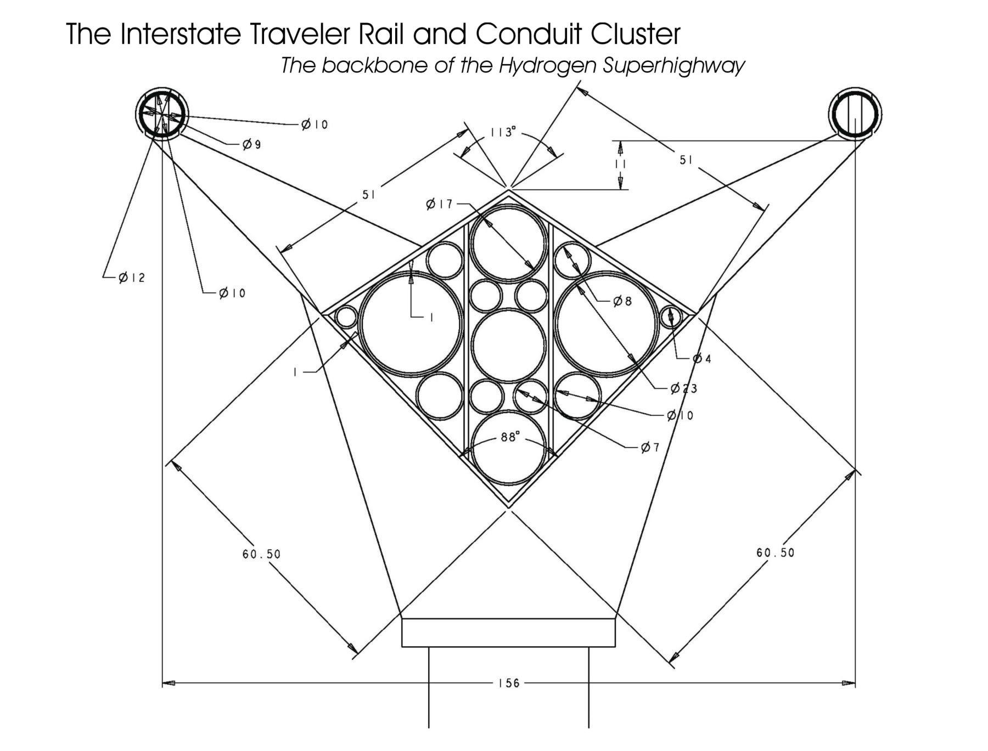

8.5 ITC Rail Switch
The method of switching is based on a sliding table that will automatically line up rail pairs. As can be seen in the illustration below, this switch table shows three positions which can be described as follows:
Position 0 = Mainline
Position 1 = Subnet on the right
Position 2 = Subnet on the left
The subnet switch table is set just above the central support housing the conduit cluster. The switches are operated using TCP/IP protocol. The switch tables employ sliding counterbalance to eliminate torque from rail pairs overhanging one side or the other. Further, the proper counterbalance ensures the greatest efficiency in opening and closing the switch. The switch table is made from simple magnetic bearing guideways like giant drawer slides, that are mounted horizontally and perpendicular to the rail in the 11 inch high plane above the central support and below the tubular rails. The switch is optimized to open or close less than 3 seconds.
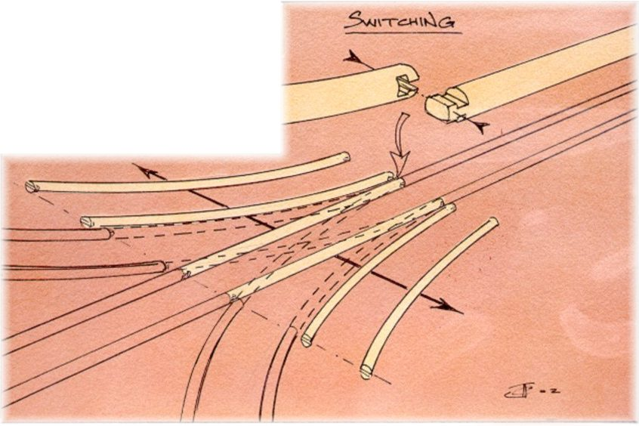 | 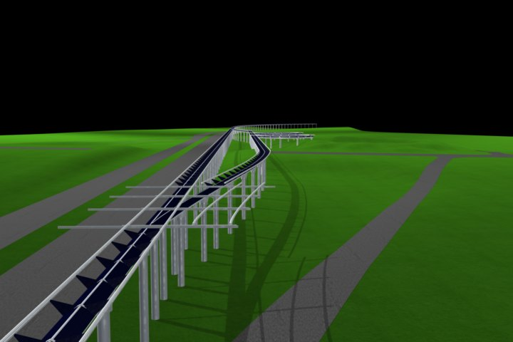
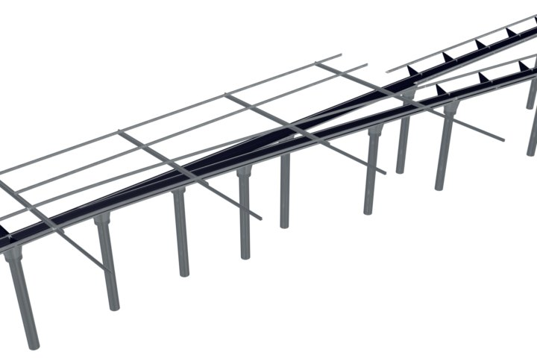 | 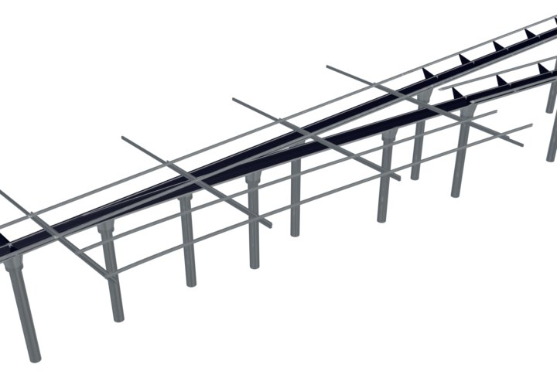

8.6 Central Support Conduit Cluster and Utility Substations
The Central Support of the ITC Rail is the structural box beam housing for the Conduit Cluster. The top of the Central Support provides the surface area for photovoltaics (PV). The top surface area is eight feet in width, therefore assuming 8 square feet of PV per lineal foot of rail. Thusly, 5280*8=42,240sqft of PV per single mile of rail. However, all construction estimates assume the installation of parallel tracks to provide simultaneous two way travel, which yields 84,480sqft of PV per mile of ITC Rail installed. Based on 10 watts per square foot at peak time, each mile of rail will produce about 844,800 watts of electricity per hour at peak time. An installation that is 100 miles long would therefore produce about 84,480,000 watts per hour at peak time, or roughly 84 megawatts per hour peak time. Essentially, a 100 mile long installation supports slightly more than 8.4 million square feet of solar cells.
The Utility Substations are installed at regular intervals and provide for pumping stations, pressure regulation, electrical conditioning and load balancing, electrolysis production of hydrogen and oxygen, hydrogen fuel cells generating electricity and pure water, storage for water, hydrogen and oxygen, fiber optic switches, wireless network access points, satellite uplinks, environmental sensors, electrophoresis liquid waste processing, high intensity ultraviolet radiation exposure to liquid waste to kill viruses and bacteria, data redundancy computers and municipal taps for local access to services.

For further light on the sanitizing properties of ultra-violet light, you may examine the following source: http://hps.org/hpspublications/articles/uv.html

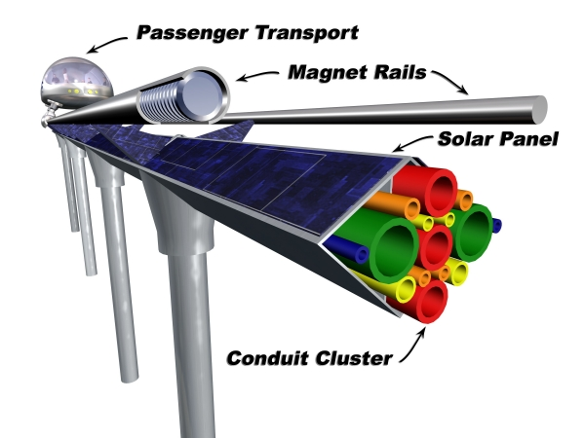 | 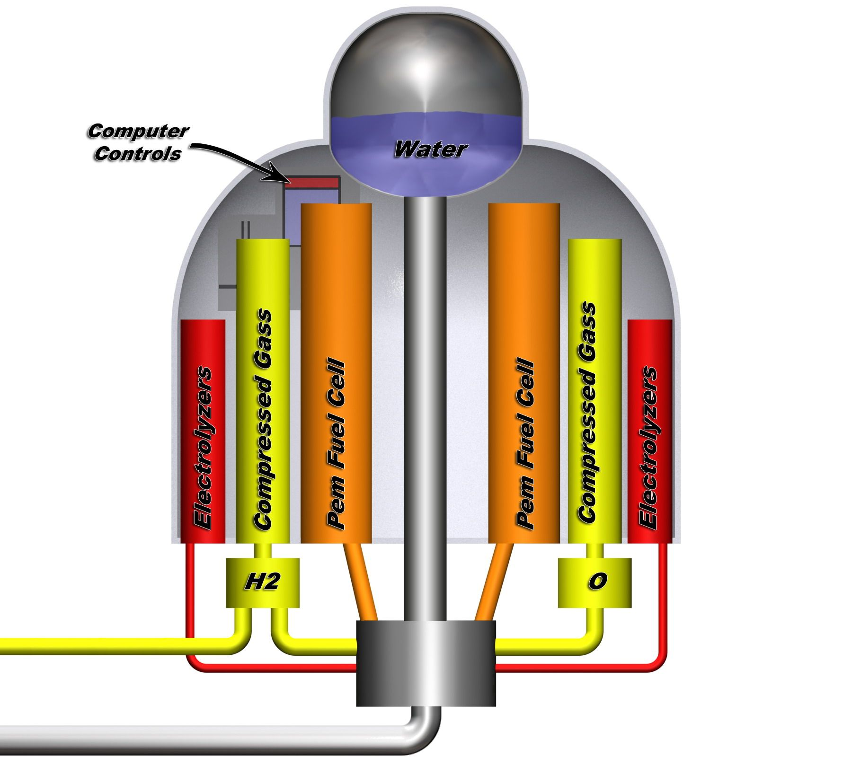

8.7 Connector Plate
The Connector Plate is used to connect sections of ITC Rail together into a rail segment and to facilitate a plug and play system allowing the immediate removal / replacement of any rail section or connector plate anywhere within a rail segment without disruption of services to the other rail sections unless the disconnection completely separates a rail segment from a utility substation. The Connector plate hosts a collection of cylindrical devices that fit inside of the conduit embedded in the conduit cluster, and when the rail conduit cluster and connector plates properly assembled, the cylinders will be inserted into the fore and aft conduit exactly 8 inches respectively. Each cylinder is wrapped with a threaded sleeve that is used to compress an o-ring to seal the assembly and provide flexibility. The Connector Plate supports each cylindrical device providing the capability to move each device along its axis so that the connector plate can displace each cylinder so as to free either fore or aft rail section so that it may be lifted out and replaced. The action of sliding the cylindreical divice more than the standard 8 inches into a conduit to free an adjacent section causes gases and fluids to be pressed backward into the network to the nearest Utility Substation where suitable fixtures are in place to compensate. This process is only applicable to fluids that are not compressible. The Cylindrical devices are suggested to be 44 inches in length, where the center 10 inches is supported in the thickness of the plate, and 17 inches protrude both sides. The Cylindrical devices should also act as linear motors to enable position control perpendicular to the plate. The Cylinder should be able to move enough in either direction in order to facilitate the extraction of a rail section, considering the requirement of one or both of the connector plates at either end of a rail section. The Cylindrical Devices service fluid and vapor conduits as well as host fiber optic bridges, fiber optic laser repeaters, and fusible links for the electrical distribution network.
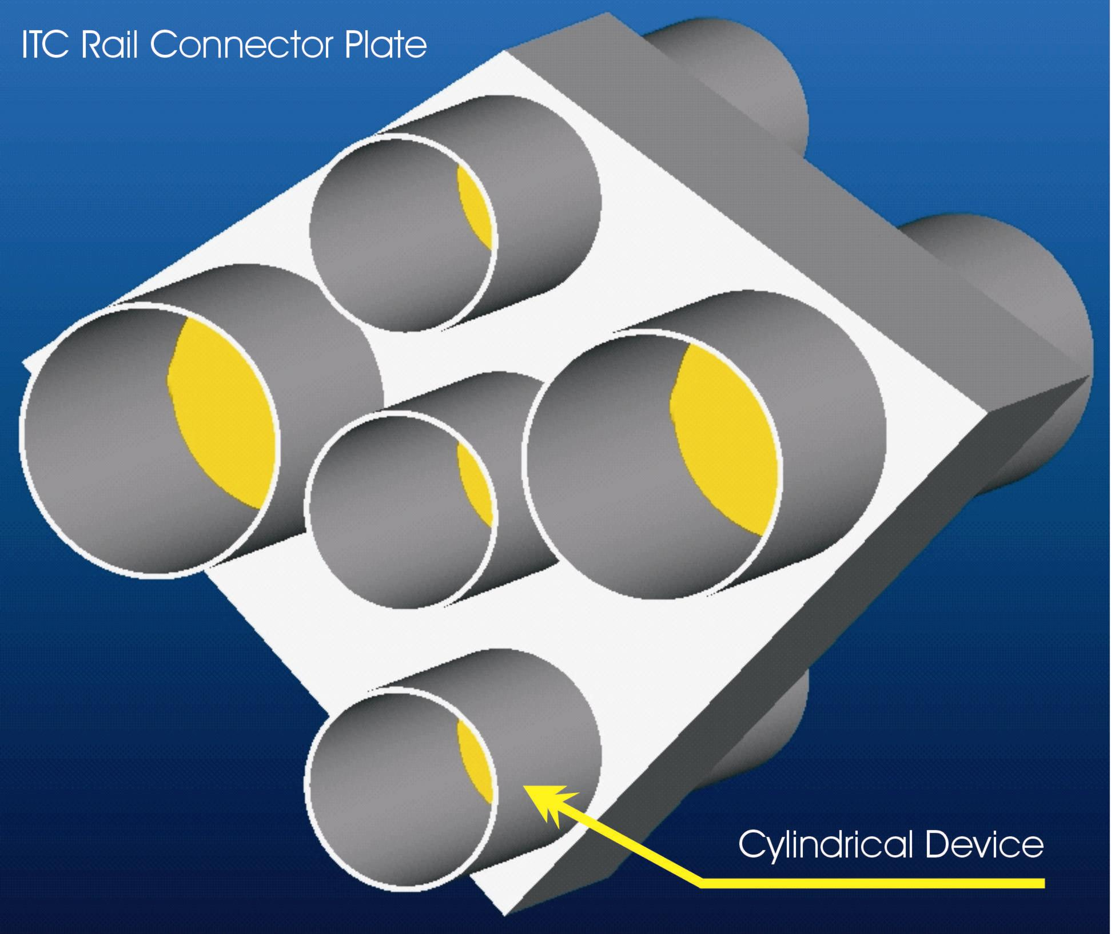

8.8 ITC Rail and Connector Plate Interaction
The interaction of the Rail and Connector Plate are that of a cylinder and sleeve assembly that can be assembled and disassembled without disrupting the functionality of adjacent rail sections which remain attached to the network. The cylinder / sleeve assembly is designed to facilitate enough tolerance that two rails can be slid apart to free the one connector plate and/or two connector pates and be slid apart to free a section of rail. This is accomplished by the existence of a space between each rail section wherein a connector plate supporting an array of cylindrical devices is employed to bridge the conduit from section to section, and a 28 inch rail tube connectors bridge the gap from rail tube to rail tube. The cylindrical devices are design to provide movement of each rail section in either direction. As each section is installed from stanchion pole to stanchion pole, the connector plate will be placed between each section with the cylindrical devices inserted into the both rail sections exactly 8 of the 17 inches leaving an additional nine inches of travel for two rail sections to slide apart a total of 17 inches travel from their combined movement to release a connector plate.

8.9 ITC Rail, Connector Plate and Stanchion Pole Interaction
The ITC Rail is designed to connect to the stanchion pole by resting in the flared V-shaped capital of the stanchion pole, where pair of guide pins limits the movement of the rail sections longitudinally by the length of the slot cut in the bottom two sides of the central support. The Connector Plate is designed to float freely between the rail sections. A cover plate is used to bridge over the space between the two rail sections to cover the connector plate and servers to lock the two sections of rail together with large machine screws. Some stanchion poles are made from the Central Support of the rail without the support arms and rail tubes which serve to provide connecting conduits to a Utility Substation, where these can be setup as direct T connections, or in parallel to provide either one way or two way conduit between the rail and Utility Substation.

8.10 ITC Slotted linear motor and magnetic levitation nacelle
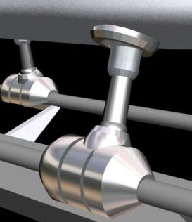
The Interstate Traveler Company slotted linear motor nacelle is designed to provide an adjustable levitation gap and linear position control between the coils in the nacelle and the coils in the rail. The nacelle wraps around the rail leaving room for the support arms that hold the rail above the conduit cluster. Each nacelle works independently of the other nacelles for the maintenance of levitation gap and position control, yet are linked with the other nacelles via the G-Force compensator which measures G-force by the displacement of a pendulum, which displaces position control sensors directly linked to the suspension system. The G-Force Compensator provides automated load balancing to optimize nacelle collaboration in the positioning, acceleration, deceleration, emergency breaking, neutral glide, of an ITC Transporter on the rail.
As the actual amount of energy required to maintain a specified levitation gap, the maglev electronics automatically provide real-time load values down to fractions of a pound. Essentially, the ITC Rail has a built in scale that is highly accurate and measures in real-time.

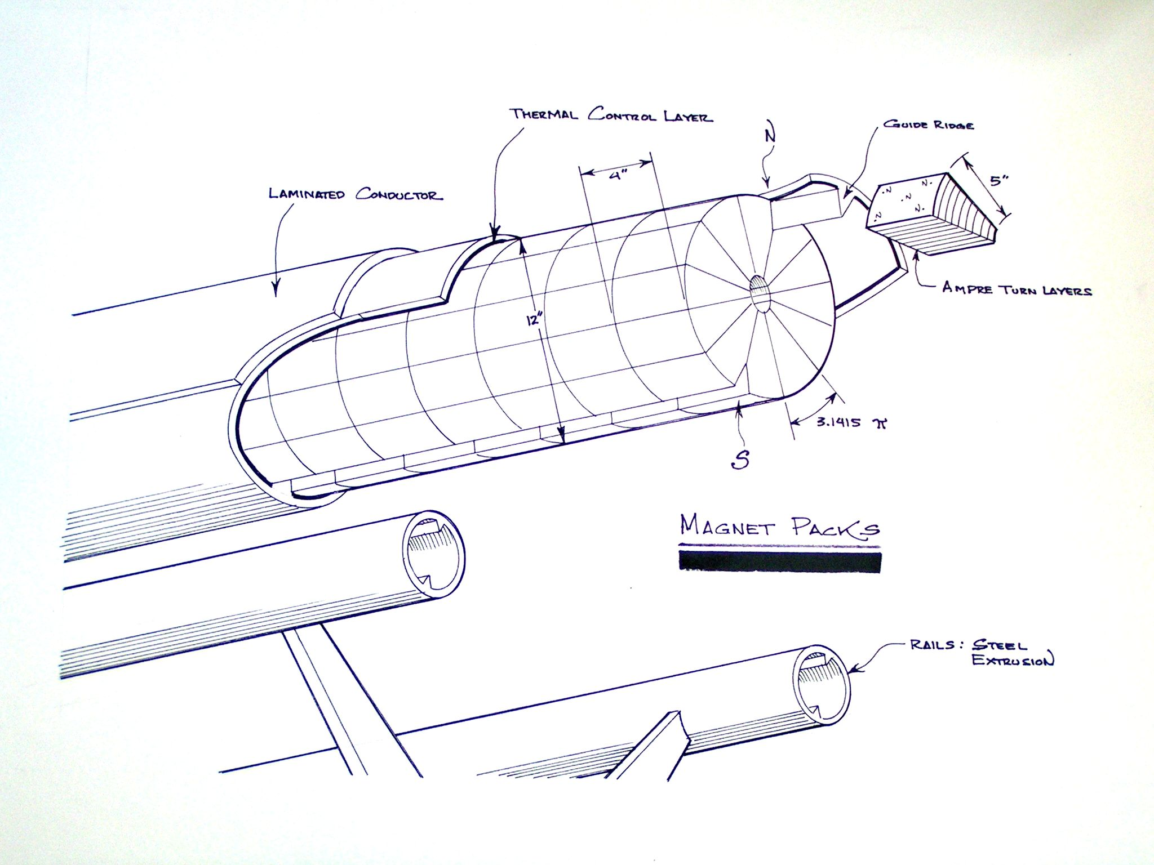 | 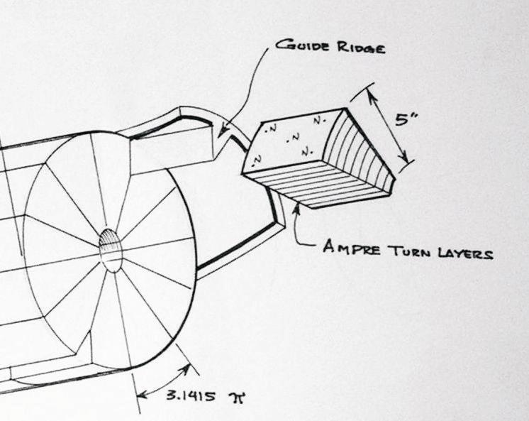

8.11 ITC Rail Slotted Linear Motor Detail
The ITC Linear Motor Nacelle affords maximum field generation and control by increasing the density of solenoids per square foot of surface area employed for magnetic levitation and position control, i.e., the surface area of the tubular rails and the internal surface area of the linear motor nacelle. Each individual coil is individually controlled via IP address managed under a centralized addressing system such as the Internet DNS system. Each individual coil benefits from a unique identifier such as the MAC address layer in the Internet TCP/IP protocol. Each individual coil is energized by a rheostatic control enabling a polarity change by switching direction of current through the coil and zero to max voltage, with enables the creation of complex magnetic field interactions, further enabling the creation of a traveling wave of flux field intensity that can be propagated longitudinally and circumferentially enabling levitation gap and position control. Position control and levitation is enabled by the variation of flux field intensity, and the motor can actually clamp down onto the rail by reversing the appropriate group of coils. This “grabbing” ability of the motor is further capitalized upon by the ITC Rail Plane articulated nacelles that open and close to enable the ITC Rail Plane to take off and land from any location on the rail.
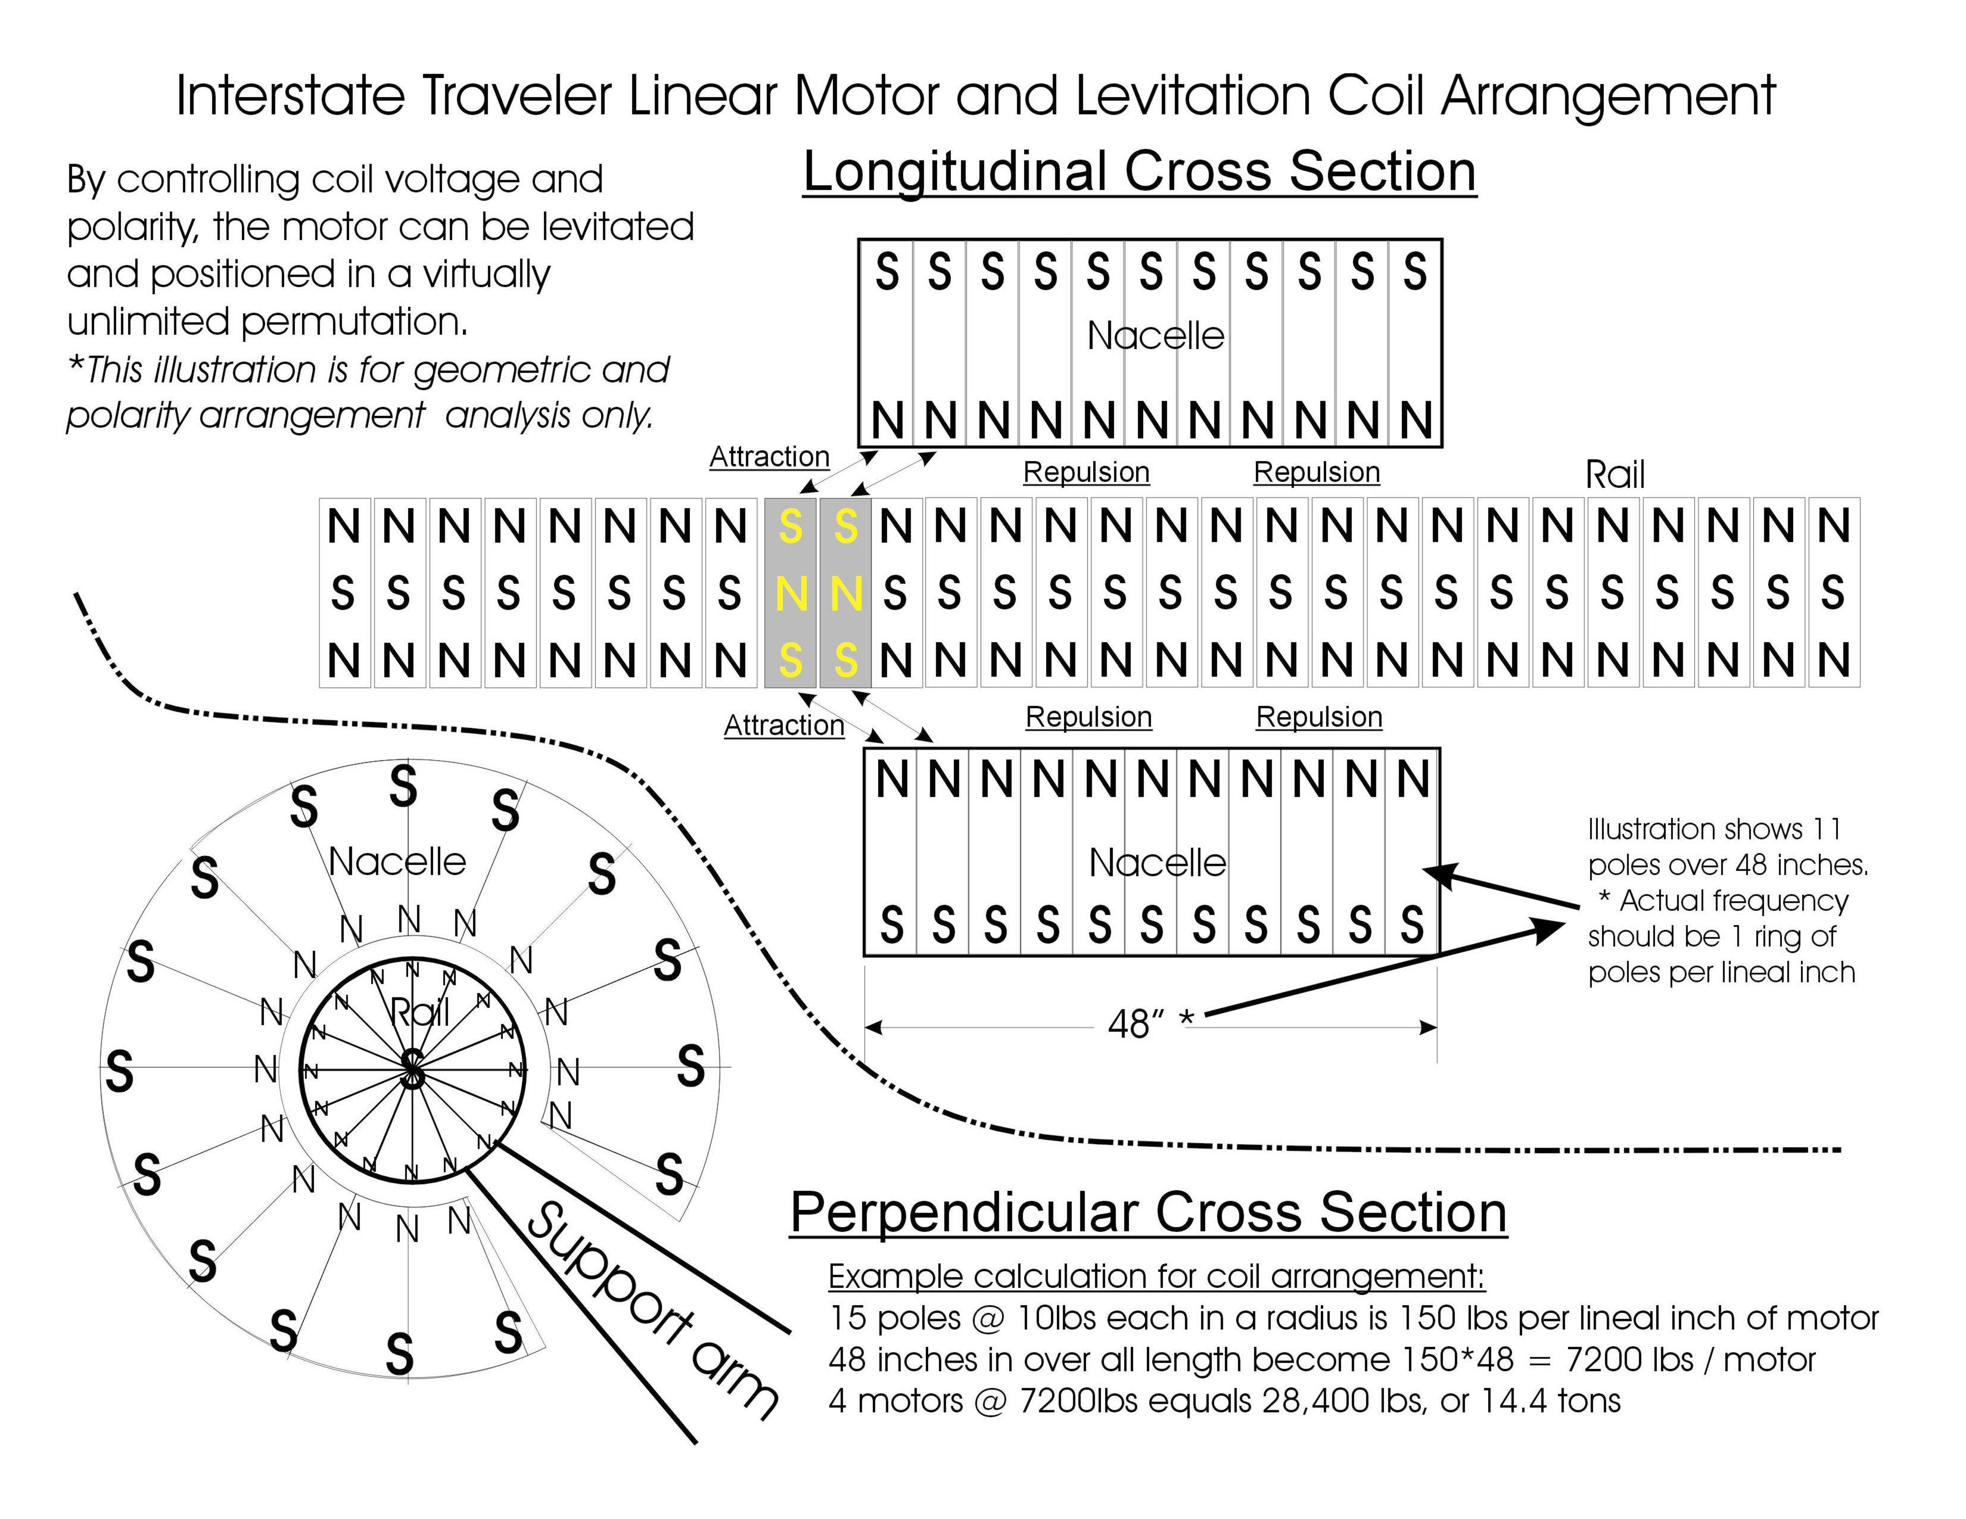
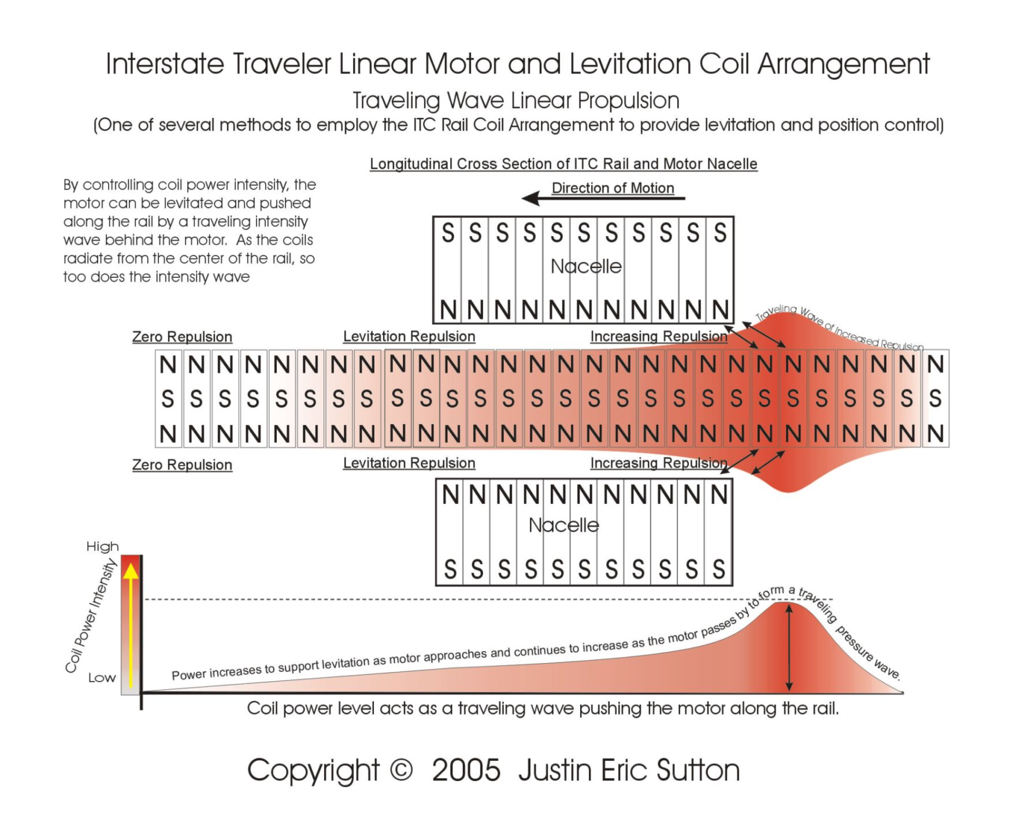

8.12 ITC Coil Density Plan
As a magnetic field is most powerful at the pole, the Interstate Traveler takes advantage of this fact by having a high density pole per square inch. As an example, consider a flat table that has a series of electromagnetic coils standing vertically to the table. Each coil is one inch square and 2 inches tall so that you would have a density of 144 coils per square foot, or one coil / square inch. Each coil would only require enough power to repel one pound for the entire square foot to be powerful enough to repel 144 lbs. By having a high density of coils the poles form a virtual surface that can be shaped by adjusting the power to each coil. Consider now a plate with the same coil arrangement sitting on the table, by inducing opposing fields in the plate and the table, the plate would float above the table. The levitation gap is proportional to the power induced into the coils so that the mass of the plate can be measured precisely by measuring how much energy is required to levitate the plate with a specific levitation gap.

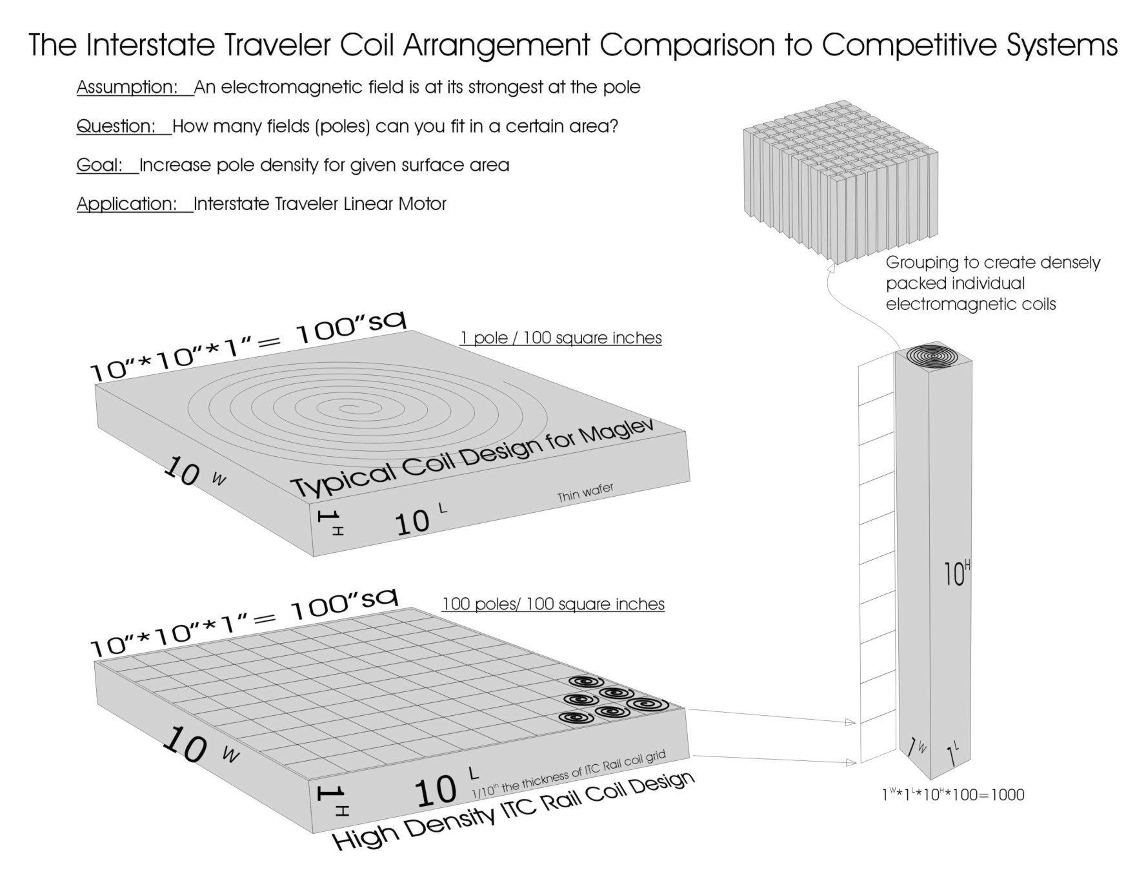

8.13 ITC Radius Study
This example of the ability to operate on a 60’ turning radius or smaller.
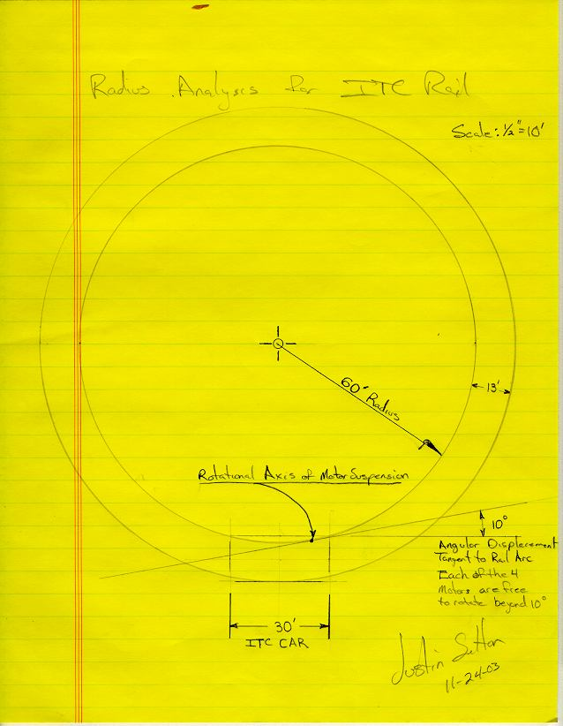

8.14 ITC Transporter Suspension
The Interstate Traveler Company Transporter Suspension System is designed to provide roll, pitch and yaw attitude control to enable the optimization of vehicle aerodynamics to enable each transporter to benefit from the efficiencies gained by aerodynamic lift. The suspension system is comprised of at least two slotted linear motor nacelles, each connected to the ITC Transporters via a ball joint articulated suspension arm which exhibits a linear extension and contraction characteristic to change its length. The suspension arms are mounted in such a way that the ball joint acts as a universal fulcrum, and where the portion of the suspension arm that extends beyond the ball-joint-fulcrum into the interior of the Transporter is mounted to three or more linear position control devices that connect the end of the suspension arm to the transporter which provides conical position control of the suspension arm. Each suspension arm and nacelle being enabled to rotate axially independent of other nacelles and suspension arms so as to provide the ability follow curves in the rail.
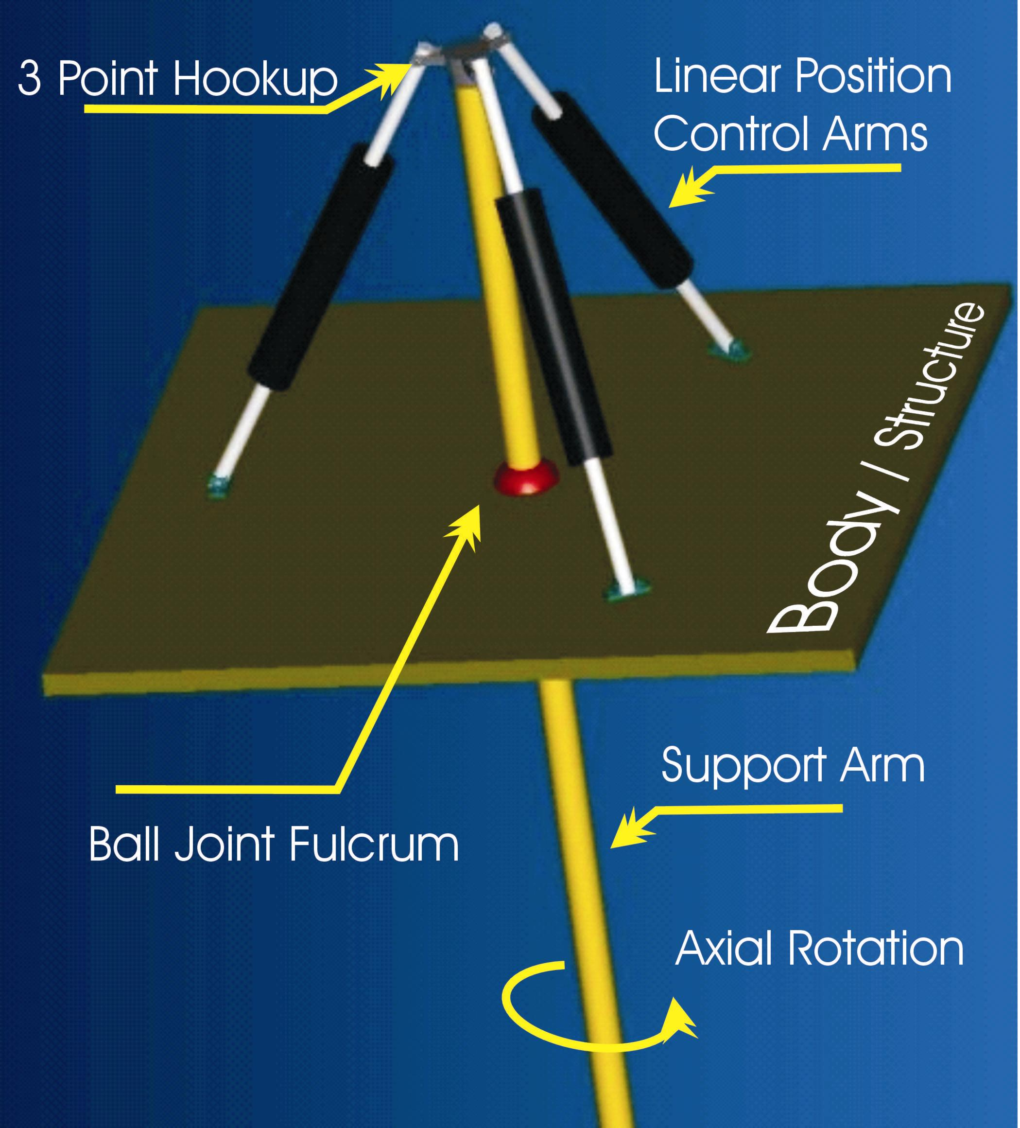

8.15 The G-Force Compensator
The G-Force Compensator is a real-time attitude control system designed to instantly translate kinetic forces into adjustments in the suspension system. The mechanical characteristics of the G-Force Compensator are nearly identical to the suspension arms yet are ideally situated with four linear position control devices. As the vehicle accelerates, decelerates or banks, the g-forces that act upon the pendulum are directly translated into the ITC Transporter Suspension System to maximize passenger comfort. The employment of the G-Force Compensator essentially adjusts the transporter’s suspension system so that the g-forces experienced during travel are as perpendicular to the floor as possible, which may allow for the placement of everyday objects on a table in an ITC Transporter, where the object on the table will not slide around during the operation of the Transporter.

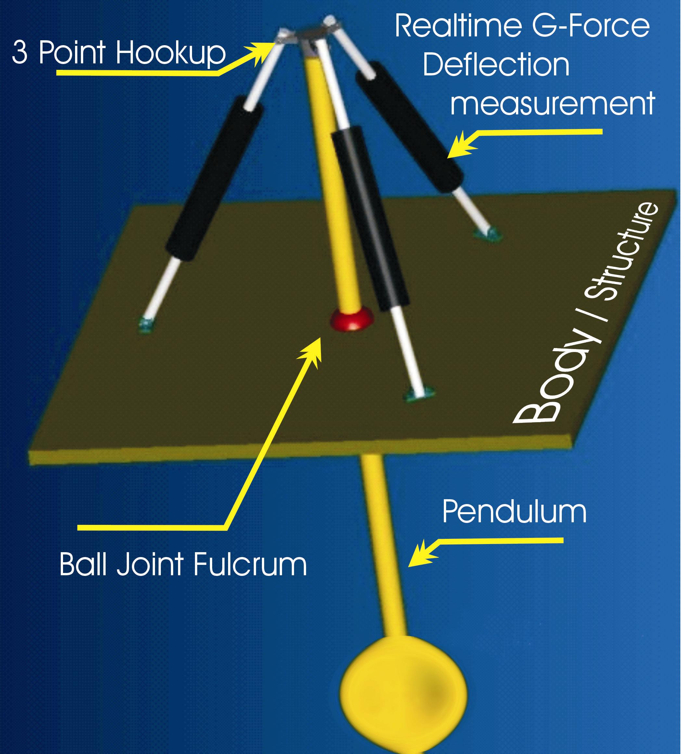

8.16 ITC Rail Assembly Process
The ITC Rail Installation Process employs specially designed equipment such as the 180 crane with counter balance to install stanchion poles, connector plates and rail sections. Supply cars are created to suit the distribution of stanchions, pile driving accessories, cutting and welding, concrete, rail sections, and connector plates, along with a service basket attachment for skilled trades, inspections, etc.

8.17 ITC Rail Pile Driver Apparatus

ITC Rail Pile Driver Apparatus employs 4000lb stackable pile caps to assist in the pile driving process by increasing the static load of the pile being driven. Heavier pile caps may be required to produce the desired effect.
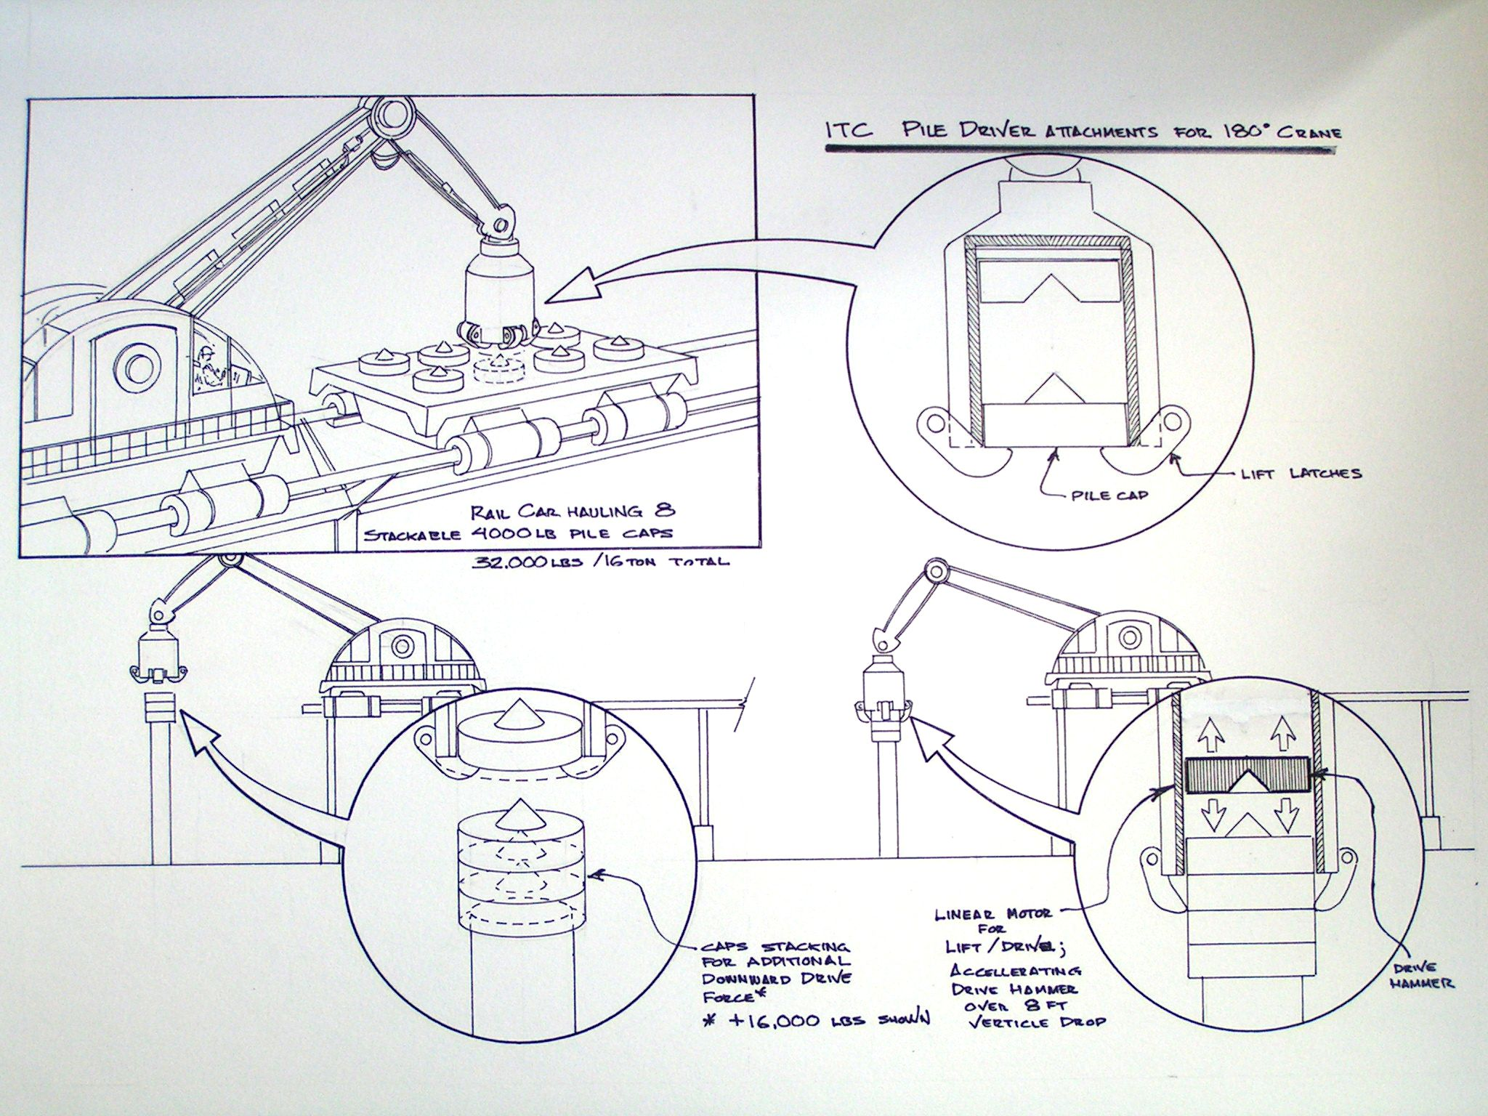

8.18 ITC Energy Cycle
Hydrogen Energy Cycle for the Interstate Traveler Project demonstrating the use of renewable hydrogen energy driven by solar power to energize electrolysis for the production of hydrogen and oxygen to power hydrogen fuel cells, (Proton Exchange Membrane) or PEM.

8.19 ITC TCP/IP Control Systems
The ITC Rail will provide an International addressing system for all ITC Transports, with the ability to expand the addressing system into other modes of transit external to the ITC Rail network, herein referred to as the ITC Operating System.
This document is entitled "TCP/IP Control System" to imply the architectural similarities between the ITC Operating System and TCP/IP. The ITC Operating System may or may not include dependency on existing TCP/IP code.
A common term in the public transit industry is Automated Guideway Transit (AGT). For the Interstate Traveler Project, our unique approach to AGT is designed to serve an unlimited number of transit vehicles and containers.
Our method of accomplishing the creation of a national AGT system is to employ a nested domain (Dendritic) addressing system running on a built in fiber optic network.
A "Domain" is a segment of a network perhaps best analogized with the branches of a tree so that a single great oak tree may have one primary domain "Trunk" where each of the main branches that grow up and out from the "Trunk" are unique individual "tree-like" structures or "domains" subordinate to the main tree "Trunk" (primary domain). This is a direct example of how the Internet is managed. For a more specific description of Internet Domains, please take a look at the following links:
http://www.internic.net/faqs/authoritative-dns.html
http://www.ntia.doc.gov/ntiahome/domainname/domainname130.htm
The basic components for the ITC Operating System are:
1. A fiber optic network
2. Radio frequency communications
3. A dendritic ordinal addressing system, where said dendritic ordinal addressing system serves routing, position control, sensor communications and component communications/control.
The ITC Operating System will conform to the Organization for Standardization (ISO) and the American National Standards Institute (ANSI) Object Identifier (OID) standard to insure globally unique object identities for all ITC Operating System functions and for all ITC Rail components. For a more specific description of OIDs please take a look at the following links:
http://middleware.internet2.edu/docs/a-brief-guide-to-OIDs.pdf
http://www.iso.org/iso/en/CatalogueDetailPage.CatalogueDetail?CSNUMBER=25774
Ideally the TCP/IP network that makes the Internet possible is an exceptional model of a dynamic network with built in tools for monitoring traffic and routing packets of data from one address to another over a truly global network which makes it possible to have real-time interaction between computers anywhere in the world. A national installation of the ITC Rail provides for a nationwide fiber optic network with real-time access to sensors for data of all kinds from weather information to demand on services, from remote control of critical components such as heat and light to the speed of each ITC Transport. Another analogy to a less complicated network system called x.10 typical "Smart Home" technology available at your local home remodeling superstore. http://www.smarthome.com/
Therefore, the comparison with TCP/IP technology with the ITC Operating System protocol is ideal for many reasons. For a typical definition of what TCP/IP is click here.
Each ITC Transport will have its own unique address (object identifier) and each section of ITC Rail will have a unique object identifier that will provide position control and routing logic on the network and act as a gateway for each Transport. The great features of a nested domain system allows for a new IP Domain for each rail sub-network. For instance, a shopping mall would have it's own "Domain" with a series of address within that Domain allowing for individual addresses unique to the shopping mall’s Domain.
A Domain can also be analogized to the "Area Code" used in telephone networks so it becomes obvious that a telephone call with a 212 area code will be a call to New York City.
All of the existing communication services, tools, monitoring and security programs currently in use on the Internet for the regulation of communications of electronic data, will have a directly analogous component on an ever expanding public network rail system. From "Fire-walls" for private rail networks in commercial, residential and military districts, to video telephone technology.
The Internet has proven the concept of constantly improving efficiency and speed in completing processes and moving data using the TCP/IP communications protocol and the ITC Operating System will use the same basic ideas to improve the efficiency of public transit for the entire United States.
We intend to capitalize on the principle successes of the Internet and apply them to the mass transit of people, and the raw goods of industry.
When ever an ITC Transport moves within a public, commercial or private rail network Domain, the system knows the relative position and speed with the ability to calculate a route to get from where it is to any place on the network based on security authorization.
The entire ITC domain system will have master root controllers that monitor forests of domains and sub-networks. These master root controllers will be protected in the same manner as the Internet Root controllers are protected by the federal government.
Naturally each device on the system will have full access to outside network resources as part of the service, but private networks can still exclude access from outside.
As an example, the following table lays out the basic scheme for addressing for ITC Rail Transports. As described above, each Transport will operate within network domains allowing the routing logic to determine point of presences at all times which is used to calculate a route to a destination domain such as a shopping mall or sports arena. The following table demonstrates the simplicity of a substitution table that represents the structure of determining location on the network with a numerical value. This numerical value much like TCP/IP represents a nested address system where the first ordinal (Country=124=USA) the second ordinal (State=48=California) the third ordinal (County=17=LA County) the fourth ordinal (City=6=LA) and the fifth ordinal (Traveler Station=35) provide a universally resolvable addressing system for the entire network. With the ability to automatically increase the number of ordinals beyond the 5th as demonstrated here yields the ability to easily manage a network of any size and complexity.
Country.State.County.City.Station | 1st . 2nd . 3rd . 4th . 5th
USA.California.LACounty.LosAngeles.TravelerStation | 124.31.17.6.35
USA.Nevada.Clark.LasVegas.TravelerStation | 124.36.14.2.14
The following references are links at the Institute of Electrical and Electronics Engineers who are leading the field in Intelligent Transportation Systems as well as links to the ITSA and others to help shed more light on the topic:
http://grouper.ieee.org/groups/scc32/ddmins4feb.html
http://grouper.ieee.org/groups/scc32/Attachments.html
http://www.itsa.org/
http://www.ewh.ieee.org/tc/its/trans.html WhitePaper?
http://www.rtnetworks.com/tcp.htm
http://web27.p15156948.pureserver.info/w2k/adswp.htm "Nested Domain"

Appendix A - Interstate Traveler Nomenclature
ITC Rail refers to the entire system of systems that make up a functional installation of rail with necessary controls, conduits, substations, traveler stations, transports, et.al,
Conduit Cluster refers to the central support rail that contains a structurally integrated cluster of conduits for a multitude of services such as the piping of fluids and gases, fiber optics, and electrical conductors, etc, where said Conduit Cluster is laminated with photovoltaic material for the daily collection of energy.
ITC Rail Section refers to a premanufactured section of rail that is 60 feet long comprised of a Central Support housing a Conduit Cluster, which supports a pair of cylindrical rails that house magnet packs that facilitate the linear motors of the ITC Transporters.
ITC Rail Segment refers to any set of Sections connected to a Utility Substation
ITC Rail Connector Plate refers to the device used to connect each prefabricated ITC Rail Section together, which also facilitates real-time flow control and flow monitoring and acts to terminate flow from conduit in the event of physical damage to a rail section before or after the Connector Plate.
Transporter refers to any of the various purpose built maglev vehicles that ride the rail
Utility Substations refer to the utility management structures built every 5 miles along the rail that provide housing for redundant computer control systems, energy conversion devices, energy storage devices, and conduit taps for local municipal access. Ideally, the Utility Substations will be built within the cloverleaf interchanges along the highway right of way. A regular installation of ITC Utility Substations approximately every 5 miles to create a redundant automatic fail-over control system which insures the greatest reliability of the ITC Rail Conduit Cluster and Transporter system via load balancing of energy systems, local conduit tap distribution systems, liquid and vapor flow controls, and the redirection of the same where necessity may require.
Traveler Stations refer to those places where passengers will enter and exit the public transit Transporters that ride the rail.
Linear Motor refers to the type of motor that provides electromagnetic position control and/or levitation to facilitate the propulsion and suspension of all Transporters on the rail.
Mag-Lev refers to a state of the art magnetic levitation system as it applies to the Transporters and the suspension, propulsion and positioning systems thereof.
Magnet Packs refers to the electromagnetic devices that are built into the rails of the ITC Rail to provide the radial counter forces necessary to provide levitation/propulsion and position control working with the forces generated by the linear motors attached to the Transporters.
Nacelle refers to the entire assembly of a slotted linear motor that wraps around the rail, i.e. typical illustrations of the ITC Rail Transporters display four nacelles.
Electrolysis refers to the process of subjecting water to an electrical current which breaks water down into hydrogen and oxygen for use as required.
Photovoltaic (Solar Array) refers to any type of material that absorbs light / electromagnetic energy, to create electrical pressure used to power electrically dependant systems.
Proton Exchange Membrane (PEM) refers to the various types of materials and technologies that provide for the molecular recombination of Hydrogen and Oxygen molecules at a controlled rate where the combination allows for the employment of the electromotive force as the nuclei combine to form water.
Regional Director (RD) refers to any entity under contract with the ITC acting as the single point of presence in a delineated region such as a State or Province or Tribal Land, or Country, or block of the same, where said RD is entitled to commissions for sales, ongoing revenue and a commission for successful acquisition of investment capital.
Strategic Partner refers to companies under contract with the ITC to share business critical information and to share in the development of all the systems requisite to the construction of the ITC Rail who by demonstrating an initial investment of time, services, and/or other tangibles position themselves as a primary dedicated supplier.
Energy Storage refers to the storage of electrical energy and/or potential energy in the form of a battery which may include a multitude of storage methods such as metal hydride materials, lithium ion, zinc/air, and others with a primary focus on the environmentally perfect storage of energy in the form of a multitude of isolated hydrogen and oxygen reserves where the recombination of those gases create a measurable electrical potential via PEM recombination.
Virtual Prototyping refers to the common practice of engineering and testing engineered data in a computational environment where known material performances are input into a parametric database that permits a reasonably accurate computer model closely approximating the physical properties of an actual physical model to be tested under stress and forces generated by a computer, which in turn will provide a reasonably accurate failure analysis as compared to an actual physical model. The process is commonly referred to as Finite Element Analysis (FEA).
TCP/IP (Nested Domain Addressing System) refers to an addressing system that uses mathematically derived numerical designations in ordinal layers similar to the telephone system where the first ordinal set of numbers instruct the telephone switch which area the call is intended for, the second ordinal set gives you a more definite region within the area, and the forth ordinal connects you to the destination telephone device. Also very accurately analogized with email systems of the Internet.
Optimized Autonomous Vehicle Control System refers to that part of the ITC Rail that supplies computer coordinated vehicle position controls and switch activation to permit an unlimited number of Transporters to use the ITC Rail system without disruption of the forward motion of other Transporters on the rail, yet providing a manual override for priority vehicles such as Emergency Transporters.
Multi-Modal Transit refers to the ability of the ITC Rail to support an unlimited number of uniquely built Transporters to service typical transit needs such as Passenger and Freight, and automobile ferry services.
University Coalition refers to a group of universities organized under the leader ship of the University subject to the agreement for the purposes of enhancing or otherwise increasing and accelerate the abilities of the University.

Appendix B - Operating Agreement

Appendix C – Subscription Agreement

Appendix D – Public Private Partnership

Appendix E – Existing Legislation

Appendix D – Industry and Organized Labor Endorsement

