MEMORANDUM OF UNDERSTANDING
BETWEEN
THE INTERSTATE TRAVELER COMPANY, LLC
AND THE UNIVERSITY OF MICHIGAN

This Memorandum of Understanding (the "Agreement") is made between Interstate Traveler Company (“ITC”), a Limited Liability Company, and University of Michigan, ("University"), a public body corporate and institution of higher education for the purpose of establishing a cooperative effort in order to develop and commercialize The Interstate Traveler Project, an Invention of Justin Eric Sutton, through a Coalition of Universities led by University of Michigan accommodating the 3rd Party Validation process.

ITC:
Admin POC: Lark Samouelian Co-Founder / Chief Communications Officer
Interstate Traveler Company, LLC
9594 Main Street
Whitmore Lake, Mi 48189-9401

Legal POC:

Technical POC: Justin Sutton, Founder / Chairman / Principle Inventor
Interstate Traveler Company, LLC
9594 Main Street
Whitmore Lake, Mi 48189-9401

University:
Admin POC:

Legal POC:

RECITALS 4
Article1 - Definitions 5
Article 2 - Cooperative Research 6
Article 3 - Reports 7
Article 4 - Financial Obligation 7
Article 5 - Title to Property 8
Article 6 - Inventions and Patents 10
Article 7 - Data and Publication 11
Article 8 - Representations and Warranties 12
Article 9 - Termination 13
Article 10 – Dispute Resolution 13
Article 11 - Liability 14
Article 12 - Miscellaneous 15
Article 13 - Duration of Agreement and Effective Date 16
IN WITNESS WHEREOF 17
For UNIVERSITY 17
For ITC: 17
Official Witness 18
Appendix A – Technology Description 19
Summary of Proprietary Information 19
Socio-Economic Impact Assumption 20
Revenue Sources 23
ITC Rail 24
ITC Rail Switch 25
Central Support Conduit Cluster and Utility Substations 26
Connector Plate 27
ITC Rail and Connector Plate Interaction 28
ITC Rail, Connector Plate and Stanchion Pole Interaction 28
ITC Slotted linear motor and magnetic levitation nacelle 29
ITC Rail Slotted Linear Motor Detail 30
ITC Coil Density Plan 31
ITC Radius Study 32
ITC Transporter Suspension 33
The G-Force Compensator 34
ITC Rail Assembly Process 35
ITC Rail Pile Driver Apparatus 37
ITC Energy Cycle 38
ITC TCP/IP Control Systems 39
Appendix B – Statement of Work 42
SOW - Statement of Work 42
Time Line 42
Project Team 43
University of Michigan 43
ITC Board of Directors 44
ITC Advisory Board Error! Bookmark not defined.
Appendix C – Reference Letters 46
See Attached. Error! Bookmark not defined.
Appendix D – Legislative Support 55
See Attached Error! Bookmark not defined.
Appendix C - Interstate Traveler Nomenclature 59

RECITALS
The program contemplated by this Agreement is of mutual interest and benefit to each party.
ITC has invested substantial sums of its own private funds in and has performed substantial research and development with respect to the Interstate Traveler Project and possesses designs, methods, systems, and relationships describing and supporting the concept for a globally standardized infrastructure network, where said designs are more efficient and effective than others. Further, where said designs are supported by a network of professionals capable of facilitating company startup and operation internationally, the commercial opportunities from the implementation of the designs and networks remain the property of the ITC where ITC retains all rights for any subsequent development of the above under this contract or other contracts, as detailed specifically in Appendix A – Technology Summary.
ITC is interested in the further development of its Technology and its application to the Interstate Traveler Project by engaging the University in performing a skilled and defensible 3rd Party Validation.
University is interested in seeing that the end-product of this Technology is utilized by the private and public sectors for the public good.
ITC and University desire to jointly seek and secure external resources for further development of the Technology.
UNIVERSITY possesses equipment, facilities, researchers, and unique capabilities, which it will engage and employ toward the performance of this agreement according to and limited by Appendix B – Statement of Work
The performance of such research and development is consistent, compatible and beneficial to the business role of ITC as a private company, and to the academic role of the University and central to its mission as an institution of higher education.
The University shall, in the light of its standing as an institution of higher education, maintain a permanent repository of original records related to the creation, development and commercialization of the Interstate Traveler and oversee the duplication and distribution of such records to all libraries around the world.
ITC desires to pursue the development and commercialization of the Interstate Traveler Project with the objective of developing a globally standardized, solar powered multimodal self-sustaining infrastructure network for transportation, communication, energy production, energy distribution and energy storage using the hydrogen energy cycle associated with the electrical decomposition of water into hydrogen and oxygen and subsequent recombination in the proton exchange membrane system or other means, with regional, geographic and global real-time automation, maintenance, load balancing and reconfigurability. Further, where this entire system facilitates massive amounts of water reproduction via the electrical decomposition of water and the recombination of its raw elements to create newly minted water molecules that are pure.
Finally, ITC, by this agreement will set forth a permanent endowment to fund a new academic chair of science and provide for the construction of permanent facilities and the purchase of equipment that will enable this new chair to organize and implement academic services to the general public as currently regulated by any laws that govern the University.

Article1 - Definitions
As used in this AGREEMENT, the following terms shall have the following meanings and such meanings should be equally applicable to both the singular and plural forms of the terms defined:
1.1 "Agreement" means this Memorandum of Understanding between ITC and University of Michigan.
1.2 "Invention" means any invention or discovery which is or may be patentable under Title 35 of the United States Code.
1.2.1 “Invented” means the conception of a patentable invention where the party or parties who originally conceived the invention is or are deemed the Inventor.
1.2.2 “Inventor” means the party or parties who have invented an invention and have first right of commercial value and control over the application and use of the invention, unless affected by legal agreement or as described in Article 6 – Inventions and Patents under the execution of this agreement.
1.3 "Made" in relation to any invention means the conception or first actual reduction to practice of such invention, be it literally and/or figuratively, and defensibly original.
1.4 "Proprietary Information" means information that embodies trade secrets developed at private expense, or information which is confidential business or financial information about an invention provided such information:
(a) is not generally known or available from other sources without obligations concerning its confidentiality;
(b) has not been made available by the owners to others without obligation concerning its confidentiality; and
(c) is not already available to the Government without obligation concerning its confidentiality.
1.5 "Subject Data" means all recorded information first produced in the performance of this Agreement.
1.6 "Subject Invention" means any invention made in the performance of work under this Agreement, not already described as Proprietary in Appendix A – Technology Description
1.7 “Interstate Traveler Terminology” see Appendix C
1.8 “University Coalition” refers to a group of universities organized under the leader ship of the University subject to the agreement for the purposes of enhancing or otherwise increasing and accelerating the abilities of the University to complete the tasks outlined in Appendix B – Scope of Work

Article 2 - Cooperative Research
2.1 Statement of Work. Cooperative research performed under this Agreement shall be performed in accordance with the Statement of Work ("SOW") attached hereto as Appendix B. Each party agrees to participate in the cooperative research and to utilize such personnel, resources, facilities, equipment, skills, know-how, and information as it considers necessary, consistent with its own policies, missions, requirements and levels of available support.
2.2 Review of Work. Periodic conferences shall be held between ITC and UNIVERSITY to review the progress of work. It is understood that reasonable efforts will be used to conduct the research under this Agreement.
2.3 Principal Investigation. ITC agrees to assign ITC portion of the work to be performed pursuant to the SOW. The work will be performed under the supervision of Justin Sutton as Principle Inventor, who has the responsibility for the scientific and technical conduct of this project at ITC and _____________________ as Principal Investigator for UNIVERSITY, who has the responsibility for the scientific and technical conduct of this project at UNIVERSITY.
2.4 Scope Change. If at any time either Principle Inventor or Principal Investigator determines that the research data dictate a substantial change in the direction of the work, that party shall promptly notify the other party, in writing, outlining the proposed change so that the other party can have due and timely notice of a proposed change where upon receiving a written proposal for change, the parties shall make a good faith effort to agree on any necessary change to the SOW within 60 days of either party receiving said written proposal for change.
2.5 Project Team. To the extent that the conduct of sponsored research requires a joint technical effort of UNIVERSITY and ITC, the parties agree to establish a joint research and development team (The "Team") shall conduct cooperative research in accordance with the SOW. Each party shall make available to the Team such resources, facilities, equipment, skills, know-how and information as it considers necessary and appropriate. Either party may propose changes to the SOW or to the scope and direction of the effort which, if agreed to by the other party, shall first be made to the Statement of Work, and then implemented by the Team. The Project team will be comprised only of those individuals who are governed by this agreement under the respective parties of this agreement AND by signing an 8 year non-disclosure and non-compete agreement before they are accepted onto the Project Team
2.5.1 Project Team Members. ITC and University will list, in subordinate sections of Appendix B – Statement of Work, all members, employees, advisors, associates, affiliates, assistants, contractors, researchers, partners and colleagues who will have access to privileged, proprietary and confidential business information and on-going communications directly related to the execution of this agreement, and hold each accountable to the provisions of this agreement.

Article 3 - Reports
Reviews and Reports: Periodic conferences shall be held by ITC and University to review work progress. Parties shall exchange formal written interim progress reports and final reports on a schedule as set forth in Appendix B “Statement of Work”.

Article 4 - Financial Obligation
4.1 ITC Salary and Travel: ITC shall provide support to ITC personnel in performance of this Agreement.
4.2 UNIVERSITY Salary and Travel: UNIVERSITY shall provide support to UNIVERSITY personnel in performance of this Agreement.
4.3 Financial Definitions
Labor: direct labor, burden, subcontractors
Building materials: all products used in a project
Other direct costs: rental equipment for specific jobs, small tools consumed on specific jobs, and professional design and labor fees for a specific job
Gross profit (margin): Sales dollars, minus labor, minus building materials, minus other direct costs
Net profit: Gross profit minus operating expenses (overhead)
Operating expenses (overhead): indirect construction costs plus sales and marketing expenses plus general and administrative expenses
General and administrative expenses: Owner compensation, personnel salaries payroll taxes and benefits, retirement, pension, profit sharing, bonuses, general office expense, rent, utilities, computers, vehicles, liability, property taxes, licenses and state and federal fees, and professional services
4.4 Endowment – ITC for the purposes of supporting the University as an institution of higher learning shall herein put forth a permanent endowment consisting of 8% of Net Profits for the first 8 years, 5% of the Net Profits for the following 5 years, and 2% in perpetuity. Said Endowment shall be used to create an interest bearing account at a federally insured financial institution. The Endowment will be used to fund a new academic chair of science at an increasing number of Universities, internationally, where the creation of these new chairs of science will be managed by the University. The Endowment shall also be used to provide for the construction of permanent facilities and the purchase of equipment that will enable each new chair to organize and implement academic services to the general public as currently regulated by any laws that govern the University and all higher governmental authorities that may have jurisdiction. Further, 8 % of the Endowment will be used to create an additional Federally insured interest bearing account where said interest will given away in the form of scholarships to pay for academic expenses at the University to be issued at the Universities discretion.
All payments to the University according to this Endowment will be made annually, and paid on the February 22nd of each year from the previous year’s revenues.
4.5 The University will assist in the planning of a physical and virtual prototype of the ITC Rail and Transporter in the scale best deemed necessary to be constructed on a mobile platform capable for traveling over common roadways, where said prototype will demonstrate levitation, position control and suspension characteristics.
4.6 University will provide facilities to house offices for the ITC Project Team for a minimum of two years located near or on University campus properties. Occupancy will be made available as soon as possible. The extension of this provision will be renegotiated after 24 months of occupancy.

Article 5 - Title to Property
5.1 Equipment: All equipment developed or purchased by ITC under this Agreement shall be the property of ITC. All equipment, developed or purchased by UNIVERSITY, provided to ITC by UNIVERSITY, or developed or acquired by ITC with funds supplied by UNIVERSITY under this Agreement, shall remain or vest in UNIVERSITY with unlimited access, granted in perpetuity, to the ITC for its use in the future, also that the ITC has full right to duplicate said equipment for its use in the future for both commercial and non commercial interests. Co-developed equipment shall be owned by ITC. Title to Equipment purchased with funds external to ITC or University as part of a grant or contract shall be settled in accordance with the terms of the grant/contract agreement.
5.1.1 Inventory Control: Anything that qualifies as “Equipment” in Section 5.1 with a value of $100.⁰⁰ or more will be immediately catalogued upon acquisition and will be assigned a permanent serial number starting with the number 1. This serial number system and all its data will be maintained in duplicate and held separately by both parties. The University shall maintain responsibility to catalog all equipment and supply copies of these records to the ITC. Both parties are independently responsible to preserve and maintain said data.
5.2 Disposal of Toxic or Other Waste. The responsibility for proper disposal at completion or termination of this Agreement of any equipment or materials that an originating party transfers to the facilities of a receiving party and which constitute hazardous, toxic or other waste shall remain with the originating party. Further, should dispute or failure to comply to this section arise, actions will be governed by Article 10 -‘Dispute Resolution’ and Article 11 - ’Liability’ of this agreement
5.3 Software.
5.3.1 UNIVERSITY Employee Software. Title to any copyright in software written by UNIVERSITY employees in the course of the performance of this agreement shall be held by UNIVERSITY. UNIVERSITY agrees to grant to ITC an exclusive and unlimited license to use or have used, throughout the world by, or on behalf of ITC, the copyright covering said software.
5.3.2 Joint Employee Software. Title to any copyright in software written jointly by UNIVERSITY and ITC employees in the course of performance of this Agreement shall be held by ITC. ITC agrees to grant to University a royalty free license to use or have used, throughout the world by, or on behalf of University, for academic purposes only.
5.3.3 ITC Employee / Contractor Software. Software written by ITC employees or contractors in the course of performance of this Agreement is considered to be the property of ITC and/or the Contractor. ITC agrees to grant to UNIVERSITY a non-exclusive royalty free license to use said software for academic purposes only. ITC, however, places the following restrictions on use by UNIVERSITY of said software:
a. UNIVERSITY shall not copy said ITC employee software without the prior written approval of the ITC Chairman or his designee;
b. UNIVERSITY shall not distribute, license or sublicense said ITC employee software to third parties without the prior written approval of the ITC Chairman or his designee; and
c. Upon written request, UNIVERSITY may obtain additional copies of said ITC employee software.
5.3.4 Limited Scope. UNIVERSITY shall retain ownership in any software or algorithms to which UNIVERSITY has title prior to this agreement.
5.4 Receipt of Exchange – All properties governed under this agreement must be accounted for with a written and legally signed receipt of exchange which will claim ownership, authorship, propriety and confidentiality of said property. The Receipt of Exchange is only affective when signed by the Principle Inventor and Principle Investigator and two witnesses. Both parties reserve the right to refuse acceptance of property. Receipt of Exchange does not in any way imply an exchange in ownership, only the acceptance of said property for the purposes of this agreement.
5.5 Title to Intellectual Property. The ITC maintains all rights to all intellectual property associated with this agreement, as outlined in Appendix A ‘Technology Description’ and for any additional knowledge, Subject Data or Subject Invention developed under the execution of this agreement, and reserves the right to assign, or sell it’s rights to said intellectual property, where sale or assignment does not conflict with this agreement. Further, the ITC maintains the right to all commercialization of the knowledge appertaining to this contract as described in Appendix A and as may be developed under the execution of this agreement.

Article 6 - Inventions and Patents
6.1 Reporting. ITC shall promptly report to UNIVERSITY each Subject Invention developed under this agreement and UNIVERSITY shall promptly report to ITC each Subject Invention reported to UNIVERSITY developed under this agreement. Each Party is required to supply a written Receipt of Exchange for any Report submitted where all submissions of Reports are governed by this agreement.
6.2 UNIVERSITY Employee Subject Inventions. UNIVERSITY agrees to timely file patent applications on such Subject Inventions invented by a University Employee at the expense of University. ITC further agrees to grant to University a non-exclusive royalty free license throughout the world for research purposes only. For each University Employee Subject Invention, ITC shall pay all maintenance fees for said patent. If ITC elects not to pay the maintenance fee, ITC must relinquish their exclusive license rights in said patent and must give University reasonable notification so as to permit University the option of paying said fee.
6.3 ITC Employee Inventions. ITC shall retain title to each Subject Invention made by its employees. In the event that ITC retains title to said Subject Inventions, ITC agrees to timely file patent applications thereon at its own expense. ITC agrees to grant to UNIVERSITY a non-exclusive royalty free license for research purposes only.
6.4 Joint Employee Inventions. Title to Subject Invention Made jointly by UNIVERSITY and ITC employees shall be jointly retained by ITC and University as in Section 6.2 above.
6.5 Filing of Patent Applications. The party having the right to retain title and file patent applications, in the USPTO or elsewhere, on a specific Subject Invention may elect to file patent applications thereon and must do so within 60 days from the date it reports the Subject Invention to the other party. In the event that the party having the right to retain title and file patent applications fails to take action to submit the patent application within 60 days from the date it reports the details of the Subject Invention and of the intent to file a patent application, the other party may elect to file patent applications on such Subject Invention on behalf of the other party.
6.6 Patent Expenses. The expenses attendant to the filing of patent applications as specified in 6.5 above, shall be borne by the filing party. Each party shall provide the other party with copies of the patent applications it files on any Subject Invention, along with the power to inspect and make copies of all documents retained in the official patent application files by the applicable patent office.
6.7 Maintenance Fees. The fees payable to the U.S. Patent and Trademark Office, or other Patent Office, in order to maintain a patent's enforcement will be payable by the ITC, at that party's option. If ITC elects not to pay the maintenance fee, ITC may relinquish their exclusive license rights in said patent and must give University reasonable notification so as to permit University the option of paying said fee.
6.8 Exclusive License means 100% control the total interest of an Invention, which is exclusive of any royalties or endowments that may be associated with this agreement.
6.8.1 Grants. University shall grant to ITC an exclusive license in each patent application, and patents issued thereon, covering a Subject Invention, which is filed by University.

Article 7 - Data and Publication
7.1 Right of Access. ITC and UNIVERSITY agree to exchange all Subject Data produced in the course of research under this Agreement, whether developed solely by ITC, jointly, or solely by UNIVERSITY. The exchange of Subject Data is subject to the provisions set forth in paragraph 7.2 below.
7.2 Proprietary Information. Both parties shall place a Proprietary Legend on each Receipt of Exchange, as described on Article – 5 ‘Title to Property’, on all information that it developed prior to or independent of this Agreement offered up as Subject Data under this Agreement asserting to be propriety. The proprietary Legend shall explicitly identify which information is Proprietary and which information is not Proprietary on pages asserted to contain Proprietary information, and the legend shall be in the following form " PROPRIETARY". Both parties agree that any such marked Proprietary Information furnished under this Agreement, or in contemplation of this Agreement, shall be used by the parties only for the purpose of carrying out this Agreement. Such marked Proprietary Information shall not be disclosed, copied, reproduced or otherwise made available outside of each organization without the consent of the party providing the Proprietary information except as such information may be subject to disclosure under the Freedom of Information Act. Both parties agree to use reasonable efforts to protect from unauthorized disclosure said information designated and marked as proprietary. Excluded from disclosure requirements hereunder is information that:
is already in the recipients party's possession at the time of disclosure;
is or later becomes part of the public domain through no fault of the recipient party;
is received from a third party having no obligations of confidentiality to the disclosing party;
is independently developed by the recipient party; or
is required by law to be disclosed.
7.3 Other Information.
7.3.1 No trade secrets or commercial or financial information that is privileged, proprietary or confidential which is obtained either in the conduct of this agreement, or as a result of activities under this Agreement shall be disclosed. Both Parties agree to use best efforts to protect from unauthorized disclosure said information.
7.3.2 For a period of up to eight (8) years after development of information that results from research and development activities conducted under this Agreement ("Subject Data") and that would be a trade secret or commercial or financial information that is privileged or confidential, if the information had been obtained from a non-Federal party participating in the MOU, both parties shall provide appropriate protection against the dissemination of such information.
7.4 Release Restrictions. The parties shall have the right to use all Subject Data, except Proprietary Information, for any ITC or UNIVERSITY purpose where:
a) University and/or ITC in reporting on the results of sponsored research may publish Subject Data in technical articles and other documents to the extent it determines to be appropriate, subject to the restrictions in paragraph 7.2, 7.4 and 7.5; and
b) University and/or ITC may release such Subject Data where such release is required pursuant to a request under the Freedom of Information Act (5 U.S.C. 552); provided, however, that such data will not be released to the public if a patent application is to be filed (35 U.S.C. Section 205) until the party having the right to file has had a reasonable time to file. Neither party shall make any disclosure which may adversely affect the other party's rights in such data, and will make all efforts possible to notify the other party of intent release, or of legal demand to release and/or publish with as much advanced notice as possible.
7.5 Publication. ITC and UNIVERSITY agree that both parties shall have the right to publish Subject Data in either a report and/or in the open literature, with written permission from the other party where a request to report/publish Subject Data is made with a formal written request. Grounds for denial include the publication of Subject Data that can be demonstrated to be harmful to the ITC or University by affecting commercial values of Subject Data. Any publication in a report and/or the open literature will be authored appropriately with the decision concerning the principal author dependent upon the content of the proposed publication. Any publication(s) in a report and/or open literature will require consultation of the parties prior to the publication of Subject Data in order to jointly assure that no Proprietary Information is released and that patent rights are not jeopardized. Prior to submitting for review a manuscript that contains the Subject Data, or prior to publication if no such review is made, each party shall be offered an ample opportunity to review such proposed publication and to file patent applications in a timely manner, if it is so entitled under this Agreement.

Article 8 - Representations and Warranties
8.1 Representations and Warranties of ITC. ITC hereby represents and warrants to UNIVERSITY as follows:
8.1.1 Organization. ITC is a Limited Liability Company, whose substantial purpose is to successfully commercialize and expand the Interstate Traveler Project, and retains the right to legally re-organize into any legally accepted business structure recognized today and in the future.
8.1.2 Mission. The performance of the activities specified by this Agreement are consistent with the mission of ITC.
8.1.3 Authority. Reviews and approvals required by regulations or law have been obtained by ITC prior to the execution of this Agreement. The ITC official executing this Agreement has the authority to do so.
8.2 Representations and Warranties of UNIVERSITY. UNIVERSITY hereby represents and warrants to ITC as follows:
8.2.1 Organization. UNIVERSITY, as of the date hereof, is a corporate entity, validly existing and in good standing under the laws of the State of Michigan.
8.2.2 Power and Authority. UNIVERSITY has the requisite power and authority to enter into this Agreement and to perform according to the terms thereof.
8.2.3 Due Authorization. UNIVERSITY has taken all actions required to be taken by law, its Articles of Incorporation, and its bylaws or otherwise, to authorize the execution and delivery of this Agreement.

Article 9 - Termination
9.1 Termination by Mutual Consent. UNIVERSITY and ITC may elect to terminate this Agreement, or portions thereof, at any time by mutual consent. In such an event, the parties shall specify the disposition of all property, patents, any other results of work accomplished or in progress, performed under this Agreement when such disposition is not otherwise specified in this Agreement. Upon a termination by mutual consent, the parties shall not make any new commitments and shall, to the extent feasible, cancel all outstanding commitments that relate to this Agreement or portions thereof mutually terminated, by the termination date, or as soon thereafter as feasible.
9.2. Termination by Unilateral Action.
9.2.1 Written Notice. Either party may unilaterally terminate this entire Agreement at any time by giving the other party written notice and a defensible cause for termination, not less than 90 days prior to the desired termination date, where such defensible cause, may at the discretion of the remaining party, be used to invoke Binding Arbitration as in Section 10.1 to determine validity of cause.

Article 10 – Dispute Resolution
10.1 Settlement. UNIVERSITY and ITC recognize that disputes arising under this Agreement are best resolved at the local working level by the parties directly involved. Both parties are encouraged to be imaginative in designing mechanisms and procedures to resolve disputes at this level. Any dispute arising under this Agreement which is not disposed of by agreement of the parties at the working level shall be submitted jointly to a mutually acceptable mediator and location for mediation. If the parties are unable to resolve the dispute in mediation, they shall proceed immediately to final and binding arbitration in accordance with the procedural rules of the American Arbitration Association.
10.2 Continuation of Work. Pending the resolution of any dispute or claim pursuant to this Article, the parties agree that performance of all obligations shall be pursued diligently in accordance with the SOW as described in Appendix B.

Article 11 - Liability
11.1 Property. ITC will be responsible for damage to any University owned property placed under the care custody and control of the ITC under this Agreement. University will be responsible for damage to any ITC owned property placed under the care custody and control of the University under this Agreement.
11.2. Employees. ITC and University agree to indemnify and hold harmless each other for any loss, claim, damage, or liability of any kind involving any employee of either party arising in connection with this Agreement, except to the extent that such loss, claim, damage or liability arises from the negligence of either or both parties.
11.3 No Warranty. Except as specifically stated in Article 8, ITC and UNIVERSITY make no express or implied warranty as to any matter whatsoever, including the conditions of the research or any invention or product or data exchanged, whether tangible or intangible, without limitation, made, or developed under this Agreement, or the ownership, merchantability, or fitness for a particular purpose of the research or any invention or product. A clause to this effect shall be included in any reports generated under this Agreement.
11.4 Force Majeure. Neither party shall be liable for any unforeseeable event beyond its reasonable control not caused by the fault or negligence of such party, which causes such party to be unable to perform its obligations under this Agreement and which it has been unable to overcome by the exercise of due diligence, including, but not limited to: flood, drought, earthquake, storm, fire, pestilence, lightning and other natural catastrophes, epidemic, war, riot, civil disturbance or disobedience, strikes, labor dispute, or failure, threat of failure, or sabotage of facilities, or any order or injunction made by a court or public agency. In the event of the occurrence of such force majeure event, the party unable to perform shall promptly notify the other party. It shall further use its best efforts to resume performance as quickly as possible and shall suspend performance only for such period of time as is necessary as a result of the force majeure event. If a Force Majeure event occurs, both parties agree to make immediate contractual amendments to this agreement, if required, to facilitate the continued effort to complete the SOW outlined in Appendix B on time.
11.5 Indemnification.
ITC shall indemnify, defend and hold harmless Principal Investigator, Personnel, University, their governing board, officers, agents and employees from any liability, loss or damage they may suffer as the result of claims, demands, costs or judgments against them arising out of activities to be carried out pursuant to this Agreement and/or the marketing or sell of the resulting products.
University shall indemnify, defend and hold harmless Principal Inventor, Personnel, LLC, their governing board, officers, agents and employees from any liability, loss or damage they may suffer as the result of claims, demands costs or judgments against them arising out of activities to be carried out pursuant to this Agreement and/or the marketing or sell of the resulting products.

Article 12 - Miscellaneous
12.1 Governing Law. This Agreement shall be governed by the laws of the State of Michigan.
12.2 Entire Agreement. This Agreement constitutes the entire agreement between the parties concerning the subject matter hereof and supersedes any prior understanding or written or oral agreement relative to said matter.
12.3 Headings. Titles and headings of the Sections and Subsections of this Agreement are for the convenience of references only and do not form a part of this Agreement and shall in no way affect the interpretation thereof.
12.4 Waivers. None of the provisions of this Agreement shall be considered waived by any party hereto unless such waiver is given in writing to all other parties. The failure of any party to insist upon strict performance of any of the terms and conditions hereof, or failure or delay to exercise any rights provided herein or by law, shall not be deemed a waiver of any rights of any party hereto.
12.5 Severability. The illegality or invalidity of any provisions of this Agreement shall not impair, affect or invalidate the other provisions of this Agreement.
12.6 Amendments. If either party desires a modification in this Agreement, the parties shall, upon reasonable notice of the proposed modification by the party desiring the change, confer in good faith to determine the desirability of such modification. Such modification shall not be effective until a written amendment is signed by all the parties hereto by their representatives duly authorized to execute such amendment.
12.9 Assignment. Neither this Agreement nor any rights or obligations of any party hereunder shall be assigned or otherwise transferred by either party without the prior written consent of the other party except that UNIVERSITY may assign this Agreement to the successors or assignees of the majority portion of ITC’s business interests to which this Agreement directly pertains.
12.9 Notices. All notices pertaining to or required by this Agreement shall be in writing and shall be signed by an authorized representative and shall be delivered by hand or sent by certified mail, return receipt requested, with postage prepaid, or by private overnight delivery service addressed as follows:

If to UNIVERSITY:

If to ITC:

Lark Samouelian Co-Founder / Chief Communications Officer
Interstate Traveler Company, LLC
9594 Main Street
Whitmore Lake, Mi 48189-9401

Any party may change such address by notice given to the other party in the manner set forth above.
12.10 Independent Contractors. The relationship of the parties to this Agreement is that of independent contractors and not as agents of each other or as joint ventures or partners. Each party shall maintain sole and exclusive control over its personnel and operations.
12.11 Use of Name or Endorsements.
Neither party shall use the name of the other party on any product or service which is directly or indirectly related to either this Agreement or any patent license or assignment agreement which implements this Agreement without the prior approval of the other party.
By entering into this Agreement neither party directly or indirectly endorses any product or service provided, or to be provided, by the other party, its successors, assignees, or licensees. Neither party shall in any way imply that this Agreement is an endorsement by the other party of any such product or service.

Article 13 - Duration of Agreement and Effective Date
13.1 Duration of Agreement. It is mutually recognized that the development program cannot be rigidly defined in advance, and that the contemplated time periods for completion of each phase are good faith guidelines, subject to adjustment by mutual agreement, to fit circumstances as the development program proceeds, therefore this agreement will last in perpetuity unless by mutual agreement the agreement is amended or terminated according to the provisions of this agreement.
The provisions of Article 3 – Reports, Article 4 – Financial Obligations, Article 5 - Title to Property, Article 6 - Inventions and Patents, Article 7 - Data and Publications, Article 11.5 – Indemnification, and Article 12.11 - Use of Name or Endorsements shall survive the termination of this Agreement.
13.2 Effective Date. The effective date of this Agreement shall be the latest date of execution below.

IN WITNESS WHEREOF
The parties have caused this AGREEMENT to be executed by their duly authorized representatives as follows:

For UNIVERSITY
U OF M Admin POC
Name __________________________________________
Title ___________________________________________

Signature___________________________________________ Date __________

U OF M Legal POC
Name __________________________________________
Title ___________________________________________

Signature___________________________________________ Date __________

U OF M Technical POC
Name __________________________________________
Title ___________________________________________

Signature___________________________________________ Date __________

For ITC:
ITC Admin POC
Name __________________________________________
Title ___________________________________________

Signature___________________________________________ Date __________

ITC Legal POC
Name __________________________________________
Title ___________________________________________

Signature___________________________________________ Date __________

ITC Technical POC
Name __________________________________________
Title ___________________________________________

Signature___________________________________________ Date __________

Official Witness
Name __________________________________________
Title ___________________________________________

Signature___________________________________________ Date __________

Name __________________________________________
Title ___________________________________________

Signature___________________________________________ Date __________

Name __________________________________________
Title ___________________________________________

Signature___________________________________________ Date __________

Appendix A – Technology Description

Summary of Proprietary Information
Justin Sutton and The Interstate Traveler Company, LLC are engaged in the research, development, installation and maintenance of a public/private plug and play infrastructure which integrates an elevated magnetic levitation transportation system with municipal conduit, cable, and fiberoptics, and with a solar powered hydrogen production system of sufficient size and scope to self sustain and create a growing surplus of stored energy. This infrastructure network is designed to be controlled by a simple TCP/IP styled electronic network operating system that will facilitate the routing of multiple transit cars, record and control the gathering, dispensing and movement of materials and energy in the conduit cluster and share data in real time to enable a growing rail network of independent interconnecting rail networks where the network operating system will furthermore provide direct addressability and control for all valves, switches, meters, gauges, motors, monitors, cameras, kiosks, sensors, relays, interfaces, lights, locks, actuators and electronic databases, where such an operating system environment may allow for the real-time communication of redundant independent computers and computer programs that host the proposed operating system that will control all of the components used in the operation of the Interstate Traveler Project et al, allowing for the seamless expansion and reconfiguration the system in a “plug and play” fashion. Further, where such an operating system will include failover backup systems, reasonable data archiving, and the ability to compute, store and report values based on system activity that may be used in ongoing performance analysis and general accounting. The system also hosts the means to monitor and control the temperature of the structural steel of the rail to mitigate expansion and icing.

The subsystems include but are not limited to the following:
Nested Domain Communications System | Pipelines
Fiberoptics | Electron Carrier (superconductor, etc)
Maglev Linear Motor Transportation | User Interface (ITC / Public Internet Kiosk)
Photovoltaics | Hydrogen and Oxygen Production
Hydrogen and Oxygen Storage | PEM fuel cells
Water Reproduction / Purification | Water Storage
Water Distribution | Sewerage Handling / High Intensity UV, etc

Socio-Economic Impact Assumption
The impact on regional and eventually global economies will be measured not only by the time saved by travelers and shippers, but by the availability of energy, high bandwidth communications, large Traveler Stations accommodating commercial and public areas, located at every entrance and exit to the Interstate Highway system will create an entirely new ecosystem wherein people will live, work and travel, for generations to come.

The creation and sustained use of this system has the potential of creating millions of employment opportunities throughout the USA and worldwide. The population would have the opportunity to move to better locations that fit personal resources for employment. It will allow for environmentally friendly energy sources, including readily available hydrogen for vehicles. It will allow people to access energy without fears of brownouts or blackouts. The potable water produced through this system will reduce the draining of our nation’s great lakes and rivers, and provide water in needed areas threatened by droughts. It can reduce the need for fossil fuel and reduce world tensions related to this issue. This system can make this world a better place for it’s current and future residents.
.

The ability to get to where you need to go reliably and on time is essential to a functional economy. Without it, nothing gets done on time, if at all.

According to the US Census, there are many things to consider, and perhaps all of the following categories will benefit from the existences of a national ITC Rail grid. Perhaps the most interesting to consider for the average citizen is the Mean Travel Time to Work in the year 2000 of 25.5 minutes. If you consider the mean travel time of 25.5 minutes with average speeds as low as 40 miles/hour, the average person could only live an average of 17 miles from work. The ITC Rail could easily expand the Live/Work geographic envelope more than 5 times. In the same 25.5 minutes, the ITC Rail would allow someone to travel more than 100 miles making it easy to get from city to city and live almost anywhere within 100 miles of where you work, and this expands opportunity for everyone..
People QuickFacts | USA
Population, 2003 estimate | 290,809,777
Population, percent change, April 1, 2000 to July 1, 2003 | 3.30%
Population, 2000 | 281,421,906
Population, percent change, 1990 to 2000 | 13.10%
Persons under 5 years old, percent, 2000 | 6.80%
Persons under 18 years old, percent, 2000 | 25.70%
Persons 65 years old and over, percent, 2000 | 12.40%
Female persons, percent, 2000 | 50.90%
White persons, percent, 2000 (a) | 75.10%
Black or African American persons, percent, 2000 (a) | 12.30%
American Indian and Alaska Native persons, percent, 2000 (a) | 0.90%
Asian persons, percent, 2000 (a) | 3.60%
Native Hawaiian and Other Pacific Islander, percent, 2000 (a) | 0.10%
Persons reporting some other race, percent, 2000 (a) | 5.50%
Persons reporting two or more races, percent, 2000 | 2.40%
Persons of Hispanic or Latino origin, percent, 2000 (b) | 12.50%
White persons, not of Hispanic/Latino origin, percent, 2000 | 69.10%
Living in same house in 1995 and 2000', pct age 5+, 2000 | 54.10%
Foreign born persons, percent, 2000 | 11.10%
Language other than English spoken at home, pct age 5+, 2000 | 17.90%
High school graduates, percent of persons age 25+, 2000 | 80.40%
Bachelor's degree or higher, pct of persons age 25+, 2000 | 24.40%
Persons with a disability, age 5+, 2000 | 49,746,248
Mean travel time to work (minutes), workers age 16+, 2000 | 25.5
Housing units, 2002 | 119,302,132
Homeownership rate, 2000 | 66.20%
Housing units in multi-unit structures, percent, 2000 | 26.40%
Median value of owner-occupied housing units, 2000 | $119,600
Households, 2000 | 105,480,101
Persons per household, 2000 | 2.59
Median household income, 1999 | $41,994
Per capita money income, 1999 | $21,587
Persons below poverty, percent, 1999 | 12.40%
Business QuickFacts | USA
Private nonfarm establishments with paid employees, 2001 | 7,095,302
Private nonfarm employment, 2001 | 115,061,184
Private nonfarm employment, percent change 2000-2001 | 0.90%
Nonemployer establishments, 2000 | 16,529,955
Manufacturers shipments, 1997 ($1000) | 3,842,061,405
Retail sales, 1997 ($1000) | 2,460,886,012
Retail sales per capita, 1997 | $9,190
Minority-owned firms, percent of total, 1997 | 14.60%
Women-owned firms, percent of total, 1997 | 26.00%
Housing units authorized by building permits, 2002 | 1,747,678
Federal funds and grants, 2002 ($1000) | 1,901,247,889
Geography QuickFacts | USA
Land area, 2000 (square miles) | 3,537,438
Persons per square mile, 2000 | 79.6

Source: http://quickfacts.census.gov/qfd/states/00000.html

Revenue Sources
The list of revenue generating deliverables include but are not limited to the following:
Advertising
Pipelines
Transportation Private
Transportation Commercial
Environmental Sensor Network
Energy Production
Energy Storage
Energy Distribution
Energy Conversion
Communications (Fiber/wire/wireless)
Data Storage
Water Reproduction
Water Distribution
Sewerage Handling / Mitigation
Hydrogen / Oxygen production and storage
Electrolysis harvesting of Ocean Brine (Gases)
Electrophoreses harvesting of Ocean Brine (Minerals / Biologicals)
Commercial property leases in Traveler Stations
Technology Licenses and Hobby/Toy Marketing

ITC Rail
The Interstate Traveler Company Rail, or ITC Rail is a uniquely efficient box beam construction supporting an internal conduit system and two or more cylindrical rails held in place by support arms which act as a vehicle guideway. The center of the cylindrical rails each host a complimentary electromagnetic coil arrangements to support magnetic levitation and position control motors attached to the vehicles that ride the rail. The simplified geometry of the rail and box beam integration provides for the least amount of cost to build with the greatest structural strength and the least amount of surface area. The external surface areas are made such that no horizontal flat surfaces are present which may collect debris, nor are there any niches, groves, slots or openings for debris to collect. As a part of this design, the ITC lays claim to any variation of this design in regard to the angular relationships of the planes and curves in the box beam structure and supporting arms. The attached illustration demonstrates 88 degrees at the lower great angle, which when made more acute (where the distance between the rail tubes is a constant) the central support becomes taller and wider thereby increasing the surface area for solar panels and the volume of the central support to increase the size of the conduit cluster. Each rail section includes built-in electronics for monitoring and control of subsystems which may include machine vision and environmental sensors to monitor the external environment of the Rail. Each rail section is designed to facilitate the most efficient distribution of electrical power to magnetic coils in the rail. The 11 inch gap between the top of the central support and the bottom of the tubular rails provides the space for switch table glides that open and close subnetworks.

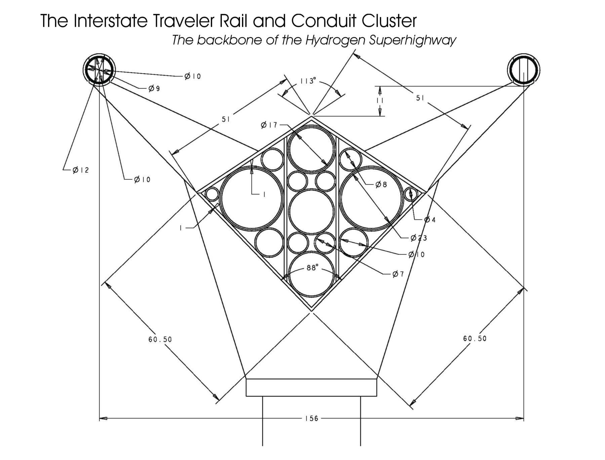

ITC Rail Switch
The method of switching is based on a sliding table that will automatically line up rail pairs. As can be seen in the illustration below, this switch table shows three positions which can be described as follows:
Position 0 = Mainline
Position 1 = Subnet on the right
Position 2 = Subnet on the left
The subnet switch table is set just above the central support housing the conduit cluster. The switches are operated using TCP/IP protocol. The switch tables employ sliding counterbalance to eliminate torque from rail pairs overhanging one side or the other. Further, the proper counterbalance ensures the greatest efficiency in opening and closing the switch. The switch table is made from simple magnetic bearing guideways like giant drawer slides, that are mounted horizontally and perpendicular to the rail in the 11 inch high plane above the central support and below the tubular rails. The switch is optimized to open or close less than 3 seconds.
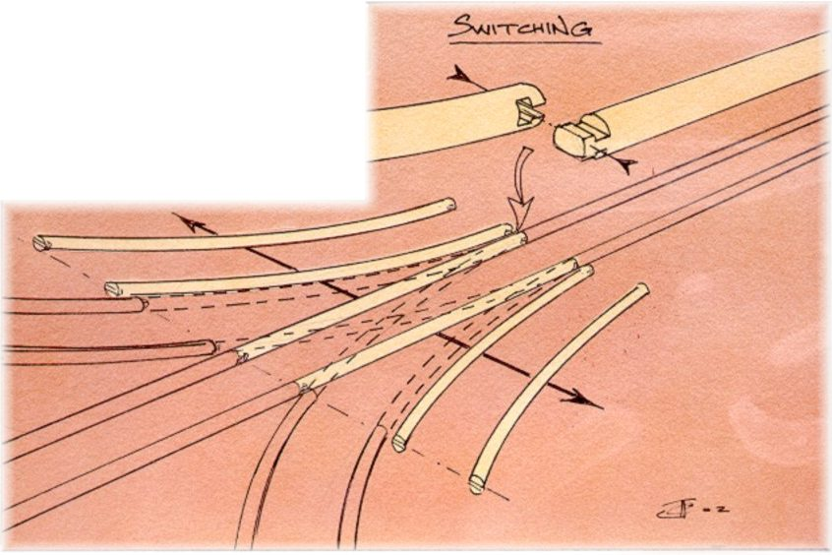 | 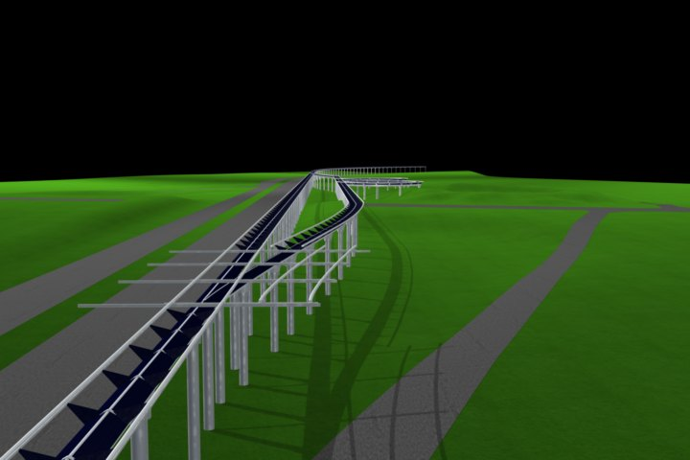
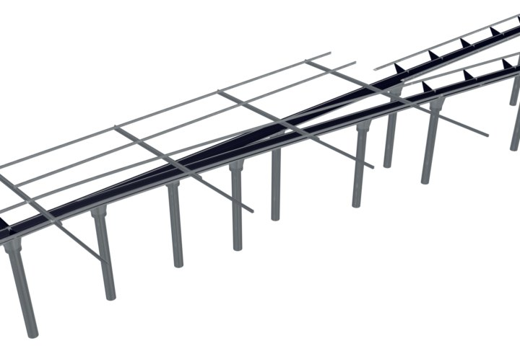 | 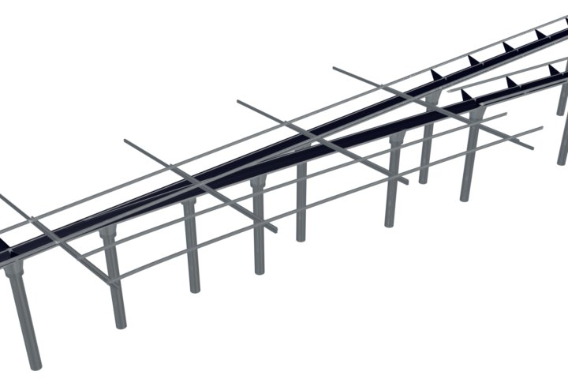

Central Support Conduit Cluster and Utility Substations
The Central Support of the ITC Rail is the structural box beam housing for the Conduit Cluster. The top of the Central Support provides the surface area for photovoltaics (PV). The top surface area is eight feet in width, therefore assuming 8 square feet of PV per lineal foot of rail. Thusly, 5280*8=42,240sqft of PV per single mile of rail. However, all construction estimates assume the installation of parallel tracks to provide simultaneous two way travel, which yields 84,480sqft of PV per mile of ITC Rail installed. Based on 10 watts per square foot at peak time, each mile of rail will produce about 844,800 watts of electricity per hour at peak time. An installation that is 100 miles long would therefore produce about 84,480,000 watts per hour at peak time, or roughly 84 megawatts per hour peak time. Essentially, a 100 mile long installation supports slightly more than 8.4 million square feet of solar cells.
The Utility Substations are installed at regular intervals and provide for pumping stations, pressure regulation, electrical conditioning and load balancing, electrolysis production of hydrogen and oxygen, hydrogen fuel cells generating electricity and pure water, storage for water, hydrogen and oxygen, fiber optic switches, wireless network access points, satellite uplinks, environmental sensors, electrophoresis liquid waste processing, high intensity ultraviolet radiation exposure to liquid waste to kill viruses and bacteria, data redundancy computers and municipal taps for local access to services.

For further light on the sanitizing properties of ultra-violet light, you may examine the following source: http://hps.org/hpspublications/articles/uv.html

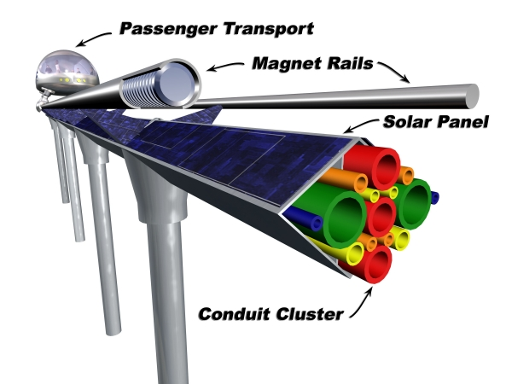 | 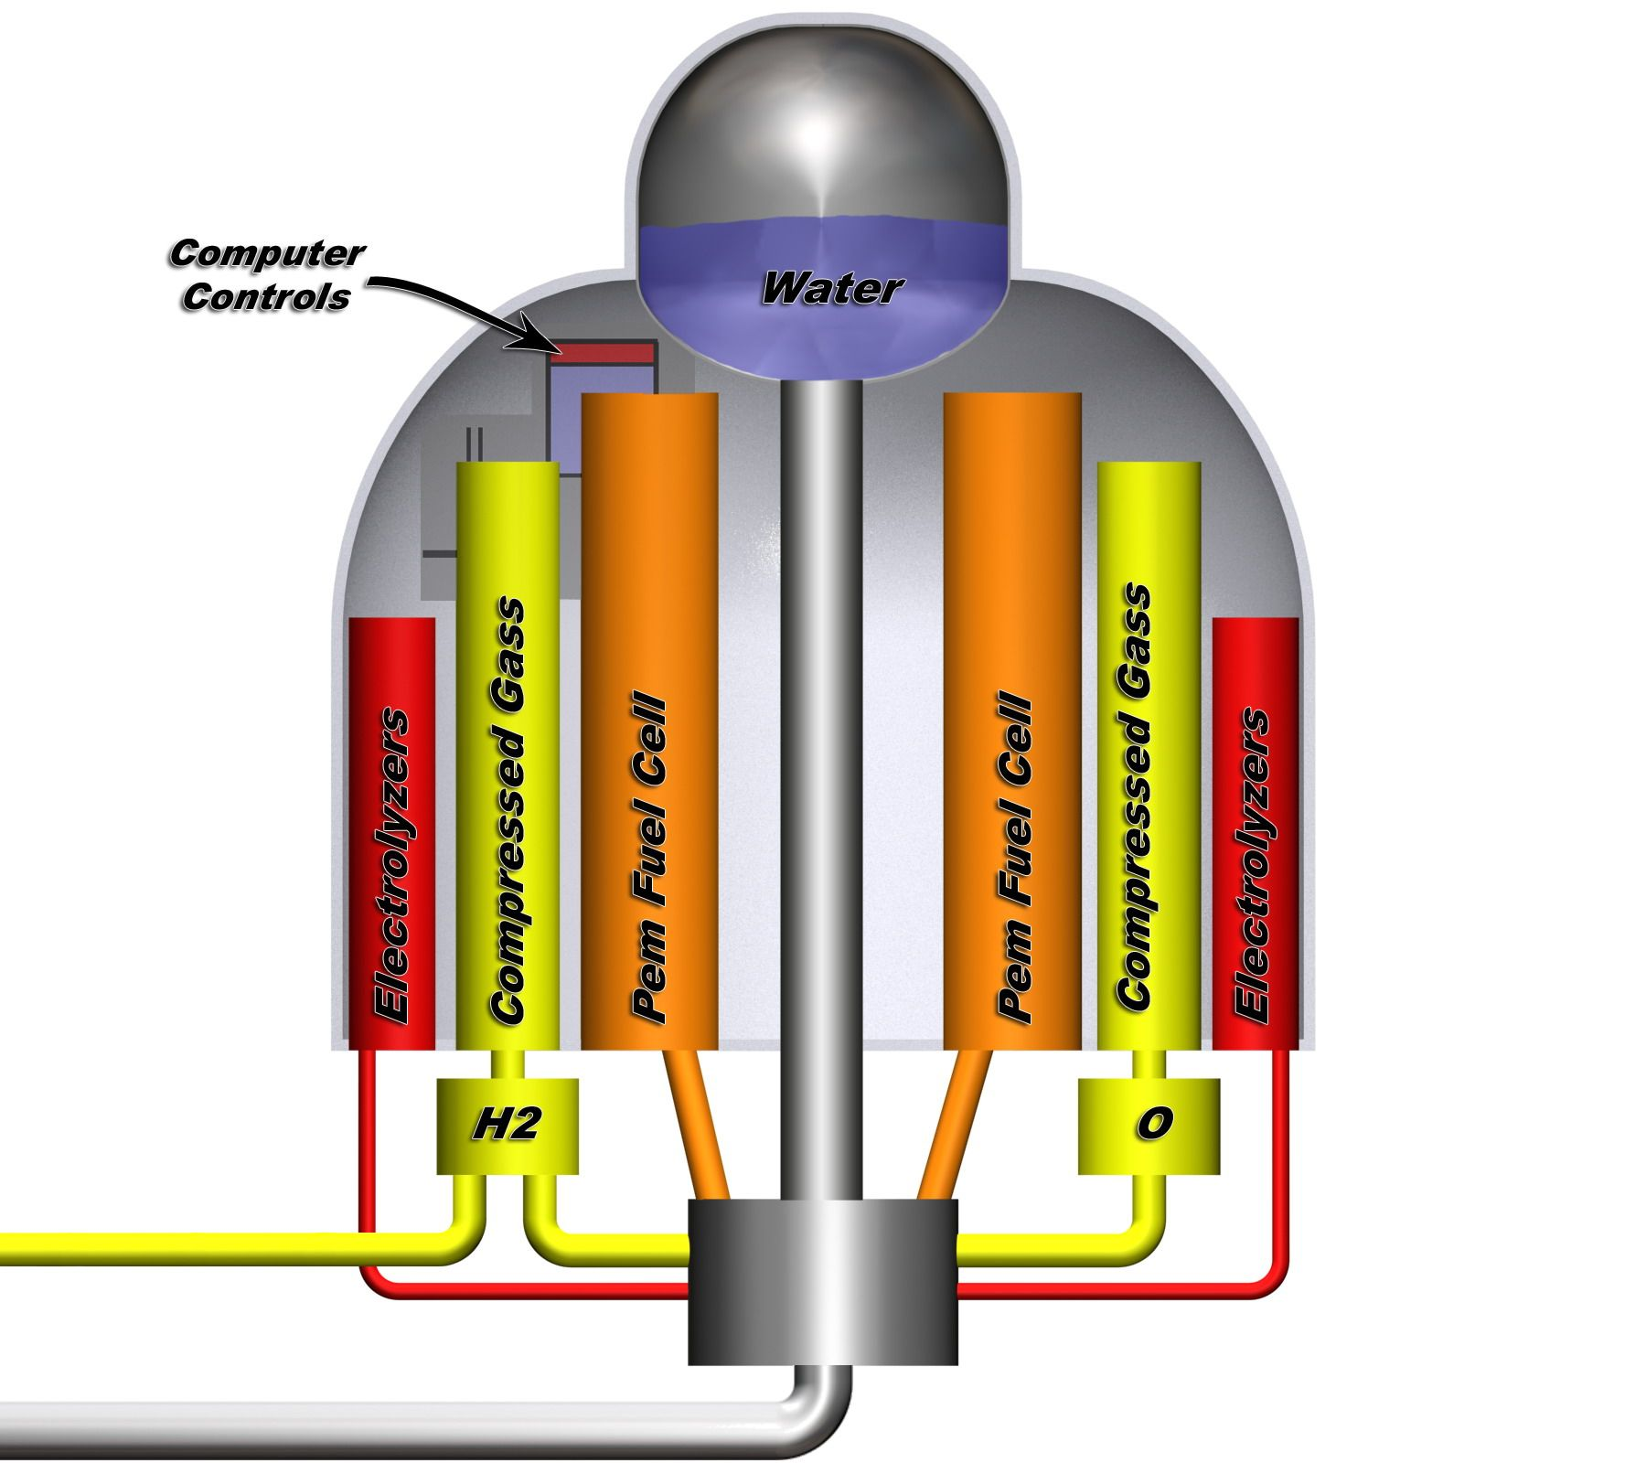

Connector Plate
The Connector Plate is used to connect sections of ITC Rail together into a rail segment and to facilitate a plug and play system allowing the immediate removal / replacement of any rail section or connector plate anywhere within a rail segment without disruption of services to the other rail sections unless the disconnection completely separates a rail segment from a utility substation. The Connector plate hosts a collection of cylindrical devices that fit inside of the conduit embedded in the conduit cluster, and when the rail conduit cluster and connector plates properly assembled, the cylinders will be inserted into the fore and aft conduit exactly 8 inches respectively. Each cylinder is wrapped with a threaded sleeve that is used to compress an o-ring to seal the assembly and provide flexibility. The Connector Plate supports each cylindrical device providing the capability to move each device along its axis so that the connector plate can displace each cylinder so as to free either fore or aft rail section so that it may be lifted out and replaced. The action of sliding the cylindreical divice more than the standard 8 inches into a conduit to free an adjacent section causes gases and fluids to be pressed backward into the network to the nearest Utility Substation where suitable fixtures are in place to compensate. This process is only applicable to fluids that are not compressible. The Cylindrical devices are suggested to be 44 inches in length, where the center 10 inches is supported in the thickness of the plate, and 17 inches protrude both sides. The Cylindrical devices should also act as linear motors to enable position control perpendicular to the plate. The Cylinder should be able to move enough in either direction in order to facilitate the extraction of a rail section, considering the requirement of one or both of the connector plates at either end of a rail section. The Cylindrical Devices service fluid and vapor conduits as well as host fiber optic bridges, fiber optic laser repeaters, and fusible links for the electrical distribution network.
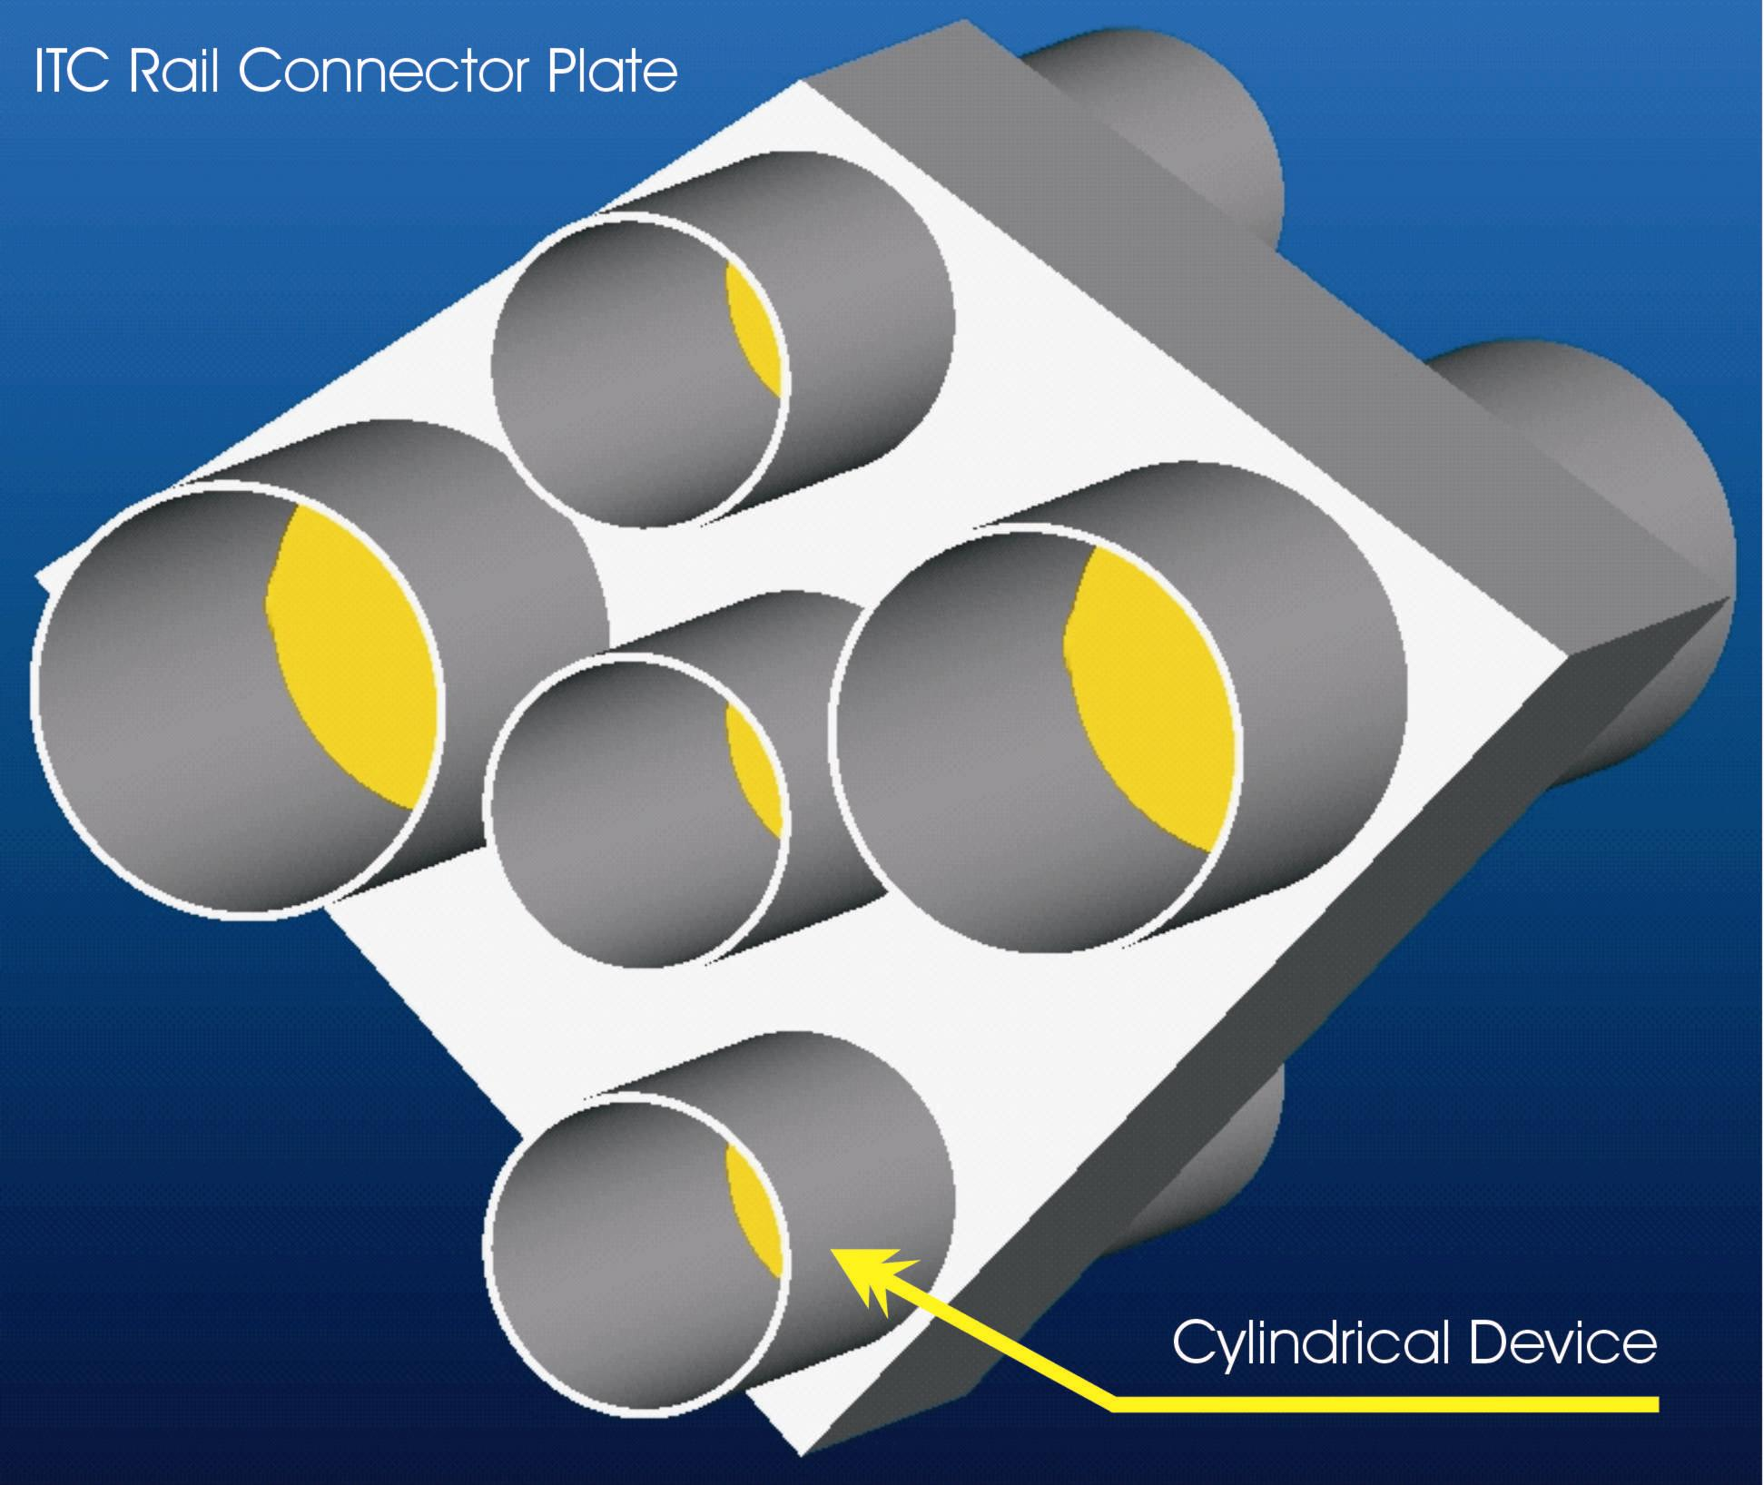

ITC Rail and Connector Plate Interaction
The interaction of the Rail and Connector Plate are that of a cylinder and sleeve assembly that can be assembled and disassembled without disrupting the functionality of adjacent rail sections which remain attached to the network. The cylinder / sleeve assembly is designed to facilitate enough tolerance that two rails can be slid apart to free the one connector plate and/or two connector pates and be slid apart to free a section of rail. This is accomplished by the existence of a space between each rail section wherein a connector plate supporting an array of cylindrical devices is employed to bridge the conduit from section to section, and a 28 inch rail tube connectors bridge the gap from rail tube to rail tube. The cylindrical devices are design to provide movement of each rail section in either direction. As each section is installed from stanchion pole to stanchion pole, the connector plate will be placed between each section with the cylindrical devices inserted into the both rail sections exactly 8 of the 17 inches leaving an additional nine inches of travel for two rail sections to slide apart a total of 17 inches travel from their combined movement to release a connector plate. Also, the actual “Plate” is optional and is only intended to speed installation, yet it may be more practical for maintainence purposes to install each two-piece cylindrical device one at a time to facilitate easy replacement of individual components without disrupting the entire conduit cluster.

ITC Rail, Connector Plate and Stanchion Pole Interaction
The ITC Rail is designed to connect to the stanchion pole by resting in the flared V-shaped capital of the stanchion pole, where pair of guide pins limits the movement of the rail sections longitudinally by the length of the slot cut in the bottom two sides of the central support. The Connector Plate is designed to float freely between the rail sections. A cover plate is used to bridge over the space between the two rail sections to cover the connector plate and servers to lock the two sections of rail together with large machine screws. Some stanchion poles are made from the Central Support of the rail without the support arms and rail tubes which serve to provide connecting conduits to a Utility Substation, where these can be setup as direct T connections, or in parallel to provide either one way or two way conduit between the rail and Utility Substation.

ITC Slotted linear motor and magnetic levitation nacelle
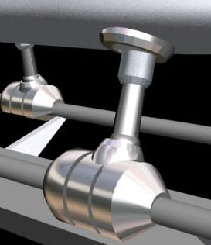
The Interstate Traveler Company slotted linear motor nacelle is designed to provide an adjustable levitation gap and linear position control between the coils in the nacelle and the coils in the rail, where the nacelle wraps around the rail leaving room for the support arms that hold the rail above the conduit cluster. Each nacelle works independently of the other nacelles for the maintenance of levitation gap and position control, yet are linked with the other nacelles via the G-Force compensator which measures G-force by the displacement of a pendulum, which displaces position control sensors directly linked to the suspension system. The G-Force Compensator provides automated load balancing to optimize nacelle collaboration in the positioning, acceleration, deceleration, emergency breaking, neutral glide, of a ITC Transporter on the rail.
As the actual amount of energy required to maintain a specified levitation gap, the maglev electronics automatically provide real-time load values down to fractions of a pound. Essentially, the ITC Rail has a built in scale that is highly accurate and measures in real-time.

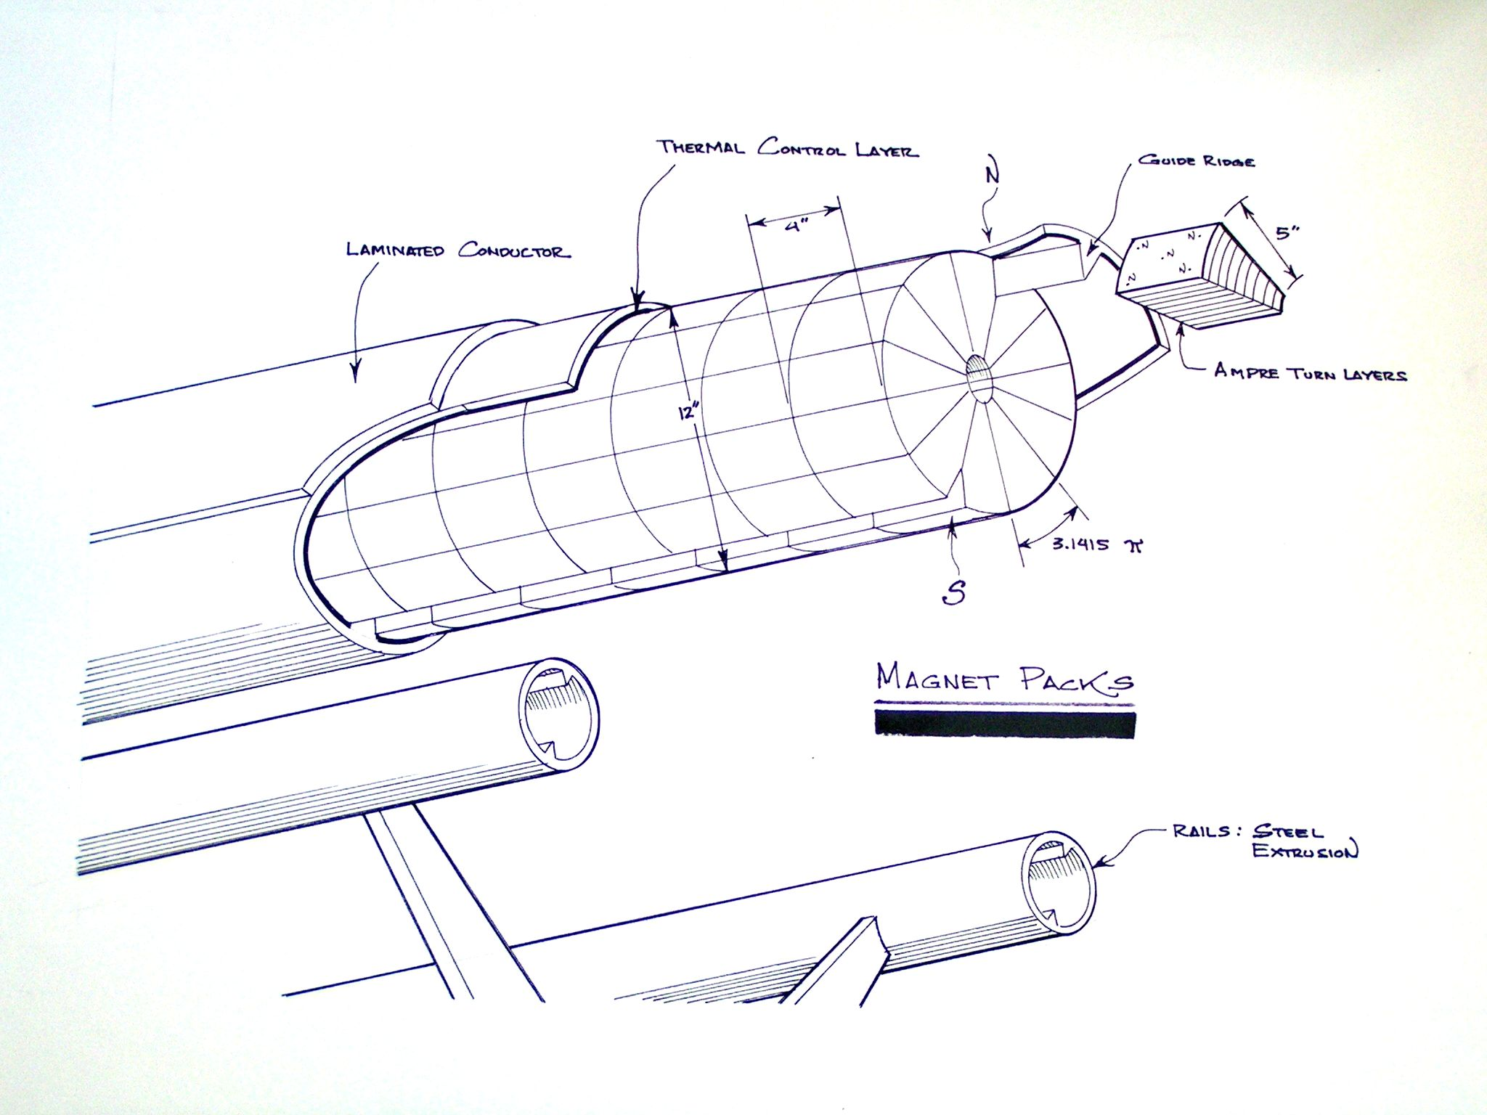 | 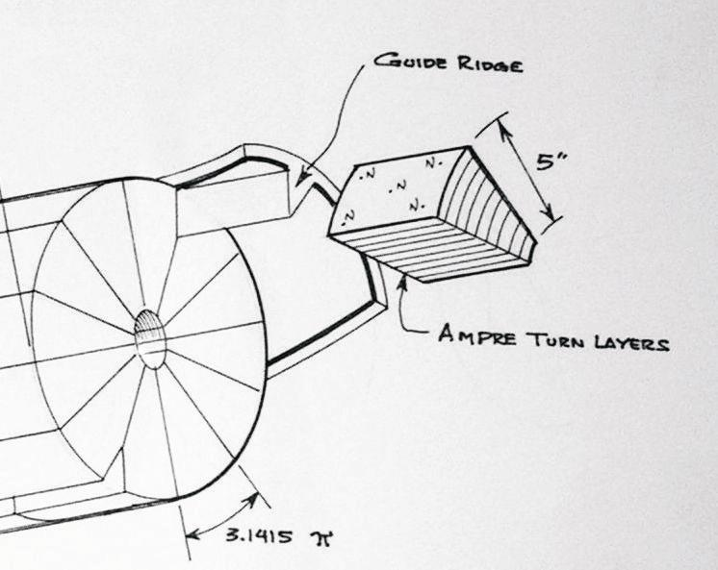

ITC Rail Slotted Linear Motor Detail
The ITC Linear Motor Nacelle affords maximum field generation and control by increasing the density of solenoids per square foot of surface area employed for magnetic levitation and position control, i.e., the surface area of the tubular rails and the internal surface area of the linear motor nacelle. Each individual coil is individually controlled via IP address managed under a centralized addressing system such as the Internet DNS system. Each individual coil benefits from a unique identifier such as the MAC address layer in the Internet TCP/IP protocol. Each individual coil is energized by a rheostatic control enabling a polarity change by switching direction of current through the coil and zero to max voltage, with enables the creation of complex magnetic field interactions, further enabling the creation of a traveling wave of flux field intensity that can be propagated longitudinally and circumferentially enabling levitation gap and position control. Position control and levitation is enabled by the variation of flux field intensity, and the motor can actually clamp down onto the rail by reversing the appropriate group of coils. This “grabbing” ability of the motor is further capitalized upon by the ITC Rail Plane articulated nacelles that open and close to enable the ITC Rail Plane to take off and land from any location on the rail.
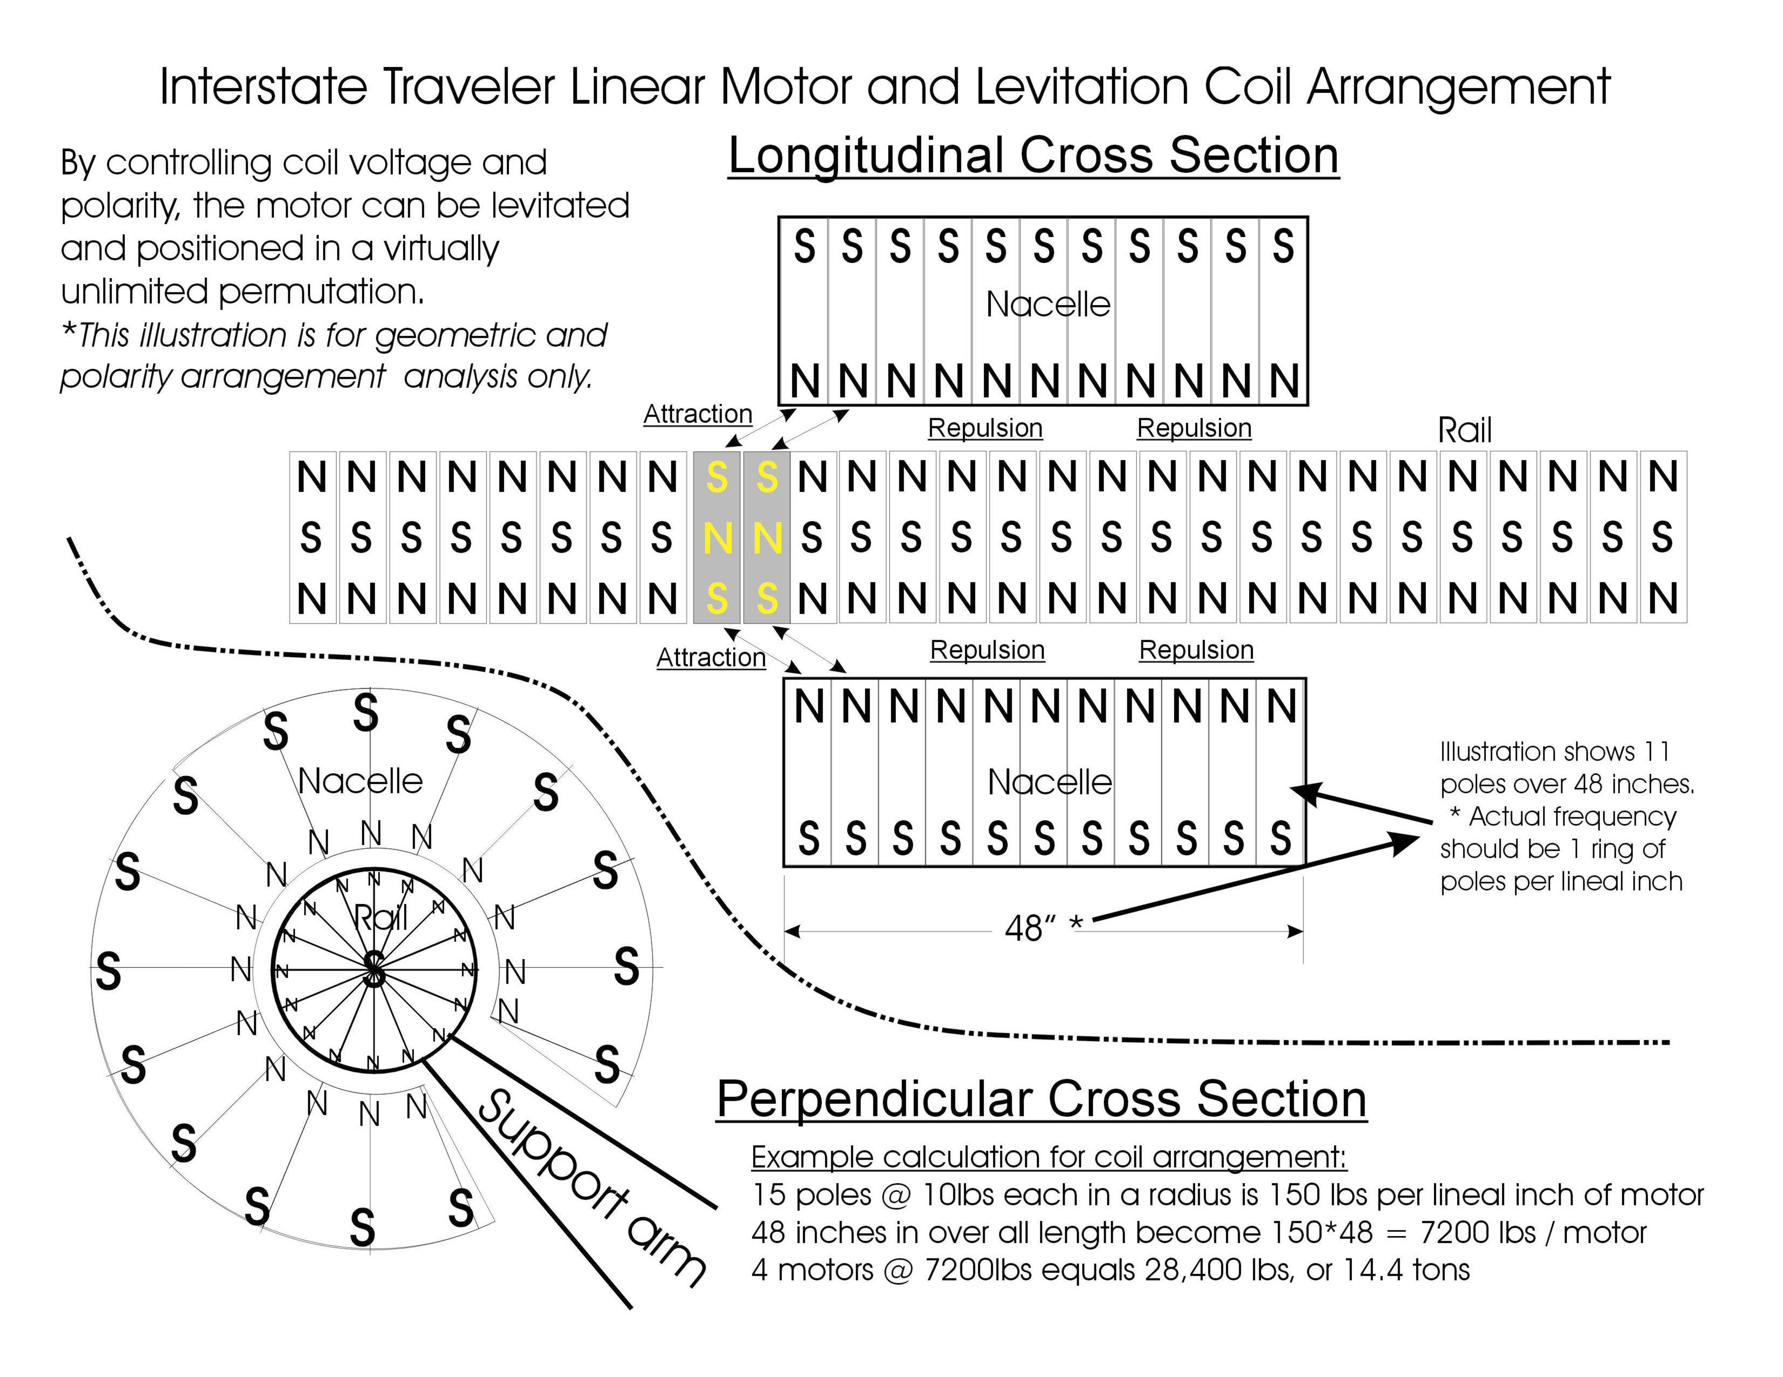

ITC Coil Density Plan
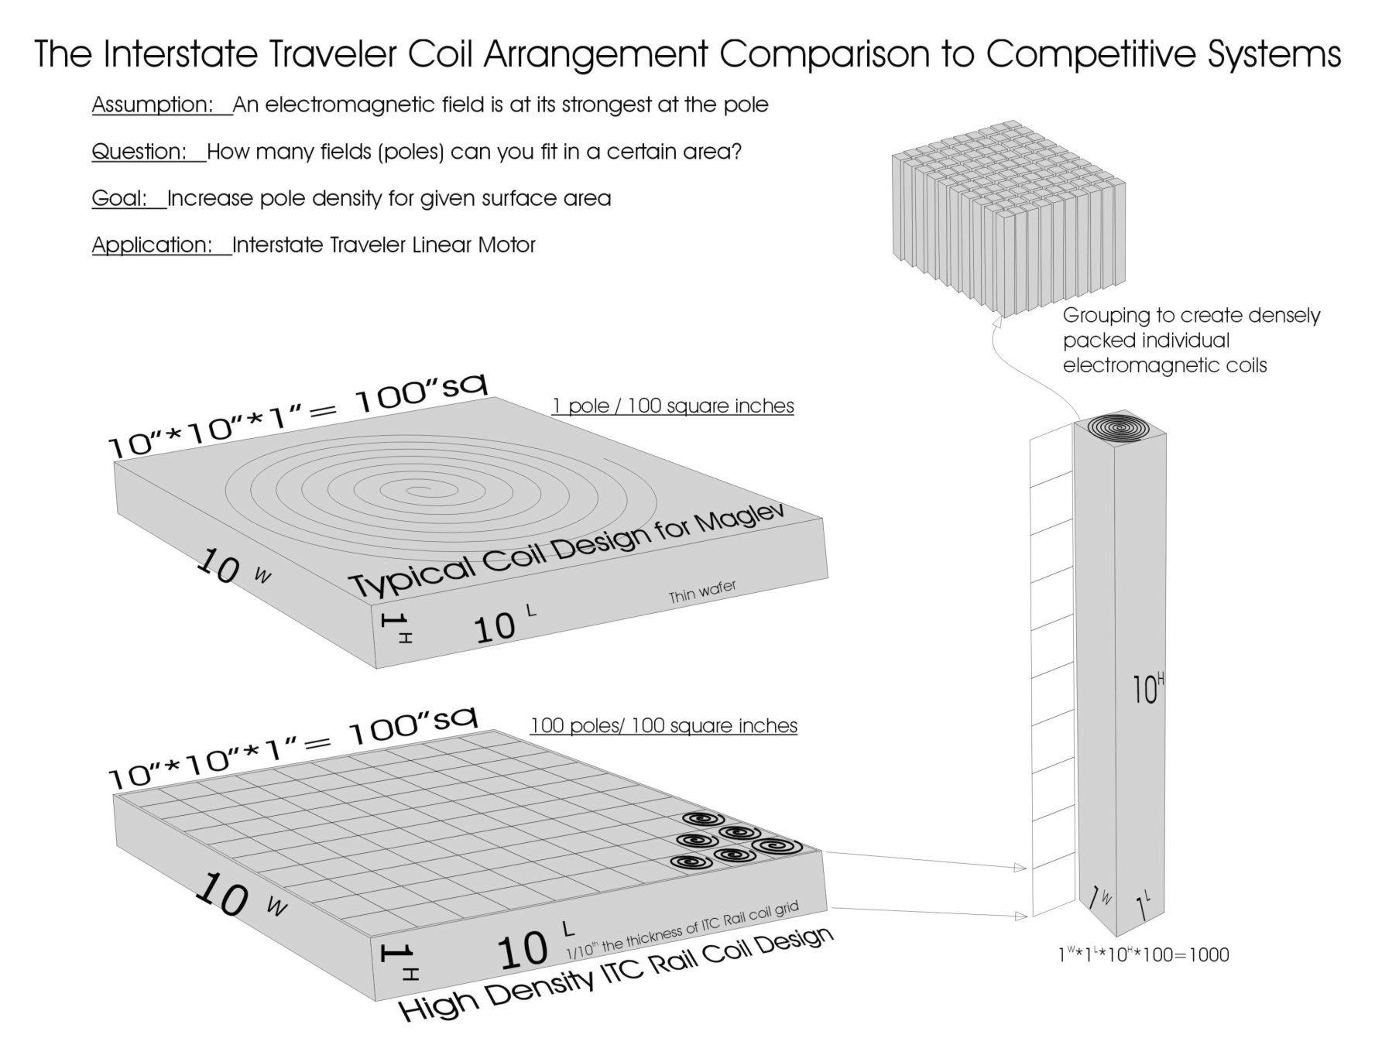

ITC Radius Study
This example of the ability to operate on a 60’ turning radius or smaller.
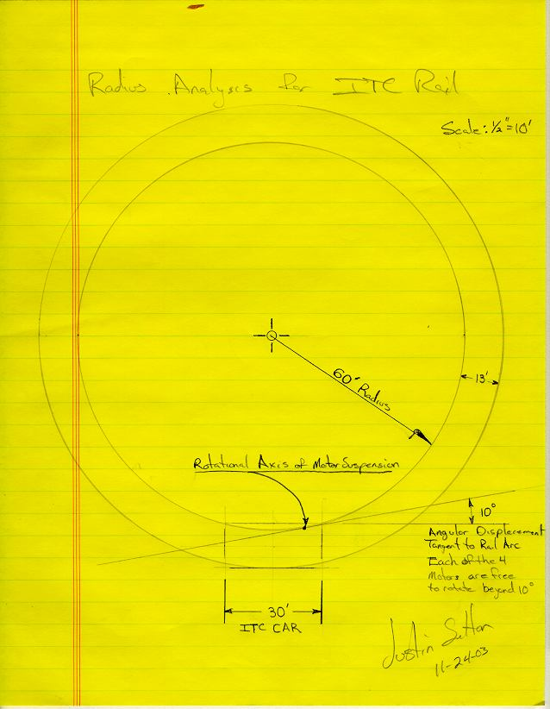

ITC Transporter Suspension
The Interstate Traveler Company Transporter Suspension System is designed to provide roll, pitch and yaw attitude control to enable the optimization of vehicle aerodynamics to enable each transporter to benefit from the efficiencies gained by aerodynamic lift. The suspension system is comprised of at least two slotted linear motor nacelles, each connected to the ITC Transporters via a ball joint articulated suspension arm which exhibits a linear extension and contraction characteristic to change its length. The suspension arms are mounted in such a way that the ball joint acts as a universal fulcrum, and where the portion of the suspension arm that extends beyond the ball-joint-fulcrum into the interior of the Transporter is mounted to three or more linear position control devices that connect the end of the suspension arm to the transporter which provides conical position control of the suspension arm. Each suspension arm and nacelle being enabled to rotate axially independent of other nacelles and suspension arms so as to provide the ability follow curves in the rail.
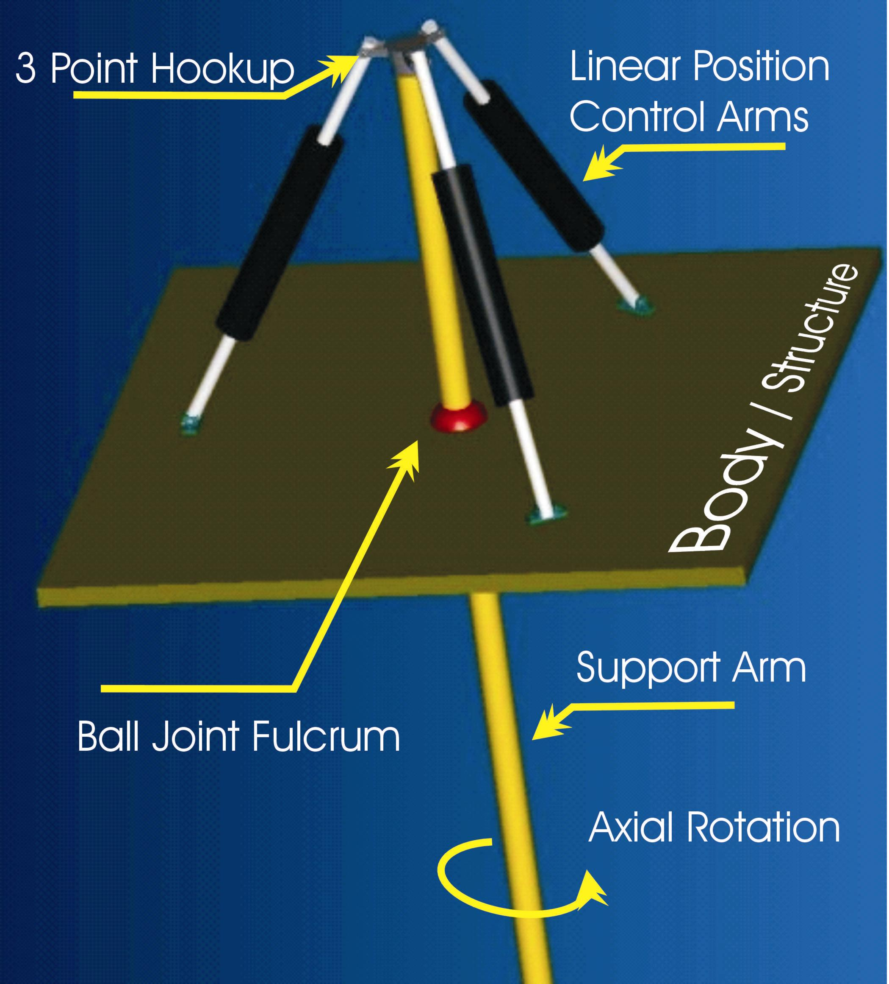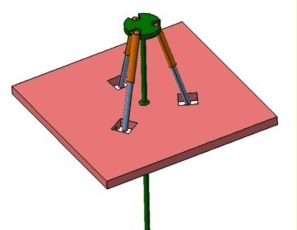
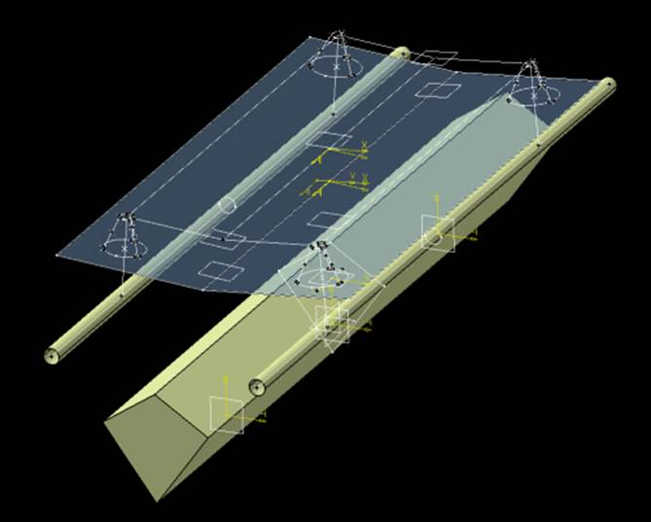

The G-Force Compensator
The G-Force Compensator is a real-time attitude control system designed to instantly translate kinetic forces into adjustments in the suspension system. The mechanical characteristics of the G-Force Compensator are nearly identical to the suspension arms yet are ideally situated with four linear position control devices. As the vehicle accelerates, decelerates or banks, the g-forces that act upon the pendulum are directly translated into the ITC Transporter Suspension System to maximize passenger comfort. The employment of the G-Force Compensator essentially adjusts the transporter’s suspension system so that the g-forces experienced during travel are as perpendicular to the floor as possible, which may allow for the placement of everyday objects on a table in an ITC Transporter, where the object on the table will not slide around during the operation of the Transporter.

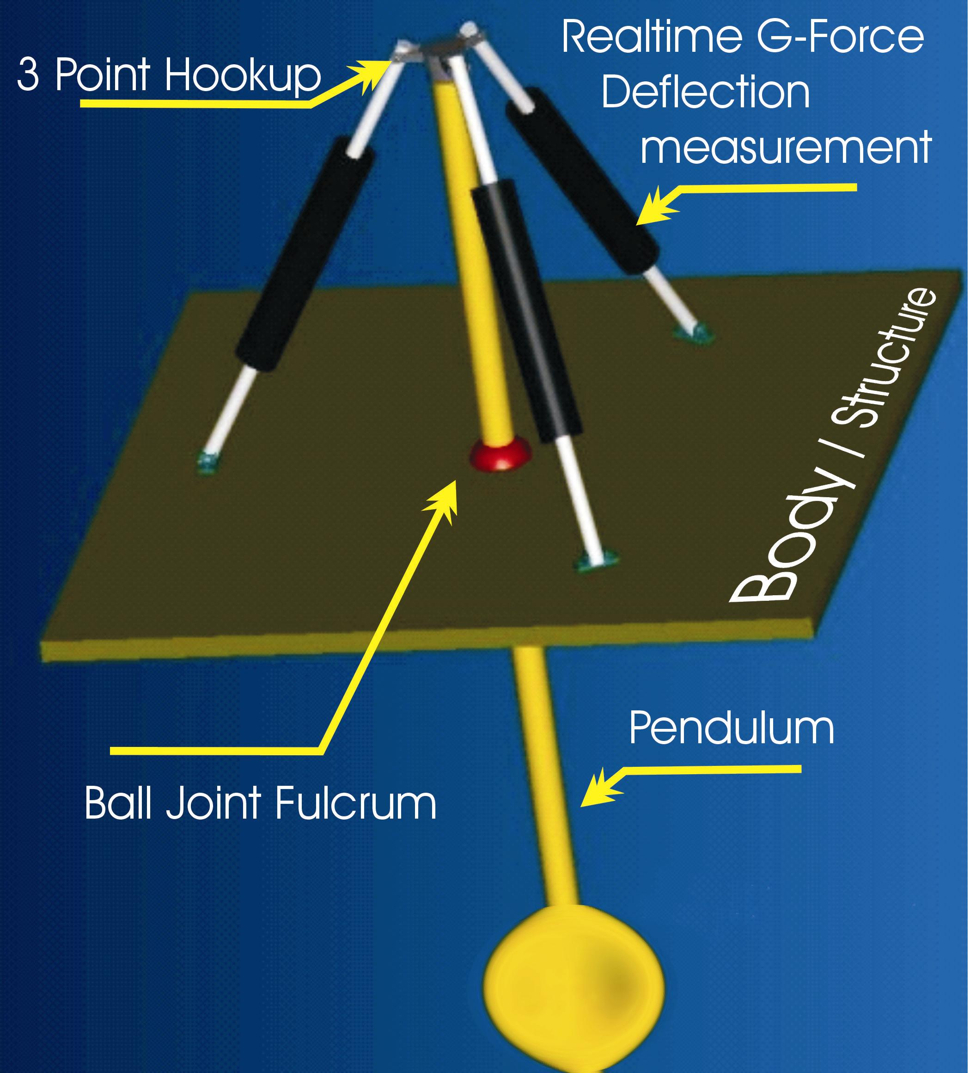

ITC Rail Assembly Process
The ITC Rail Installation Process employs specially designed equipment such as the 180 crane with counter balance to install stanchion poles, connector plates and rail sections. Supply cars are created to suit the distribution of stanchions, pile driving accessories, cutting and welding, concrete, rail sections, and connector plates, along with a service basket attachment for skilled trades, inspections, etc.
Rail installation process is targeted at beginning average of one section of rail per hour. Based on expected production rates of 200 sections of rail per day per factory we would expect to employ no less than 8 installation teams such that there would be two going North, two South, two West and two East facilitating a simultaneous installation of parallel track heading in four directions. 8 Installation Cranes installing 1 section per hours yields 192 sections per day leaving 8 sections a day factory surplus. Additional teams of 8 Installation Cranes will be set up for each factory, or as needed to keep up with production.

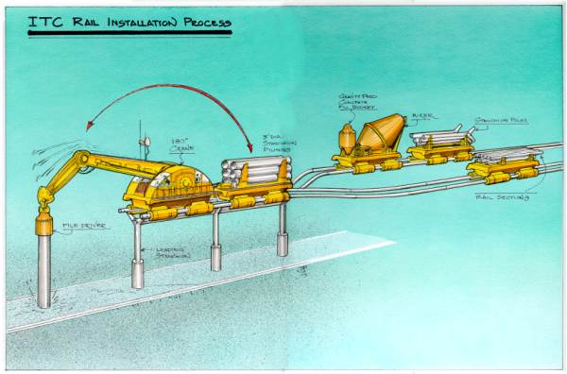

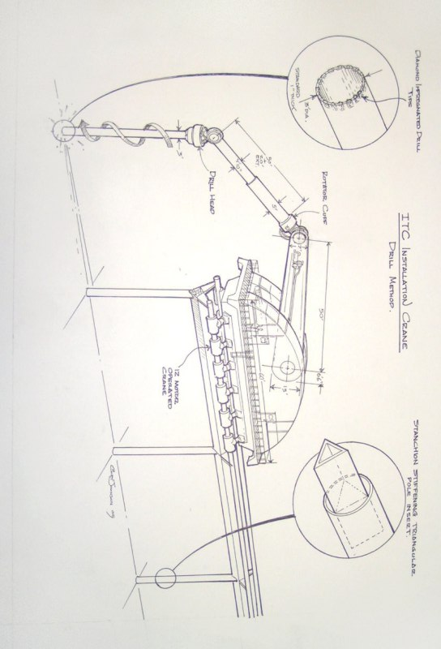

ITC Rail Pile Driver Apparatus

ITC Rail Pile Driver Apparatus employs 4000lb stackable pile caps to assist in the pile driving process by increasing the static load of the pile being driven. Heavier pile caps may be required to produce the desired effect.
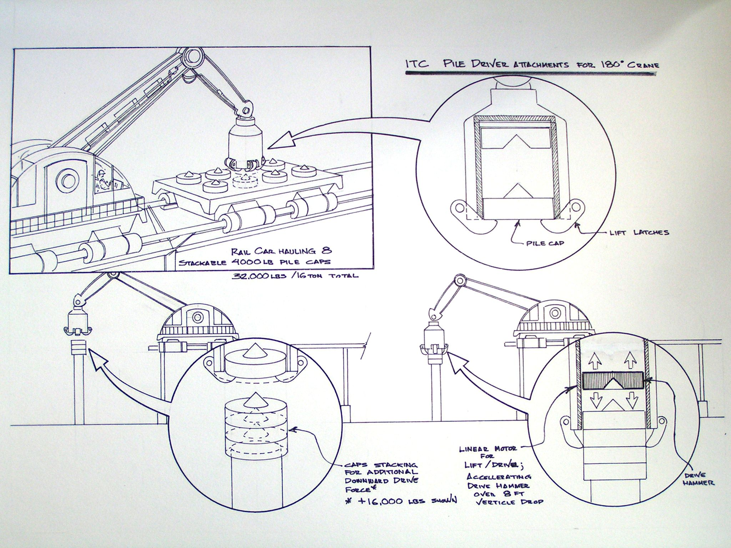

ITC Energy Cycle
Hydrogen Energy Cycle for the Interstate Traveler Project demonstrating the use of renewable hydrogen energy driven by solar power to energize electrolysis for the production of hydrogen and oxygen to power hydrogen fuel cells, (Proton Exchange Membrane) or PEM.

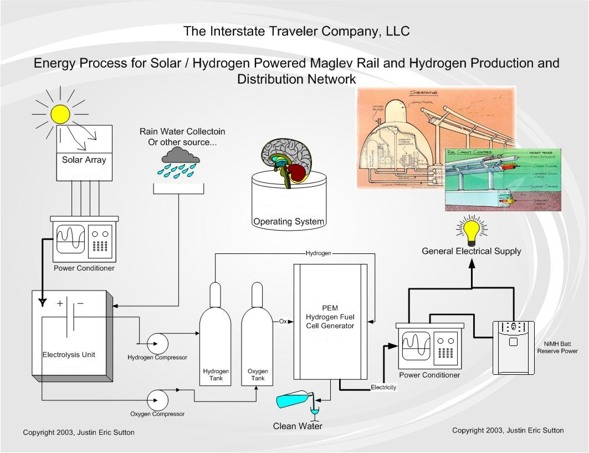

ITC TCP/IP Control Systems
The ITC Rail will provide an International addressing system for all ITC Transports, with the ability to expand the addressing system into other modes of transit external to the ITC Rail network, herein referred to as the ITC Operating System.
This document is entitled "TCP/IP Control System" to imply the architectural similarities between the ITC Operating System and TCP/IP. The ITC Operating System may or may not include dependency on existing TCP/IP code.
A common term in the public transit industry is Automated Guideway Transit (AGT). For the Interstate Traveler Project, our unique approach to AGT is designed to serve an unlimited number of transit vehicles and containers.
Our method of accomplishing the creation of a national AGT system is to employ a nested domain (Dendritic) addressing system running on a built in fiber optic network.
A "Domain" is a segment of a network perhaps best analogized with the branches of a tree so that a single great oak tree may have one primary domain "Trunk" where each of the main branches that grow up and out from the "Trunk" are unique individual "tree-like" structures or "domains" subordinate to the main tree "Trunk" (primary domain). This is a direct example of how the Internet is managed. For a more specific description of Internet Domains, please take a look at the following links:
http://www.internic.net/faqs/authoritative-dns.html
http://www.ntia.doc.gov/ntiahome/domainname/domainname130.htm
The basic components for the ITC Operating System are:
1. A fiber optic network
2. Radio frequency communications
3. A dendritic ordinal addressing system, where said dendritic ordinal addressing system serves routing, position control, sensor communications and component communications/control.
The ITC Operating System will conform to the Organization for Standardization (ISO) and the American National Standards Institute (ANSI) Object Identifier (OID) standard to insure globally unique object identities for all ITC Operating System functions and for all ITC Rail components. For a more specific description of OIDs please take a look at the following links:
http://middleware.internet2.edu/docs/a-brief-guide-to-OIDs.pdf
http://www.iso.org/iso/en/CatalogueDetailPage.CatalogueDetail?CSNUMBER=25774
Ideally the TCP/IP network that makes the Internet possible is an exceptional model of a dynamic network with built in tools for monitoring traffic and routing packets of data from one address to another over a truly global network which makes it possible to have real-time interaction between computers anywhere in the world. A national installation of the ITC Rail provides for a nationwide fiber optic network with real-time access to sensors for data of all kinds from weather information to demand on services, from remote control of critical components such as heat and light to the speed of each ITC Transport. Another analogy to a less complicated network system called x.10 typical "Smart Home" technology available at your local home remodeling superstore. http://www.smarthome.com/
Therefore, the comparison with TCP/IP technology with the ITC Operating System protocol is ideal for many reasons. For a typical definition of what TCP/IP is click here.
Each ITC Transport will have its own unique address (object identifier) and each section of ITC Rail will have a unique object identifier that will provide position control and routing logic on the network and act as a gateway for each Transport. The great features of a nested domain system allows for a new IP Domain for each rail sub-network. For instance, a shopping mall would have it's own "Domain" with a series of address within that Domain allowing for individual addresses unique to the shopping mall’s Domain.
A Domain can also be analogized to the "Area Code" used in telephone networks so it becomes obvious that a telephone call with a 212 area code will be a call to New York City.
All of the existing communication services, tools, monitoring and security programs currently in use on the Internet for the regulation of communications of electronic data, will have a directly analogous component on an ever expanding public network rail system. From "Fire-walls" for private rail networks in commercial, residential and military districts, to video telephone technology.
The Internet has proven the concept of constantly improving efficiency and speed in completing processes and moving data using the TCP/IP communications protocol and the ITC Operating System will use the same basic ideas to improve the efficiency of public transit for the entire United States.
We intend to capitalize on the principle successes of the Internet and apply them to the mass transit of people, and the raw goods of industry.
When ever an ITC Transport moves within a public, commercial or private rail network Domain, the system knows the relative position and speed with the ability to calculate a route to get from where it is to any place on the network based on security authorization.
The entire ITC domain system will have master root controllers that monitor forests of domains and sub-networks. These master root controllers will be protected in the same manner as the Internet Root controllers are protected by the federal government.
Naturally each device on the system will have full access to outside network resources as part of the service, but private networks can still exclude access from outside.
As an example, the following table lays out the basic scheme for addressing for ITC Rail Transports. As described above, each Transport will operate within network domains allowing the routing logic to determine point of presences at all times which is used to calculate a route to a destination domain such as a shopping mall or sports arena. The following table demonstrates the simplicity of a substitution table that represents the structure of determining location on the network with a numerical value. This numerical value much like TCP/IP represents a nested address system where the first ordinal (Country=124=USA) the second ordinal (State=48=California) the third ordinal (County=17=LA County) the fourth ordinal (City=6=LA) and the fifth ordinal (Traveler Station=35) provide a universally resolvable addressing system for the entire network. With the ability to automatically increase the number of ordinals beyond the 5th as demonstrated here yields the ability to easily manage a network of any size and complexity.
Country.State.County.City.Station | 1st . 2nd . 3rd . 4th . 5th
USA.California.LACounty.LosAngeles.TravelerStation | 124.31.17.6.35
USA.Nevada.Clark.LasVegas.TravelerStation | 124.36.14.2.14
The following references are links at the Institute of Electrical and Electronics Engineers who are leading the field in Intelligent Transportation Systems as well as links to the ITSA and others to help shed more light on the topic:
http://grouper.ieee.org/groups/scc32/ddmins4feb.html
http://grouper.ieee.org/groups/scc32/Attachments.html
http://www.itsa.org/
http://www.ewh.ieee.org/tc/its/trans.html WhitePaper?
http://www.rtnetworks.com/tcp.htm
http://web27.p15156948.pureserver.info/w2k/adswp.htm "Nested Domain"

Appendix B – Statement of Work

SOW - Statement of Work
The University will engage all means at its ready disposal to validate the technology proposed in Appendix A, to include but not limited to

Structural Engineering
Electrical, Electronic and Electromagnetic Engineering
Finite Element Analysis
Computational Fluid Dynamics (Virtual and Real Wind Tunnel)
Metallurgy
Advanced Math, Physics, and Chemistry
Database Design
Socio-Economic Impact Analysis
Environmental Impact Analysis
Solar-Electrolysis / H2O / Proton Exchange Membrane energy cycle
Electromagnetic linear propulsion and levitation
Socioeconomic impact of national transition from fossil fuel to hydrogen
TCP/IP styled addressing system for transit routing and component communications
Security, Quality, Safety and ADA accommodation.
Mass production optimization
Affiliation with leading Scientific Standards Organizations i.e. ISO, NIST, NSF
Various additional material sciences

The University and ITC agree to collaborate and cooperate to achieve the goals outlined in the following timeline, and to collaborate with other Universities within their areas of expertise to enable specific ITC technology to be scientifically proven through simultaneous study.

Time Line
30 Days-

60 Days-

90 Days -

120 Days -

150 Days -

180 Days -

210 Days -

240 Days –

270 Days –
300 Days –

330 Days –

360 Days –

Project Team
The Project Team is comprised of the following individuals and companies as affliated with either University of Michigan or ITC.

University of Michigan
List Team Members Here

ITC Board of Directors
Founder and Managing Partner --- Justin E. Sutton

Chairman of the Board -- Dr. Timm J. Finfrock

CEO The Chief Executive Officer --- Open Chair

CFO The Chief Financial Officer --- Open Chair

CCO The Chief Communications Officer --- Lark L. Samouelian

CLO The Chief Labor Officer --- Tom O’Rourke and Gary M. Wellings

CTO The Chief Technology Officer --- Ted Nichols

COO Chief Operations Officer --- Jack Salo

CCH Chief Company Historian --- Open Chair

CIO Chief Information Officer --- Michael Galella

Senior Advisor -- H. Frank Sutton

Director of University Relations -- Ray Fullerton

Board of Presidents
Senior Vice President, Asian/American Academic Relations
--- Zixiang (Edward ) Xiong

Senior Vice President, Geological Sciences
--- Li Zhang

http://www.interstatetraveler.us/OrgChart.htm

Appendix C – Reference Letters
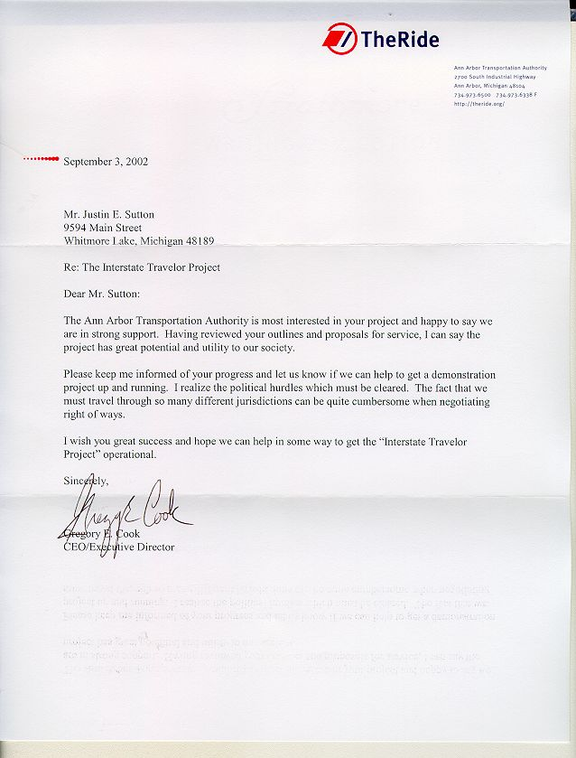
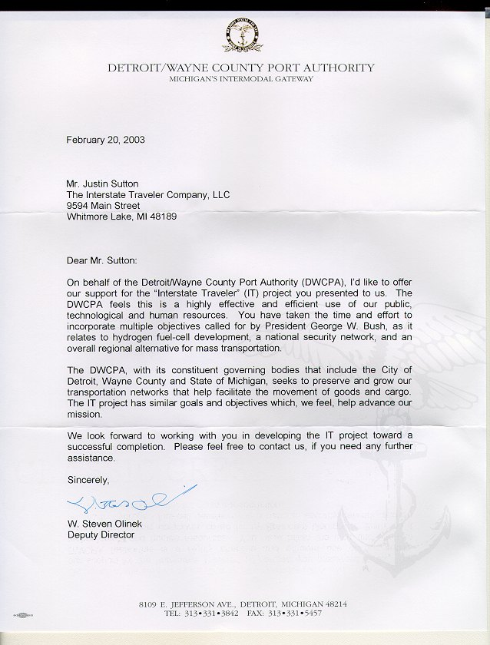

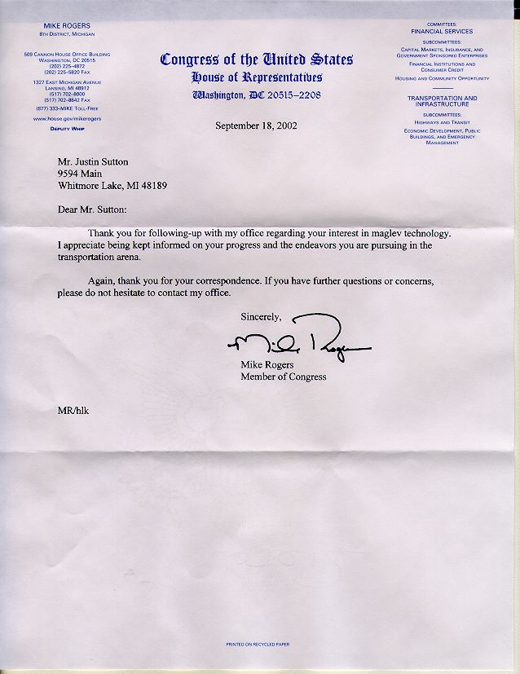

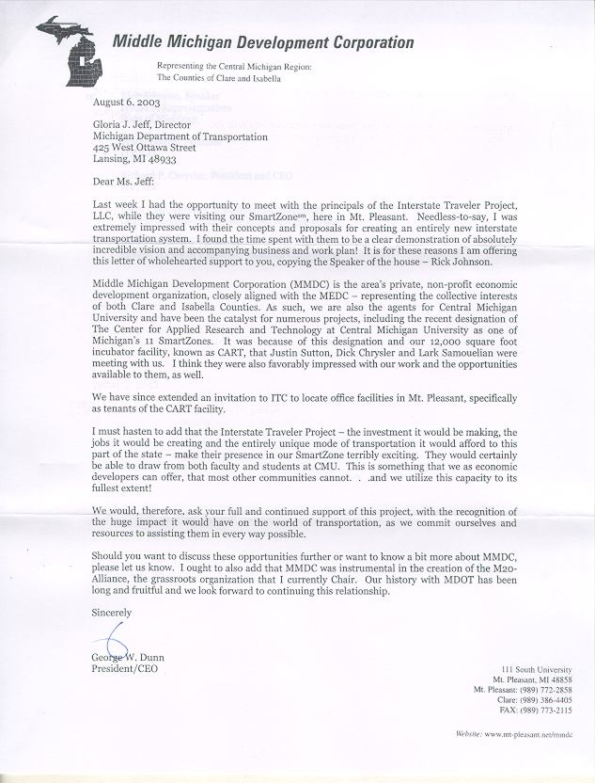



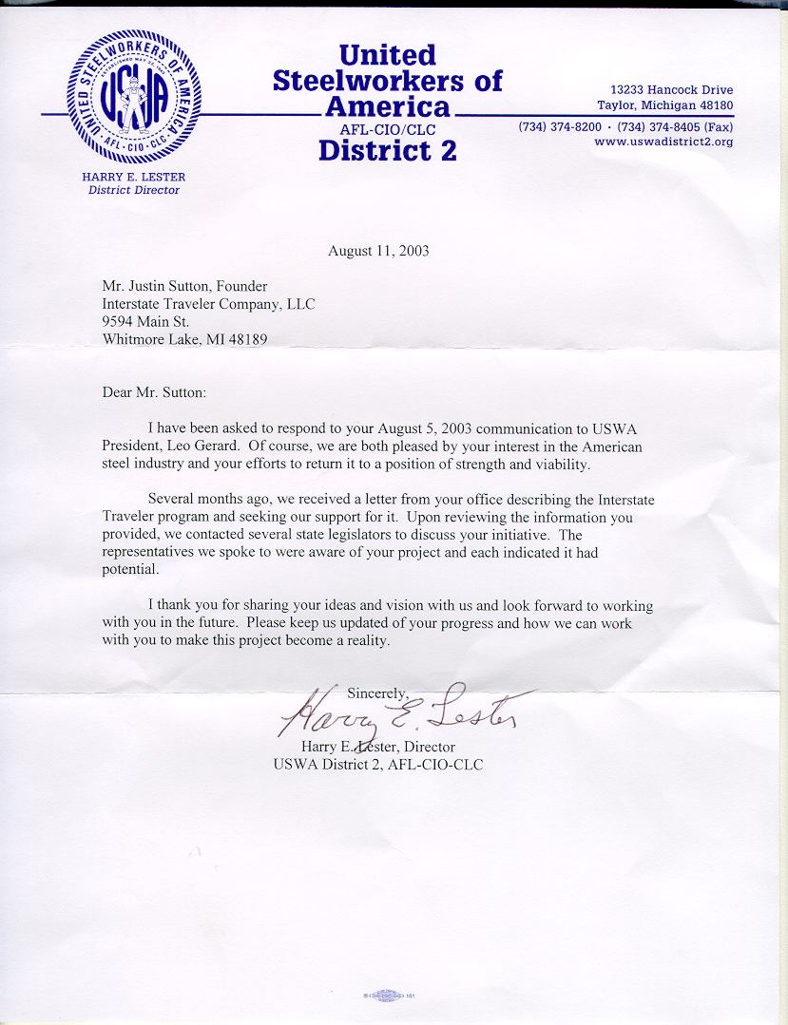

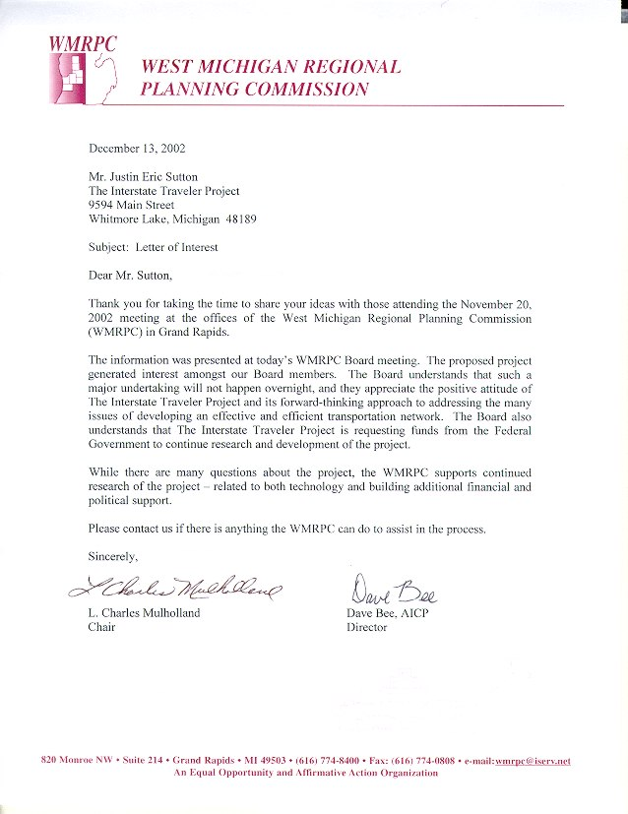

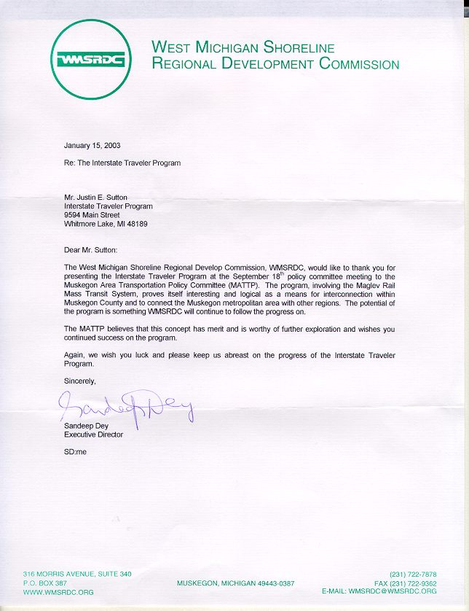

Appendix D – Legislative Support


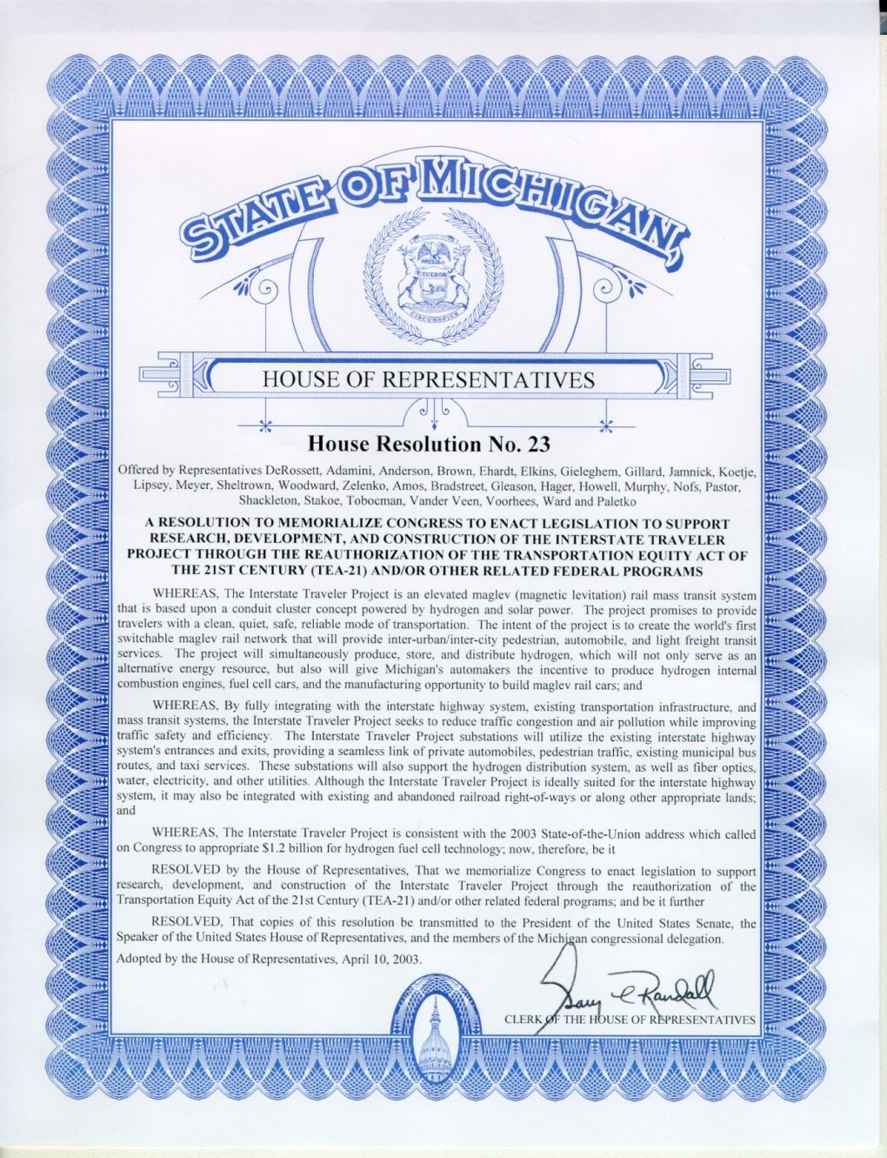

Appendix C - Interstate Traveler Nomenclature
ITC Rail refers to the entire system of systems that make up a functional installation of rail with necessary controls, conduits, substations, traveler stations, transports, et.al,
Conduit Cluster refers to the central support rail that contains a structurally integrated cluster of conduits for a multitude of services such as the piping of fluids and gases, fiber optics, and electrical conductors, etc, where said Conduit Cluster is laminated with photovoltaic material for the daily collection of energy.
ITC Rail Section refers to a premanufactured section of rail that is 60 feet long comprised of a Central Support housing a Conduit Cluster, which supports a pair of cylindrical rails that house magnet packs that facilitate the linear motors of the ITC Transporters.
ITC Rail Segment refers to any set of Sections connected to a Utility Substation
ITC Rail Connector Plate refers to the device used to connect each prefabricated ITC Rail Section together, which also facilitates real-time flow control and flow monitoring and acts to terminate flow from conduit in the event of physical damage to a rail section before or after the Connector Plate.
Transporter refers to any of the various purpose built maglev vehicles that ride the rail
Utility Substations refer to the utility management structures built every 5 miles along the rail that provide housing for redundant computer control systems, energy conversion devices, energy storage devices, and conduit taps for local municipal access. Ideally, the Utility Substations will be built within the cloverleaf interchanges along the highway right of way. A regular installation of ITC Utility Substations approximately every 5 miles to create a redundant automatic fail-over control system which insures the greatest reliability of the ITC Rail Conduit Cluster and Transporter system via load balancing of energy systems, local conduit tap distribution systems, liquid and vapor flow controls, and the redirection of the same where necessity may require.
Traveler Stations refer to those places where passengers will enter and exit the public transit Transporters that ride the rail.
Linear Motor refers to the type of motor that provides electromagnetic position control and/or levitation to facilitate the propulsion and suspension of all Transporters on the rail.
Mag-Lev refers to a state of the art magnetic levitation system as it applies to the Transporters and the suspension, propulsion and positioning systems thereof.
Magnet Packs refers to the electromagnetic devices that are built into the rails of the ITC Rail to provide the radial counter forces necessary to provide levitation/propulsion and position control working with the forces generated by the linear motors attached to the Transporters.
Nacelle refers to the entire assembly of a slotted linear motor that wraps around the rail, i.e. typical illustrations of the ITC Rail Transporters display four nacelles.
Electrolysis refers to the process of subjecting water to an electrical current which breaks water down into hydrogen and oxygen for use as required.
Photovoltaic (Solar Array) refers to any type of material that absorbs light / electromagnetic energy, to create electrical pressure used to power electrically dependant systems.
Proton Exchange Membrane (PEM) refers to the various types of materials and technologies that provide for the molecular recombination of Hydrogen and Oxygen molecules at a controlled rate where the combination allows for the employment of the electromotive force as the nuclei combine to form water.
Regional Director (RD) refers to any entity under contract with the ITC acting as the single point of presence in a delineated region such as a State or Province or Tribal Land, or Country, or block of the same, where said RD is entitled to commissions for sales, ongoing revenue and a commission for successful acquisition of investment capital.
Strategic Partner refers to companies under contract with the ITC to share business critical information and to share in the development of all the systems requisite to the construction of the ITC Rail who by demonstrating an initial investment of time, services, and/or other tangibles position themselves as a primary dedicated supplier.
Energy Storage refers to the storage of electrical energy and/or potential energy in the form of a battery which may include a multitude of storage methods such as metal hydride materials, lithium ion, zinc/air, and others with a primary focus on the environmentally perfect storage of energy in the form of a multitude of isolated hydrogen and oxygen reserves where the recombination of those gases create a measurable electrical potential via PEM recombination.
Virtual Prototyping refers to the common practice of engineering and testing engineered data in a computational environment where known material performances are input into a parametric database that permits a reasonably accurate computer model closely approximating the physical properties of an actual physical model to be tested under stress and forces generated by a computer, which in turn will provide a reasonably accurate failure analysis as compared to an actual physical model. The process is commonly referred to as Finite Element Analysis (FEA).
TCP/IP (Nested Domain Addressing System) refers to an addressing system that uses mathematically derived numerical designations in ordinal layers similar to the telephone system where the first ordinal set of numbers instruct the telephone switch which area the call is intended for, the second ordinal set gives you a more definite region within the area, and the forth ordinal connects you to the destination telephone device. Also very accurately analogized with email systems of the Internet.
Optimized Autonomous Vehicle Control System refers to that part of the ITC Rail that supplies computer coordinated vehicle position controls and switch activation to permit an unlimited number of Transporters to use the ITC Rail system without disruption of the forward motion of other Transporters on the rail, yet providing a manual override for priority vehicles such as Emergency Transporters.
Multi-Modal Transit refers to the ability of the ITC Rail to support an unlimited number of uniquely built Transporters to service typical transit needs such as Passenger and Freight, and automobile ferry services.
University Coalition refers to a group of universities organized under the leader ship of the University subject to the agreement for the purposes of enhancing or otherwise increasing and accelerate the abilities of the University.

